Appendix 7C-12 Triangular Median Ditch Flow Chart

(Side Slopes = 6:1, 6:1)

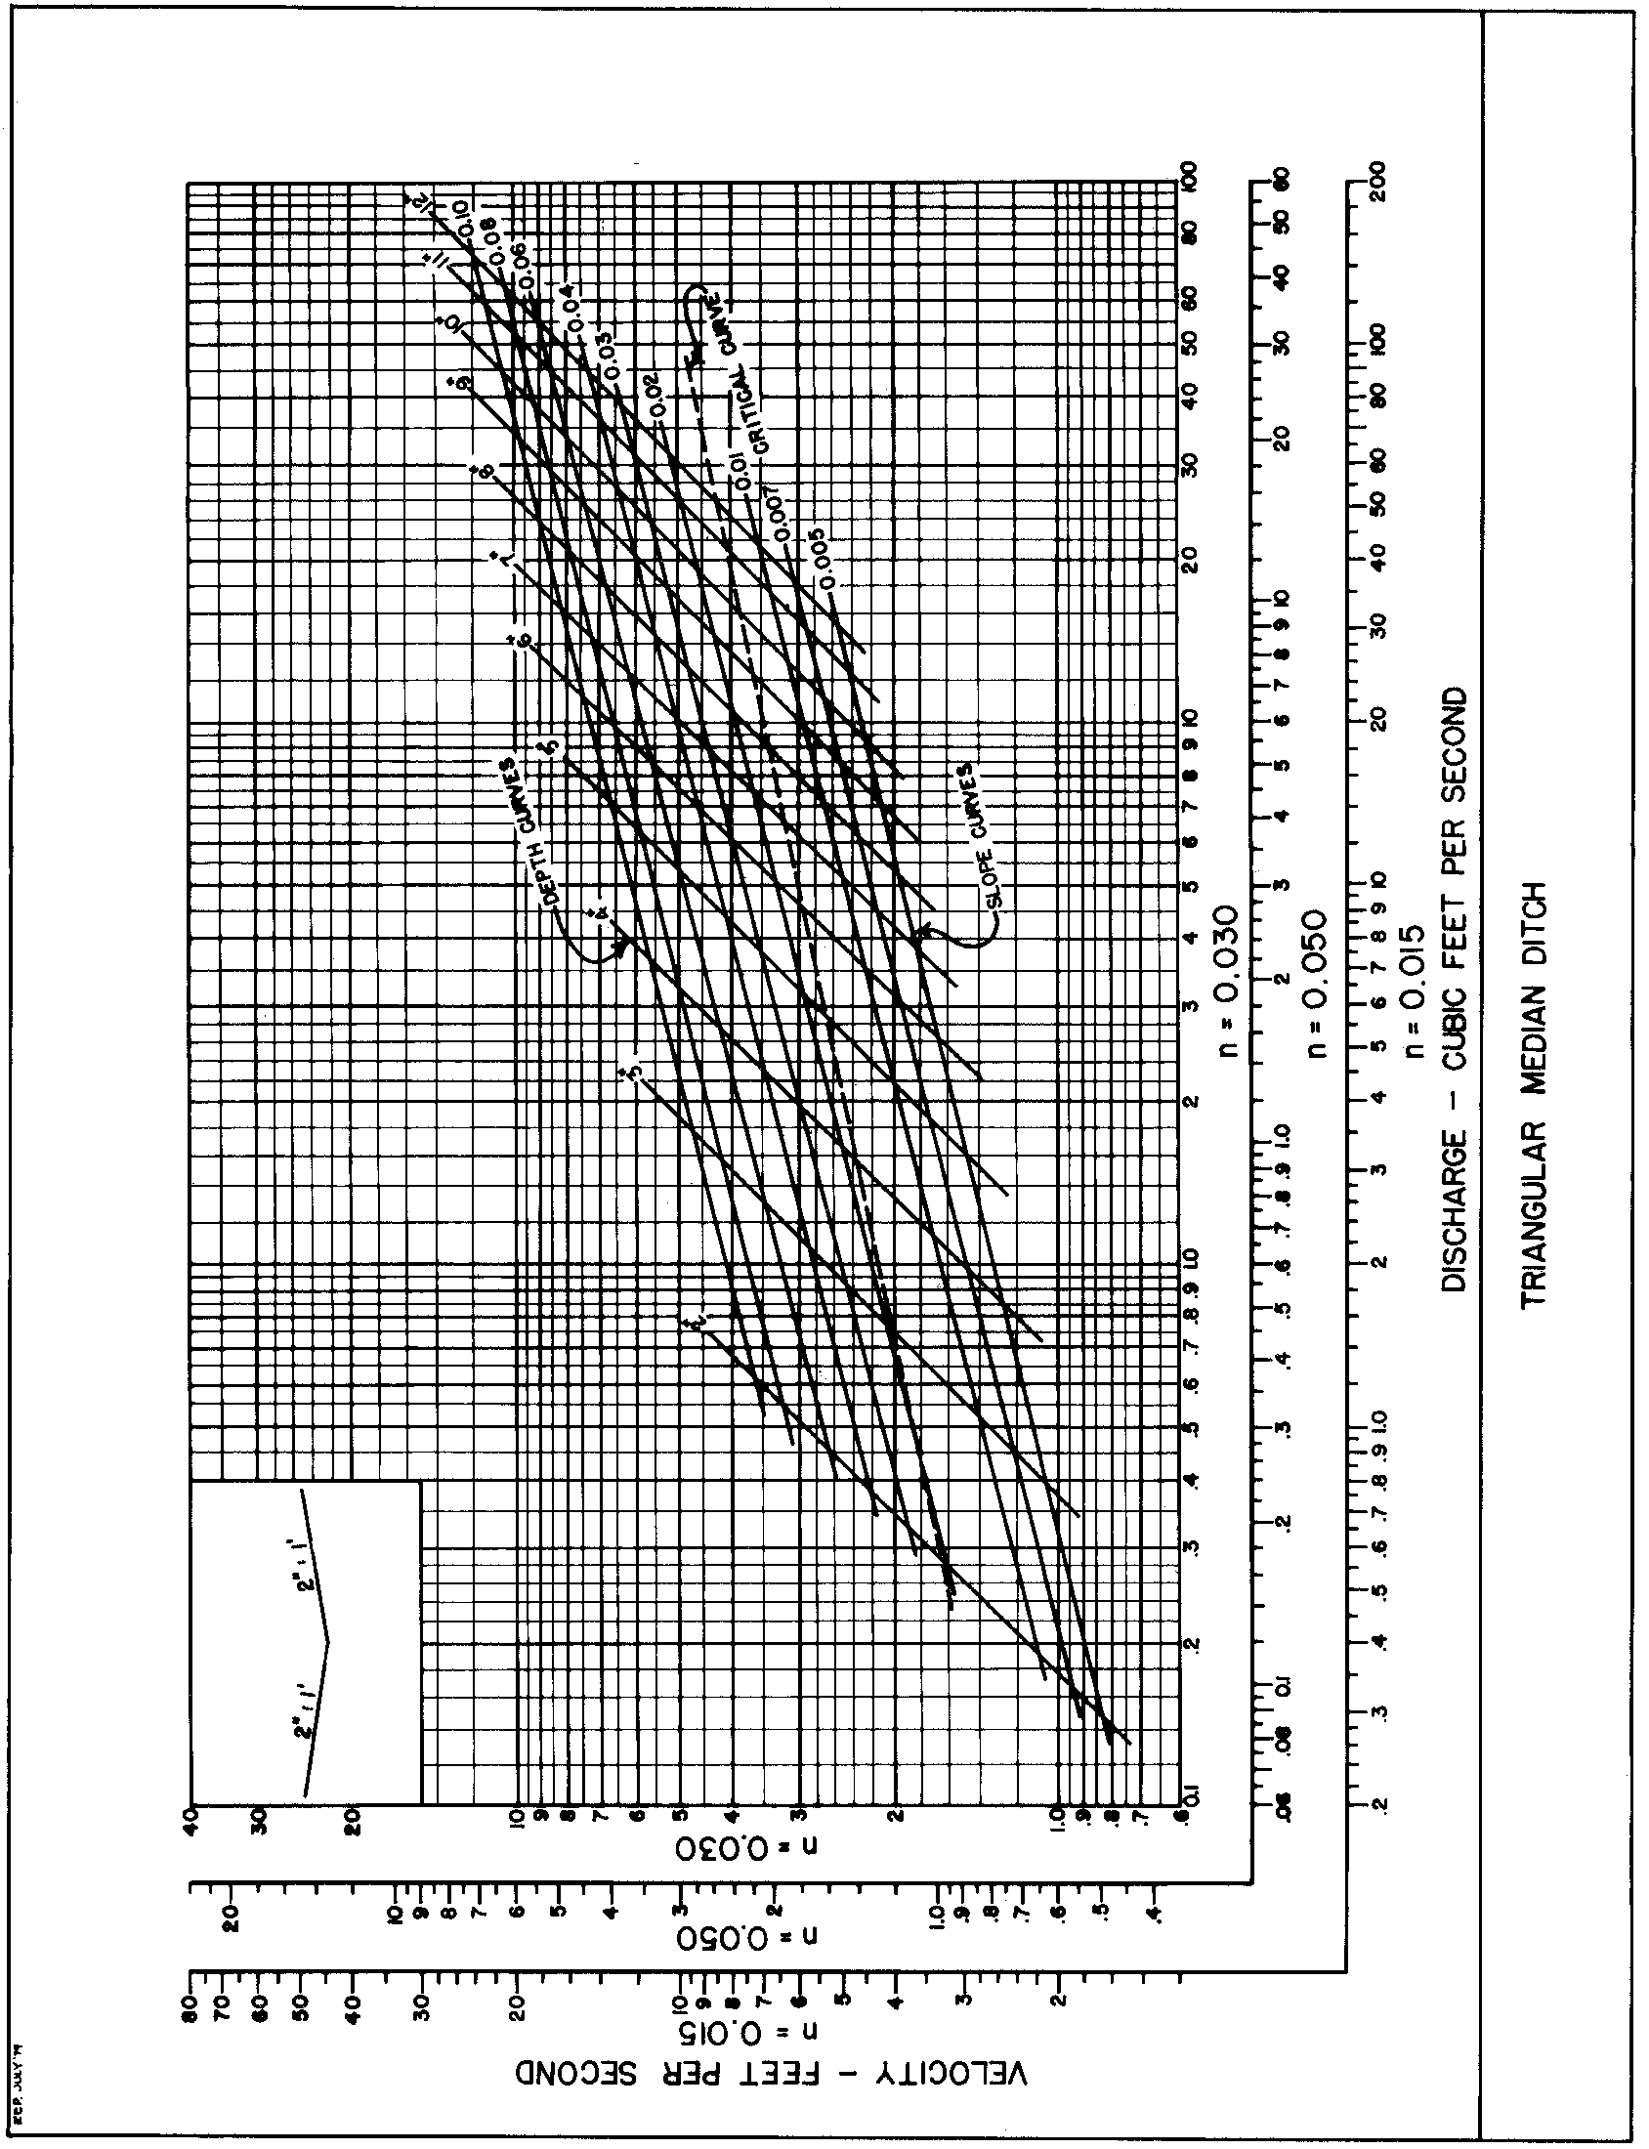

Source: VDOT

