Appendix 7C-11 Side Ditch Flow Chart

(Side Slopes = 6:1, 4:1)

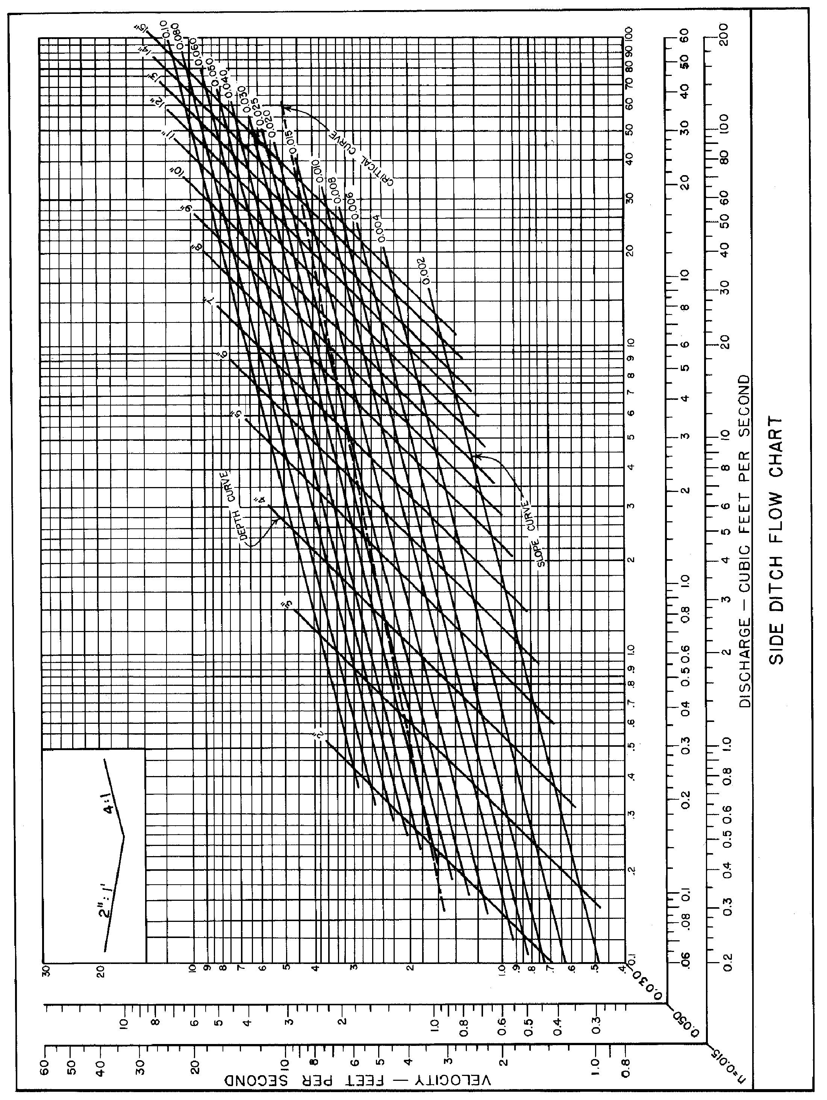
Source: VDOT

