Appendix 7C-8 Side Ditch Flow Chart

(Side Slopes = 3:1, 1.5:1)
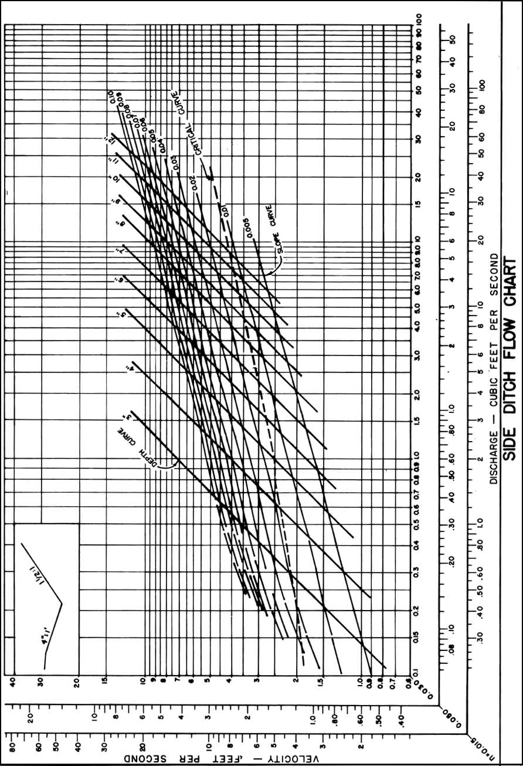

Source: VDOT

