Appendix 6J-1 Major Drainage Basins
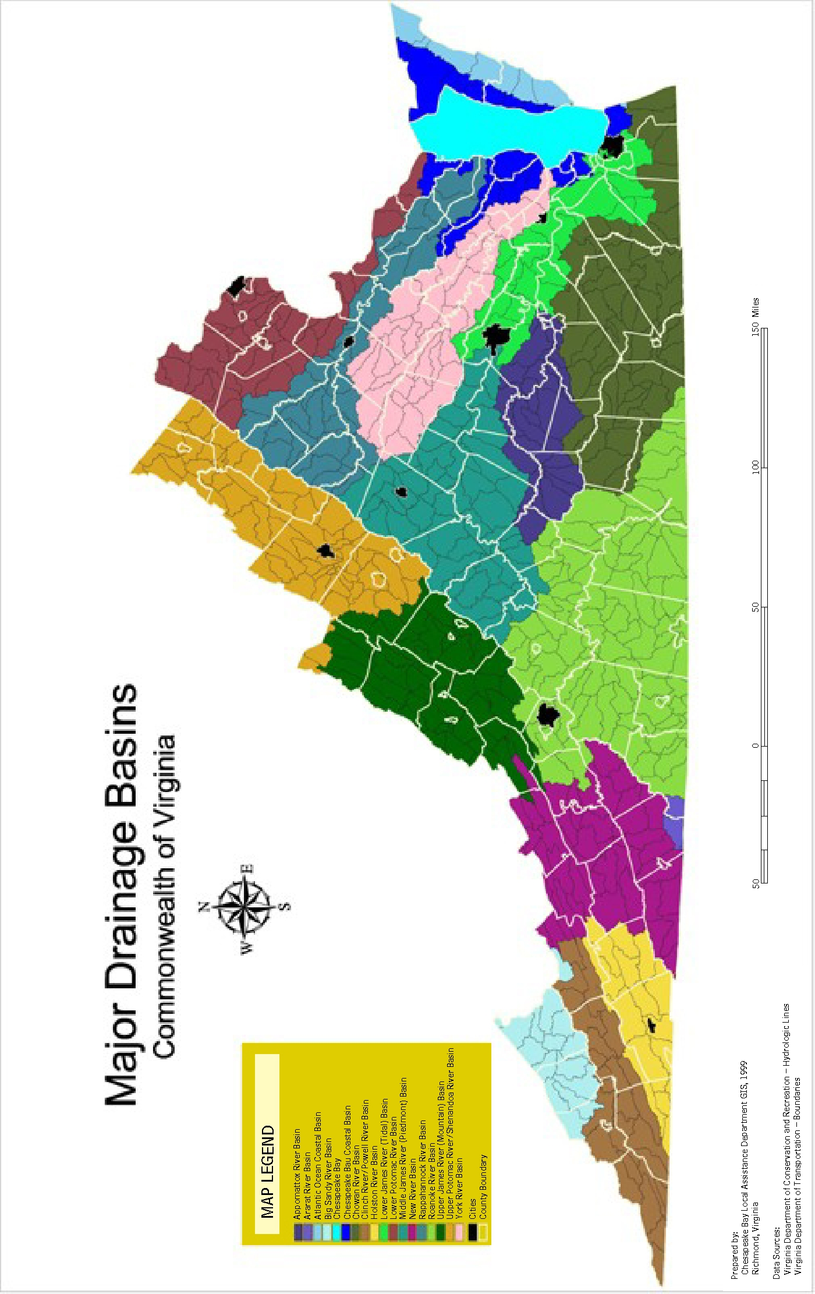
Source: CBLAD

