Appendix 6I-4 Tide Frequency, Virginia Beach

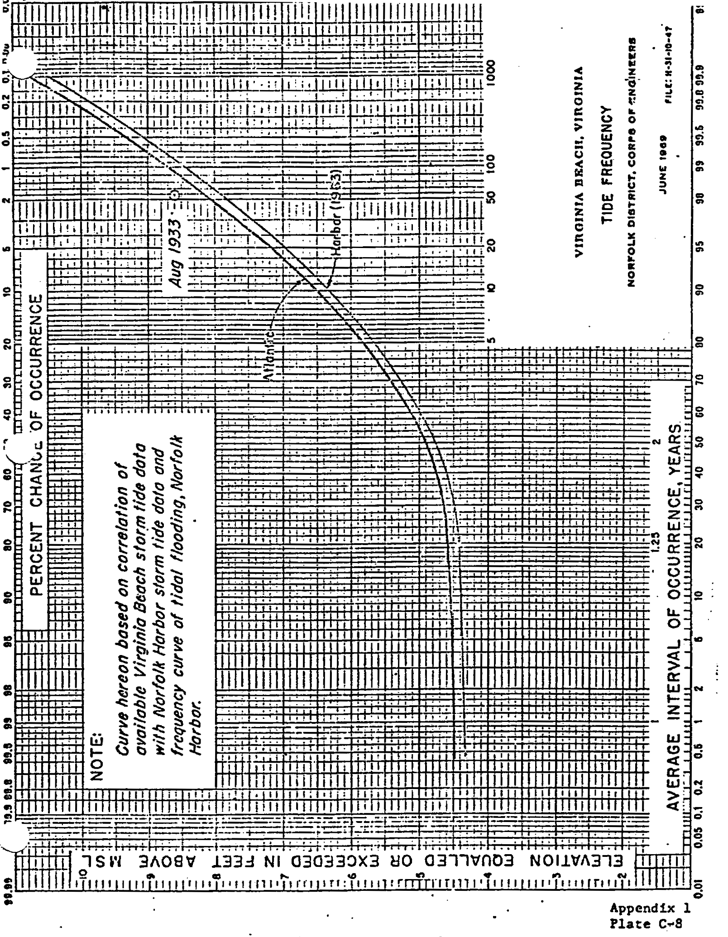

Source: U. S. Army Corps of Engineers

