Appendix 6I-2 Rainfall Coincident with

Tidal EL. 2.5 FT and 5.4 FT
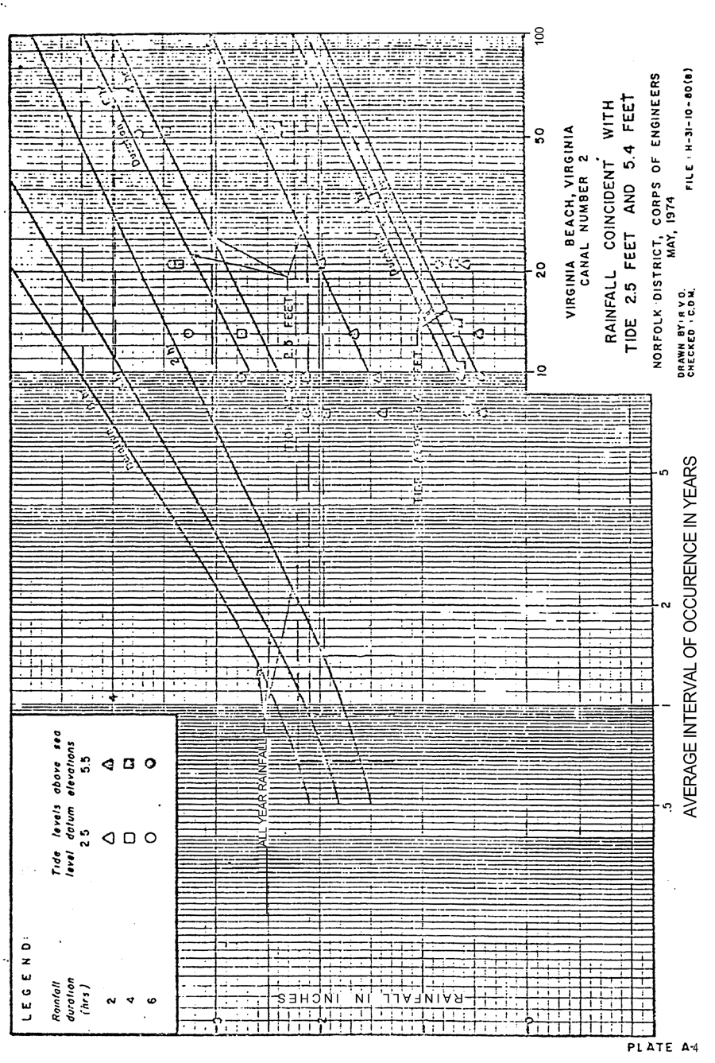
Source: U. S. Army Corps of Engineers

