Appendix 6H-2 SCS Relation Between Direct Runoff,

CN and Precipitation

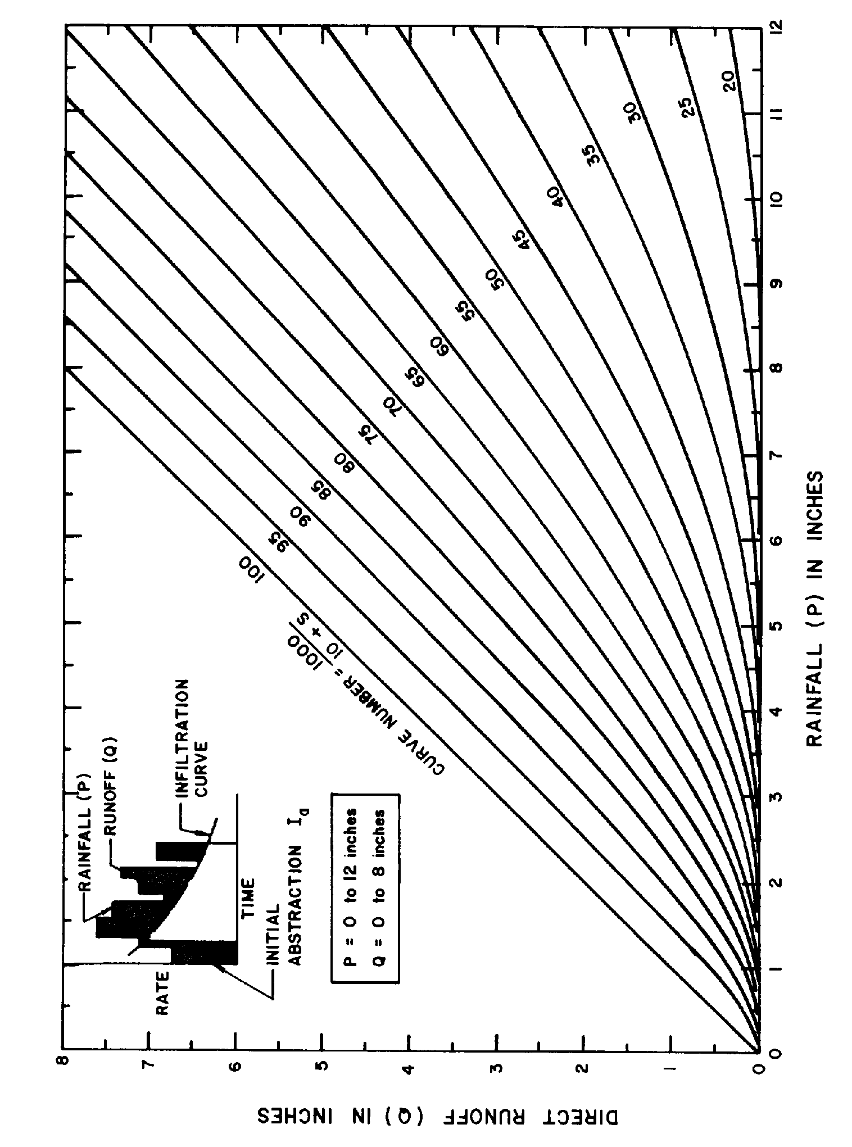
Source: HEC No. 19, FHWA

