Appendix 6H-1 Type II Design Storm Curve

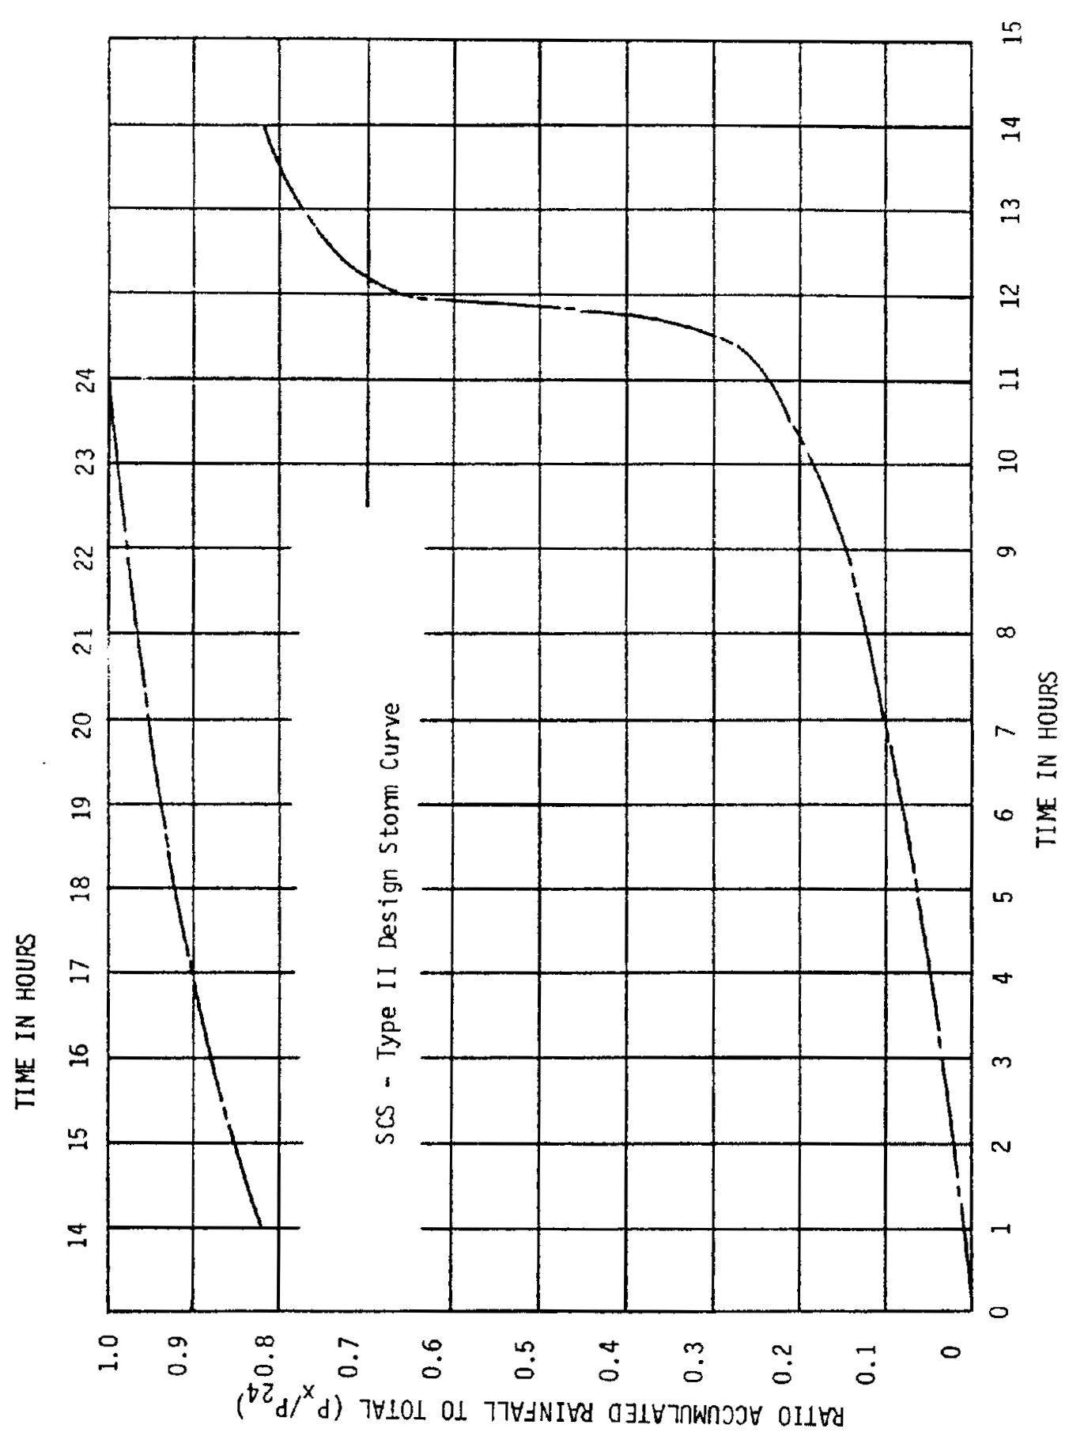

Source: SCS-TP-149

