Appendix 6G-9 Snyder Method: Staunton (City)

Rainfall Depth Curve
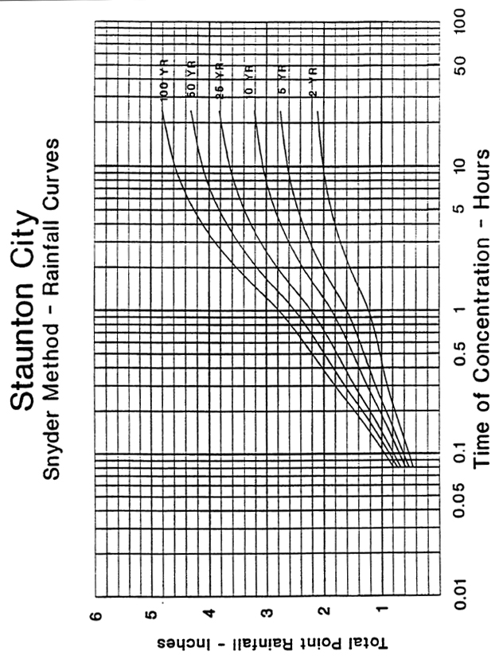

Source:

