Appendix 6G-6 Snyder Method: Lynchburg

Rainfall Depth Curve
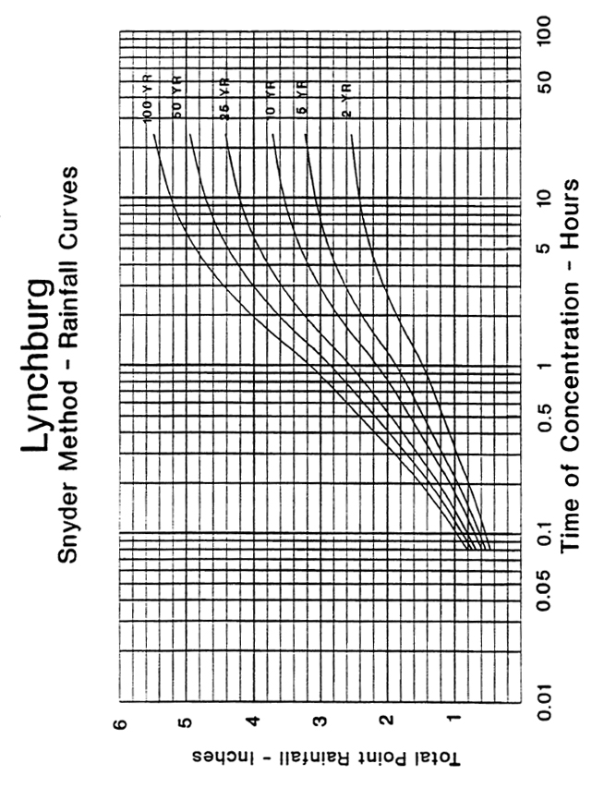
Source:

