Appendix 6G-5 Snyder Method: Dickenson County

Rainfall Depth Curve
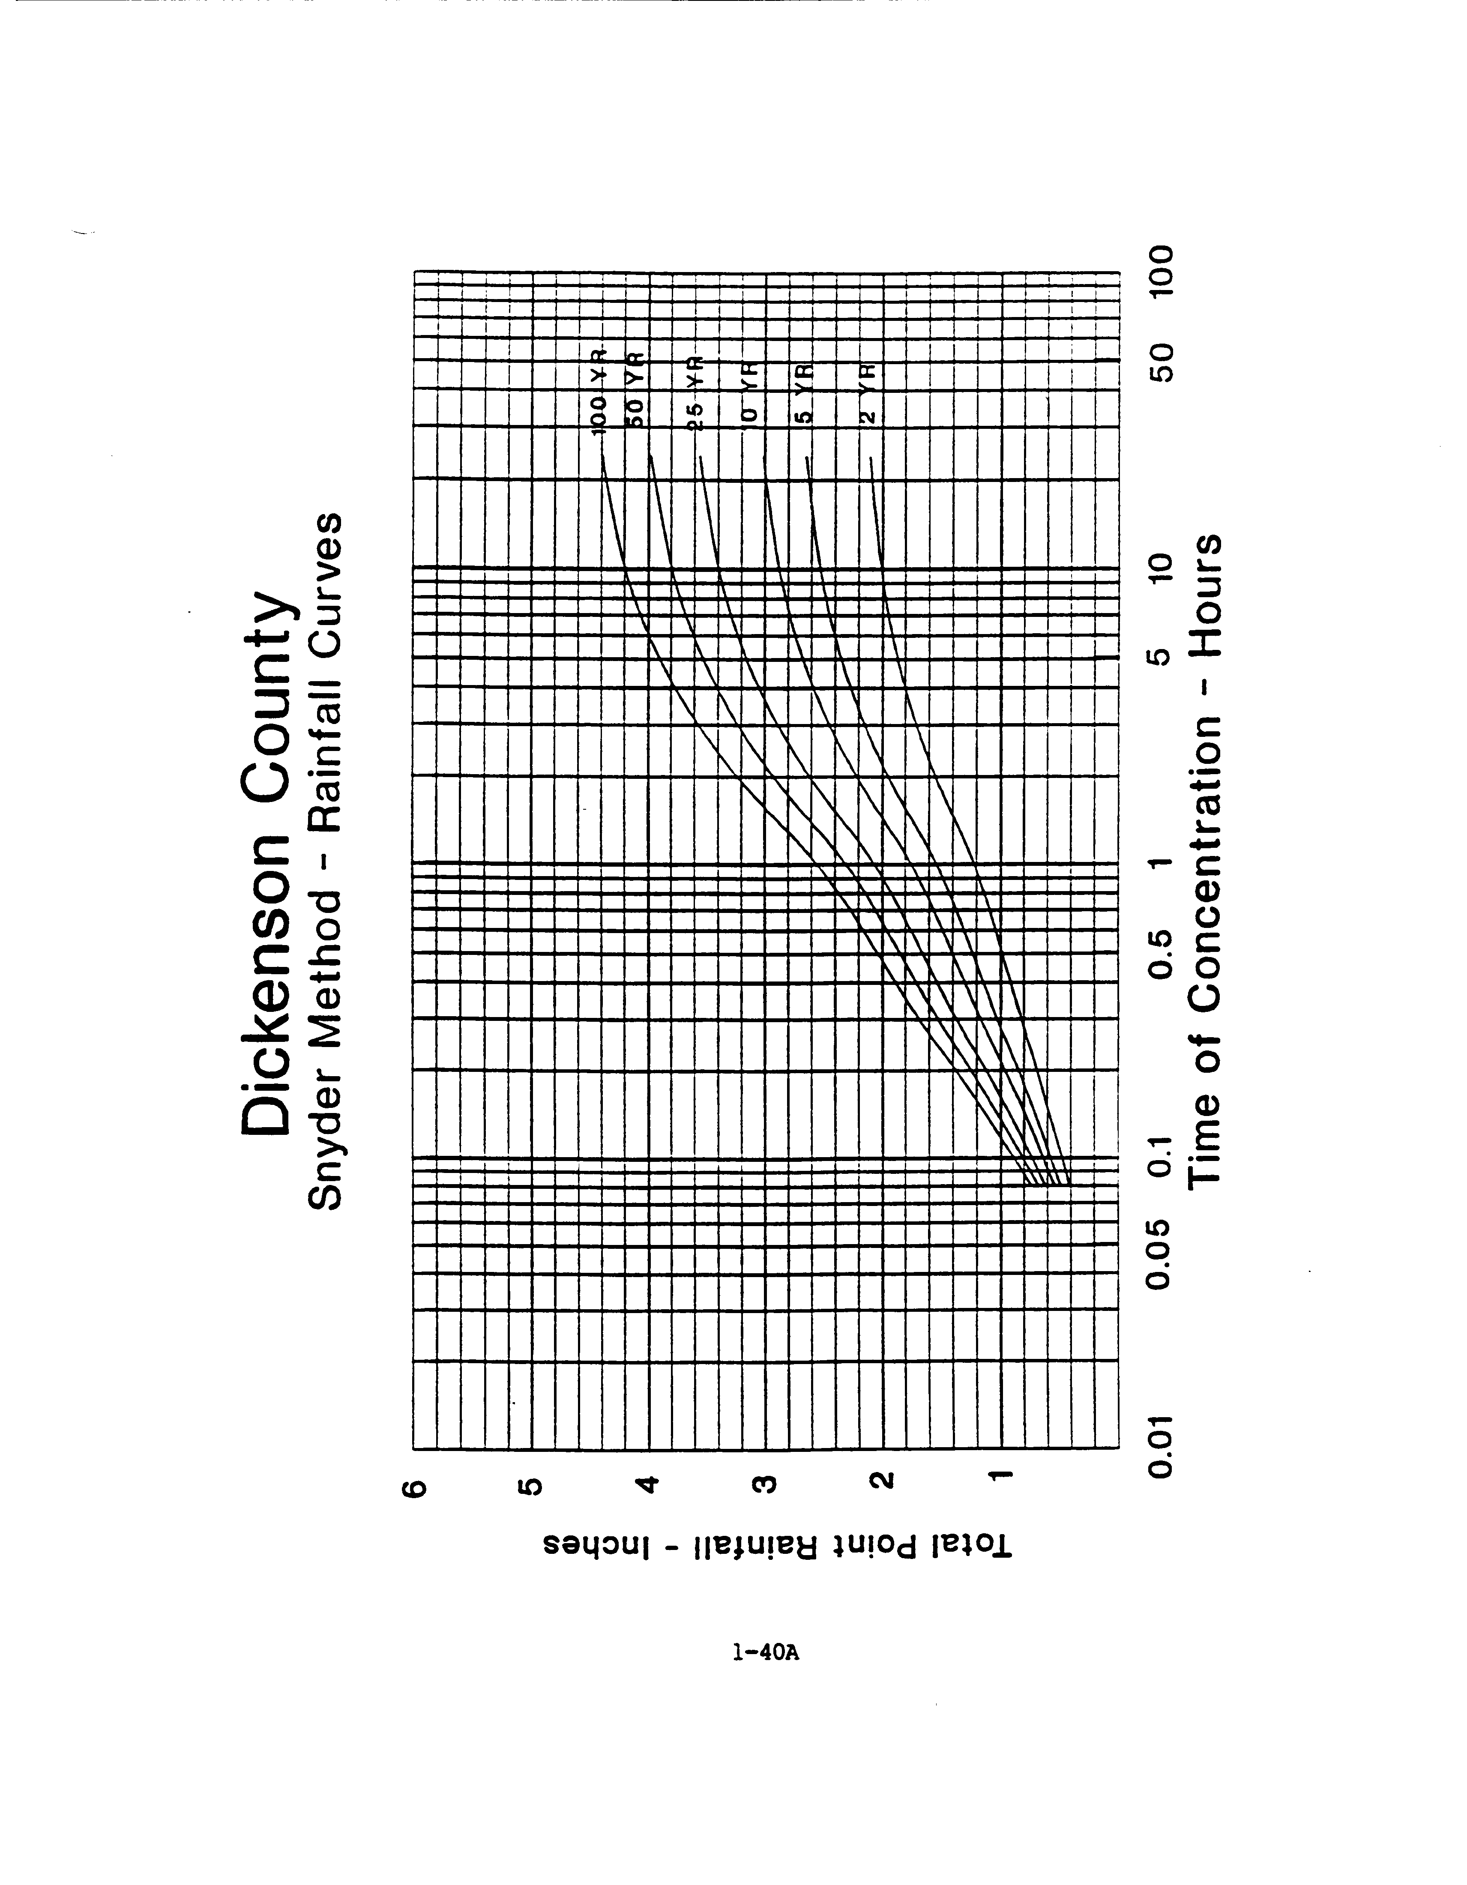

Source:

