Appendix 6G-4 Snyder Method: Bath County

Rainfall Depth Curve
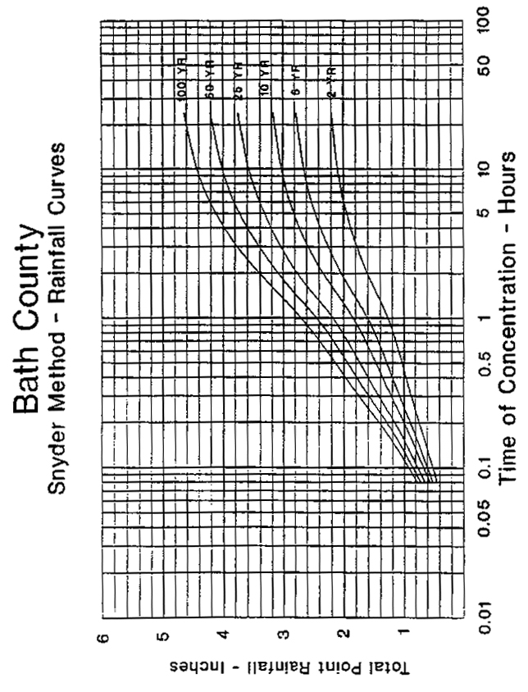

Source:

