Appendix 6G-2 % Impervious Area vs. % Adjusted Runoff

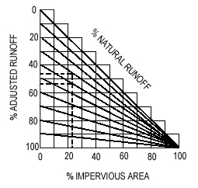

Source:

