Appendix 6F-2 Lag Time vs. Length-Slope Index

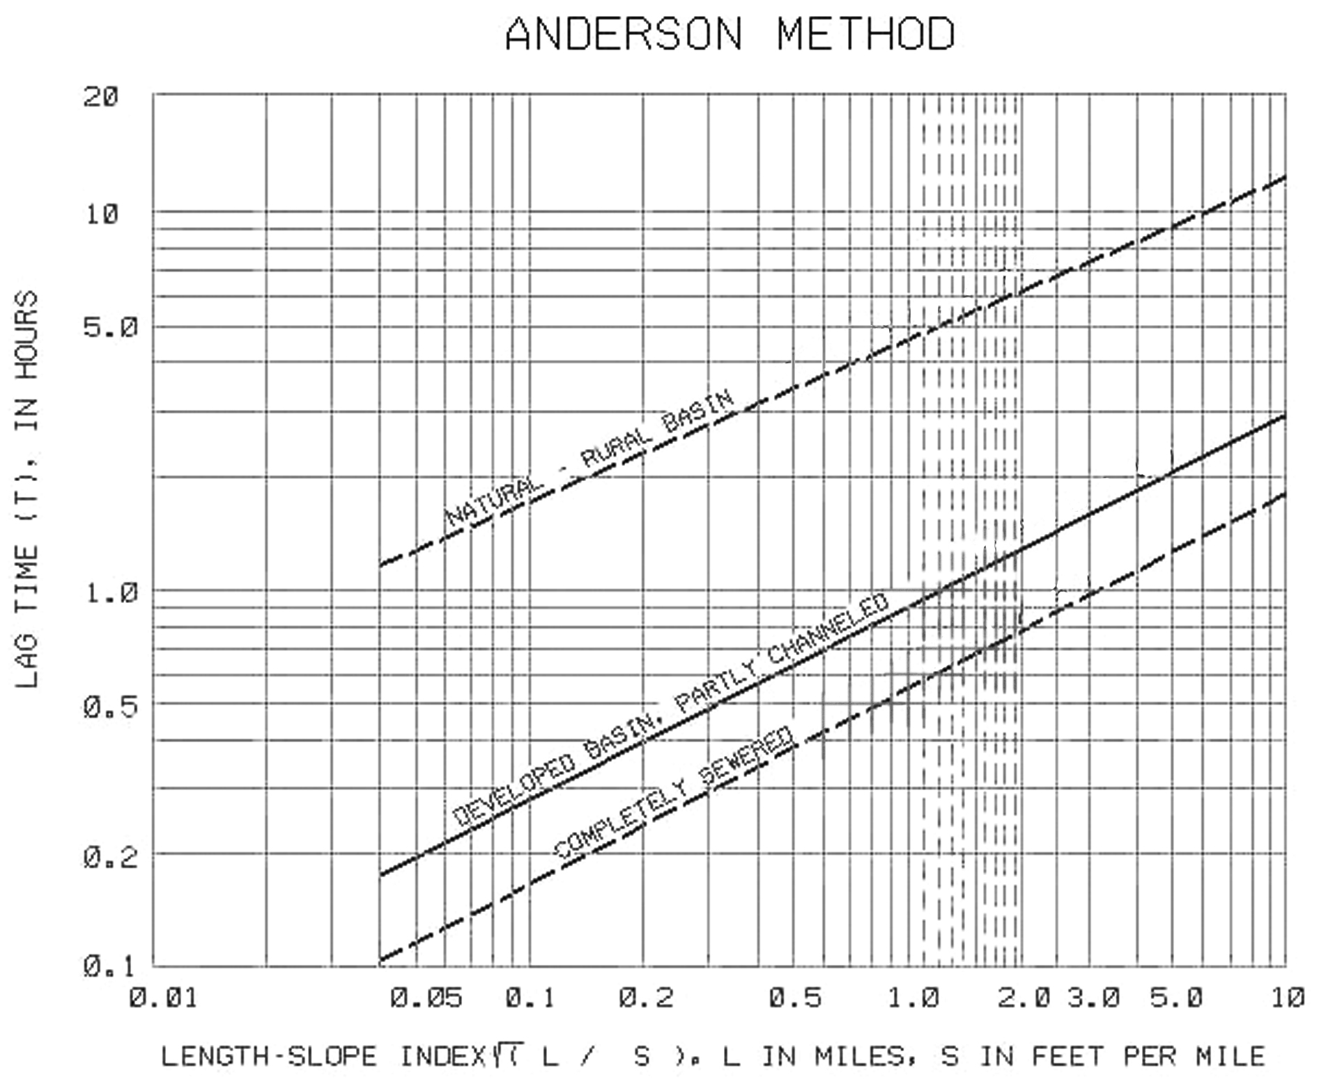

Natural Rural Basin
Developed Basin Partly Channelized
Completely Developed and Sewered Basin

Source:

