Appendix 6F-1 Anderson Method: R Values

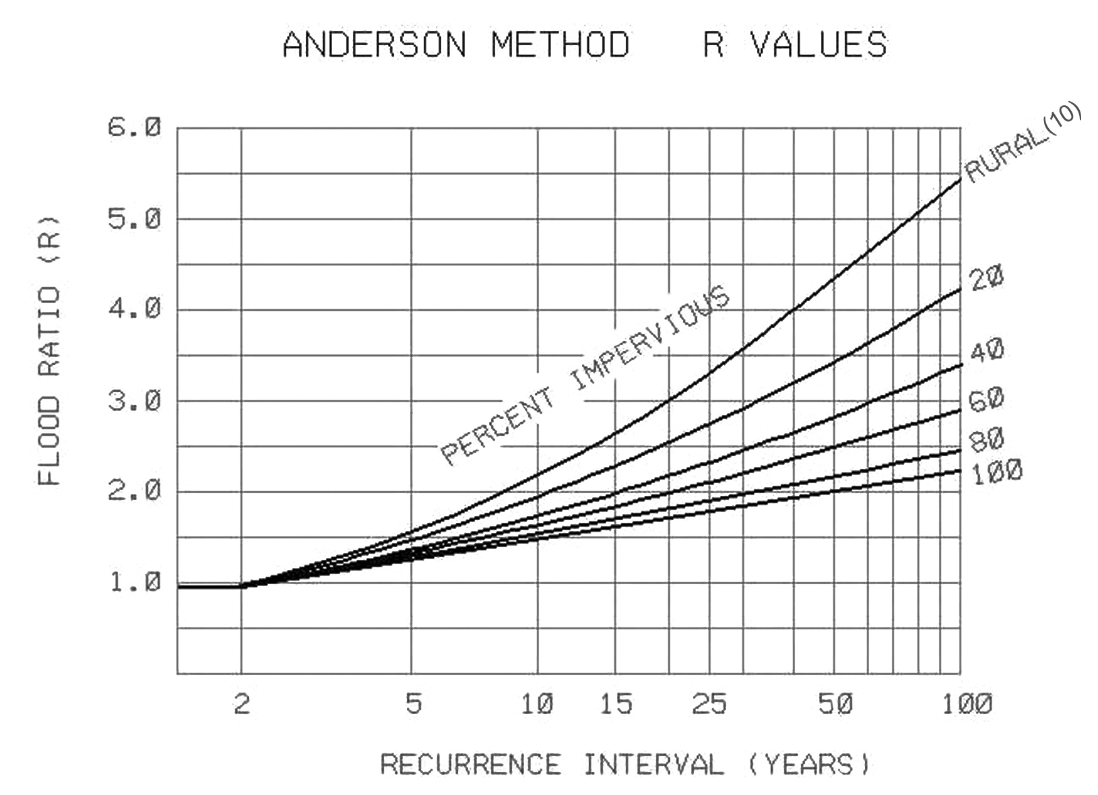

Source:

