Appendix 6D-2 Kinematic Wave Formulation

Overland Flow

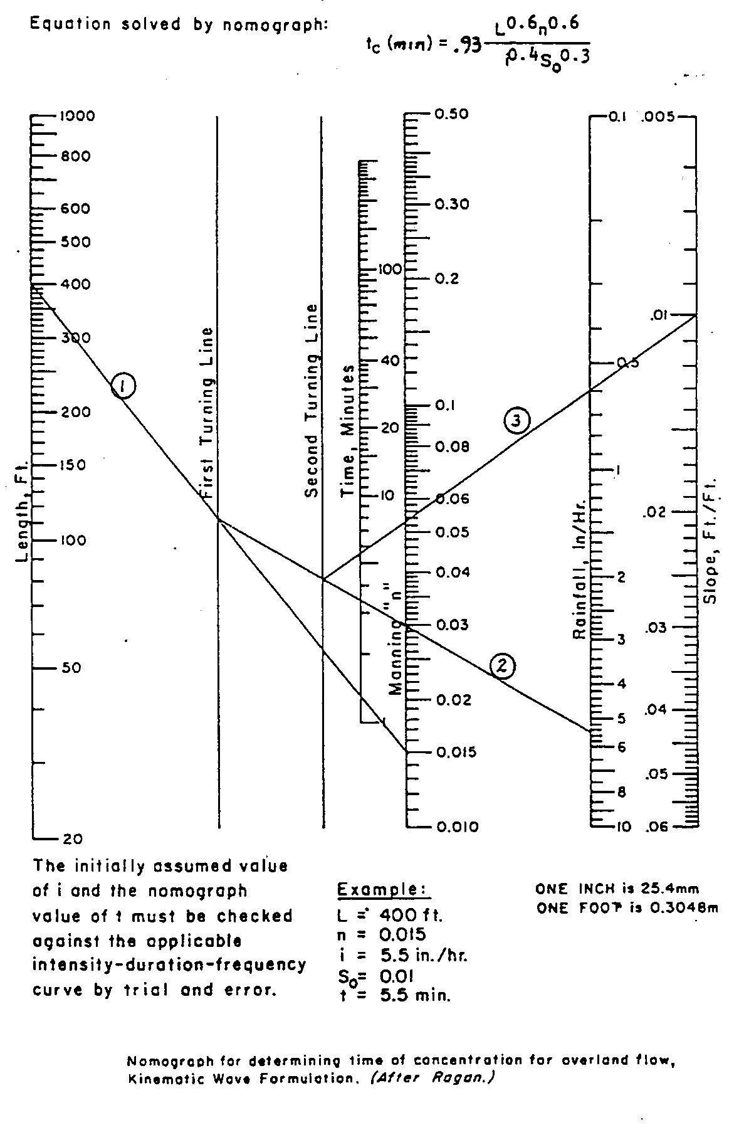
Comments:
VDOT has determined that the Kinematic Wave Method should only be used for:
a) Impervious Surfaces
b) n = 0.05 or less
c) Length = 300’ Maximum

