Appendix 6B-18 Rainfall Intensity Inches Per Hour

Wytheville
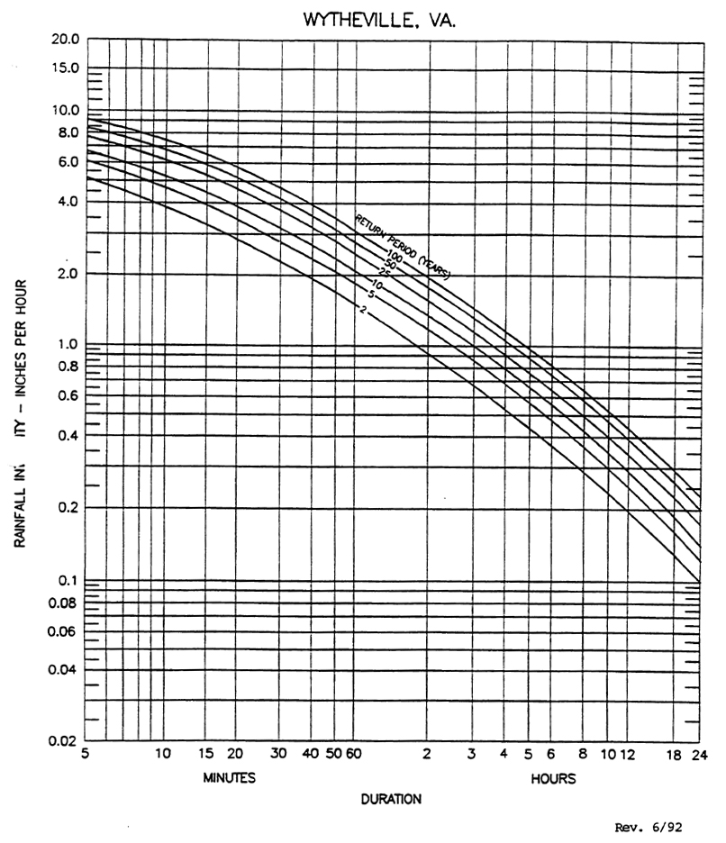
Regression Constants

a b
2 116.78 18.83
5
10 174.91 22.13
25
50
100 261.68 24.25

Source:
Regression Constants from Virginia Stormwater Management Handbook, 1st Ed., Vol. II, 1999

