Appendix 6B-5 Rainfall Intensity Inches Per Hour

Bath Co.

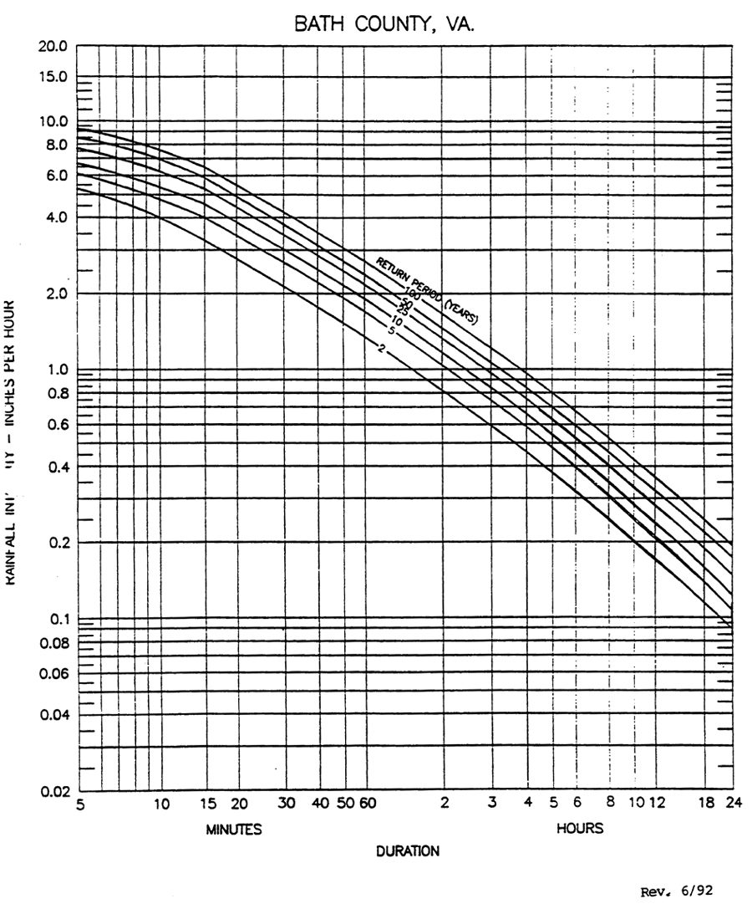
Regression Constants

Freq. | a | b
2
5
10
25
50
100

Source:
Regression Constants from Virginia Stormwater Management Handbook, 1st Ed., Vol. II, 1999

