

Virginia Department of Transportation

Pollutant Discharge Elimination System

General Permit for Stormwater Discharges from Small Municipal Separate Storm Sewer Systems

Serving the

Urbanized Areas of Virginia

Registration # VA040115 - coverage from July 1, 2008 to June 30, 2013

YEAR TWO PROGRESS REPORT

July1, 2009 to June 30, 2010

October 18, 2010

Final

Virginia Department of Transportation
Location and Design Division
1401 East Broad Street
Richmond, Virginia 23219

Certification:

“I certify under penalty of law that this document and all attachments were prepared under my direction or supervision in accordance with a system designed to assure that qualified personnel properly gather and evaluate the information submitted. Based on my inquiry of the person or persons who manage the system or those persons directly responsible for gathering the information, the information submitted is to the best of my knowledge and belief true, accurate, and complete. I am aware that there are significant penalties for submitting false information including the possibility of fine and imprisonment for knowing violations.”

Print Name: Mr. Gregory A. Whirley Title: Commonwealth Transportation Commissioner

Signature: _______________________________________ Date: ___________________________

Virginia Department of Transportation

Stormwater Management Program

The Virginia Department of Transportation’s (VDOT’s) Stormwater Management (SWM) Program is presented in the form of the six minimum control measures required by the Virginia MS-4 General Permit. This program has been developed with a consistent statewide implementation strategy since VDOT maintains regulated MS4s (or components of regulated MS4s) within the public right-of-ways within all thirteen designated urbanized areas of Virginia. While VDOT’s SWM Program is targeted toward those that construct, maintain and utilize its transportation infrastructure and facilities, many of the program’s proposed goals have the potential for a broader appeal.

The VDOT SWM program has and continues to improve environmental compliance, quality and stewardship on VDOT land-disturbing activities through effective management, implementation, and enforcement of sound technical guidelines, criteria, and practices for stormwater management and erosion and sediment control.

This Annual Report identifies the progress towards achieving the measurable goals, as well as any changes and/or additions identified for each BMP. A description of VDOT’s proposed Best Management Practices (BMPs) for each minimum control measure, and the Year 2 goals and accomplishments, is summarized on the following pages:

- Best Management Practices for Public Education and Outreach
pages 4 - 5
- Public Involvement/Participation
pages 6 - 7
- Illicit Discharge Detection and Elimination
pages 8 - 17
- Construction Site Stormwater Runoff Control
pages 18 - 21
- Post Construction Stormwater Management in New Development and Redevelopment
pages 21 - 23
- Pollution Prevention/Good Housekeeping for Municipal Operations
pages 24 - 27
- Attachment # 1 – pages 28 - 34 VDOT Stormwater Facilities in MS4 Areas
- Attachment #2 – pages 35 - 41 Maintenance Activity Disposal Area Policy –
- Attachment # 3 – pages 42 - 47 MOA between DEQ and VDOT on Solid Waste and Implementation Guide
- Attachment # 4 – page 48 TMDLs approved prior to 7/1/08 with WLA assigned to VDOT’s MS4
- Attachment # 5 – page 49 VDOT’s WLAs for TMDLs within the MS4
- Attachment # 6 – page 50 TMDLs approved by the SWCB after 7/1/2008 with WLA assigned to VDOT's MS4
- Attachment # 7– page 51 Slope Erosion Control Selection Chart

1 | Best Management Practices for Public Education and Outreach  Distribute educational materials and perform outreach to inform citizens about the impacts polluted stormwater runoff discharges can have on water quality.
A | Public Education
A | Provide information on storm water quality, regulatory requirements; information on public participation, and links for additional information.
B | Public Outreach
B | Employ diverse strategies to target audiences specific to the area serviced by the regulated MS4

BMP 1A | Public Education - Public Affairs Lead Division
Measurable Goal(s) | - Goal: Develop and maintain a Stormwater Management Web page on www.VirginiaDOT.org  - Measure: The development of the page, and visitor statistics based on industry-accepted Web metrics tools.  - Goal: Post and promote the availability of the Stormwater Management educational video and public service announcements (PSAs) on the VDOT Stormwater Management Web page and the Commonwealth of Virginia’s YouTube Web page.  - Measure: The posting of the video and PSAs on both Web pages and number of requests received for copies.  - Goal: Develop a VDOT Stormwater Management fact sheet. An electronic version of the fact sheet will be posted on the VDOT Web page. Additionally, copies may be printed and distributed to the public and other MS4 operators.  - Measure: The development of the fact sheet and its posting on the VDOT Web page, and the number of copies distributed.  - Goal: Partner with other MS4 operators to broadcast SWM Public Service Announcements (PSAs) twice in each urbanized area per permit cycle.  - Measure: Number of times PSAs are broadcast.
Milestone Yr 2 | - Maintain the Stormwater Management Web page on www.VirginiaDOT.org.  - Continue posting information regarding VDOT’s Stormwater Management Program as available.  - Partner with other MS4 operators to broadcast the Stormwater Management.
Accomplishments | - The VDOT Stormwater Management webpage has been developed. The webpage can be found at http://www.virginiadot.org/programs/stormwater_management.asp  - The webpage includes information on VDOT’s MS4 Program, including the implementation plan, annual reports and links to public service announcements/educational videos. The webpage also provides a specific e-mail address (MS4@vdot.virginia.gov) that enables individuals to contact program officials directly.  - The public service announcements/educational videos also are available for public consumption on the Commonwealth of Virginia’s YouTube channel.

BMP 1B(1) (a) | Public Outreach – Maintenance Lead Division
Measurable Goal(s) | - Goal: Install message signs and mechanism for distribution of informational brochures at pet waste stations at safety rest stations and welcome centers regarding environmental effects of pet waste and encouraging pet owners to properly dispose of their pet waste.  - Measure: Number of signs installed and number of brochures distributed.
Milestone Yr 2 | - Install message signs at pet waste stations on environmental effects and proper disposal of pet waste. Develop and implement procedures for distribution of informational brochures at pet waste stations on environmental effects and proper disposal of pet waste.
Accomplishments | - One or more Pet waste stations similar to the DOGIPOT pet stations have been installed at all rest areas/welcome centers. The pet waste station is stocked with disposal bags as part of the normal maintenance operation. To further assure compliance of this procedure, the pet stations are part of VDOT’s Monthly Quality Assessment Review/Safety Rest Area Inspection. This inspection reviews the Pet Stations for functionality and to assure they are being maintained and stocked.  - Due to budget priorties, a decision on the placement of additional signage and mechanisms for distribution of informational brochures has been delayed.

BMP 1B(1) (b) | Public Outreach – Maintenance Lead Division
Measurable Goal(s) | - Goal: Promote storm drain stenciling and Adopt-a-Highway programs.  - Measure: Number of land use permits issued for storm drain stenciling and highway miles adopted under the Adopt-a-Highway program.
Milestone Yr 2 | - Promote storm drain stenciling and Adopt-a-Highway programs and track number of permits issued and highway miles adopted.
Accomplishments | - During this reporting cycle, a total of 10 storm drain stenciling Land Use Permits were issued.  - A total of 11,632 miles are currently adopted by citizens for clean up in the Adopt-a-Highway Program. During this reporting cycle a total of 4,664 cubic yards of waste collection and disposal was reported.

BMP 1B(2) | Public Outreach – Traffic Engineering Lead Division
Measurable Goal(s) | - Goal: Participate in watershed sign installation program based on available funding.  - Measure: Total number of signs installed.
Milestone Yr 2 | - Install up to 32 watershed signs (based on total budgeted estimated cost of $37,500).
Accomplishments | - 25 watershed signs were installed at various locations across the state of Virginia at a cost of $36,000

2 | Best Management Practices for Public Participation and Involvement  Provide opportunities for citizens to participate in program development and implementation, including effectively publicizing public hearings and/or encouraging citizen representatives on a stormwater management panel.
A | Public Involvement
A | Provide public access to information pertaining to VDOT’s MS4 Program.
B | Public Participation
B | Participate in watershed organizations and local government technical advisory committees to ensure that provisions for linear development projects are incorporated into local watershed planning.

BMP 2A | Public Involvement - Public Affairs Lead Division
Measurable Goal(s) | - Goal: Make available for public review VDOT’s MS4 Program Plan and subsequent annual reports on the VDOT Stormwater Management Web page. Promote the location of the Stormwater Management Web page in VDOT publications, where applicable.  - Measure: Visitor statistics based on industry-accepted Web metrics tools.
Milestone Yr 2 | - Post MS4 Program Plan on the VDOT Stormwater Management Web page.  - Continue to promote the location of the Stormwater Management Web page in VDOT publications, where applicable.
Accomplishments | - The VDOT Stormwater Management webpage has been developed, and MS4 Program Plan is prominently featured. The webpage can be found at http://www.virginiadot.org/programs/stormwater_management.asp

BMP 2B(1) | Public Participation – Location and Design Lead Division for project design related issues
Measurable Goal(s) | - Goal: Participate in local activities aimed at increasing public awareness of water quality and stormwater issues.  - Measure: Number of watershed planning meetings attended.
Milestone Yr 2 | - Participate in watershed planning meetings and maintain a summary of issues considered.
Accomplishments | - VDOT employees participated in the following meetings / activities  - IDDE informational meetings  - BMP Education Initiatives  - Anti-Cigarette Litter Initiative  - Enterprise Rent-a-Car Washing  - EPA workshop  - Phase II Stormwater Committee meetings-York County Development Services  - Joint Environmental Subcommittee Meetings - HRPDC Chesapeake  - 11 – Stormwater Regulatory Action and related meetings -Technical Advisory  Committee, BMP Clearing House Committee, SWM Handbook Committee  SWCB meetings  - Rivanna Regional Educational Partnership (RRSEP) meetings.  - Fredericksburg Area MS-4 stakeholders meetings  - Rivanna Rambler for Outreach meetings  - James River Roundtable
BMP 2B(2) | Public Participation – Environmental Lead Division for water quality related regulatory issues
Measurable Goal(s) | - Goal: Participate in local activities aimed at increasing public awareness of water quality and stormwater issues.  - Measure: Number of watershed planning meetings attended.
Milestone Yr 2 | - Participate in watershed planning meetings and maintain a summary of issues considered
Accomplishments | 29 meetings – Coastal Zone Management Policy Team Meetings, Sustainable Shoreline and Community Management Project Workgroup, Rivanna River TAC, Accotink Creek Watershed Advisory Group, SWCD Workshop, Hampton Roads Planning District Commission’s Multiple Benefit’s Technical Advisory Committee, Chesapeake Bay TMDL Public Meetings and Stakeholders’ Meeting, Coastal Zone Policy Team Focus Group for Section 309 Coastal Strategies, Virginia Water Monitoring Council 2010 Conference, Chesapeake Bay TMDL webinars, Rivanna River Technical Advisory Committee Meeting, VDOT Statewide Environmental Division Administrator Meeting, Fredericksburg District Inspector Conference, Environmental Research Advisory Committee, Accotink Creek Watershed Advisory Group, Nichol Run/Pond Branch Watershed Advisory Group, Virginia CZM Program Change Meeting

3 | Best Management Practices for Illicit Discharge Detection and Elimination (IDDE)  Develop, implement, and enforce a program to detect and eliminate illicit discharges into VDOT’s stormwater system.
A | Prevent or minimize to the maximum extent practicable, the discharge of hazardous substances or oil
A | Guidance addresses the issues of illicit discharge. Non-storm water discharges will be prohibited, except for those of uncontaminated water as listed in the permit requirements.  Education on illicit discharges will be a key component.
B | Evaluate guidance to identify and report Illicit Discharges Connections
B | Guidance and procedures to detect and report the source of the illicit discharges into MS4
C | Continue to develop Inventory of Storm Water Systems
C | An updated GIS-compatible digital database of storm water infrastructure outfalls.
D | Track the number of illicit discharges identified and eliminated
D | Guidance for tracking and reporting illicit discharges
E | Prohibit, through ordnance, or other regulatory mechanism non-stormwater discharges
E | Practices to eliminate and/or minimize illicit discharges
F | Address Total Maximum Daily Load (TMDL) Waste Load Allocation (WLA) streams within each MS4
F | Update plan within 18 months to include measurable goals, schedules, and strategies to ensure MS4 consistency with any TMDL for which waste loads have been allocated to the MS4

BMP 3A | Evaluate guidance and training programs to prohibit non-stormwater discharge into MS4 – Maintenance Lead Division
Measurable Goal(s) | - Goal: Review training guidance and current practices and update and revise as necessary  - Measure: An annual evaluation of guidance and practices  - Goal: Provide IDDE training programs to appropriate audiences.  - Measure: Number of employees, contractors, and volunteers trained.
Milestone Yr 2 | - Revise training guidance and current practices related to IDDE as necessary.  - Revise other training materials to incorporate guidance dealing with IDDE.  - Provide IDDE training to appropriate audiences.
Accomplishments | - The Maintenance and Environmental Divisions have assigned EEE, ( the Department’s MS-4 Consultant) the task of developing an IDDE protocol. When the protocol is completed, an IDDE definition and communication message will be developed. The Maintenance Division will work closely with other VDOT divisions to incorporate the definition and communications message into all material and training associated with the Adopt-A-Highway and other programs.  - An IDDE module is being developed and will be incorporated into the In Stream Training program that is presented to maintenance personnel. This module is being developed in coordination with other modifications to the In Stream Training program.

BMP 3B | Guidance to identify and report Illicit Discharges Connections – Maintenance Lead Division
Measurable Goal(s) | - Goal: Develop/revise illicit discharge identification and reporting protocols.  - Measure: Establishment of identification and reporting protocols.  - Goal: Establish a means for the public to report illicit discharges.  - Measure: Development of reporting system and number of reports received of potential illicit discharges.
Milestone Yr 2 | - Modify illicit discharge identification and reporting protocols as necessary based on software purchased and /or the results of user acceptance testing of software.  - Implement illicit discharge reporting system utilizing the VDOT SWM Program webpage, Adopt-A-Highway Program or through direct contact with the appropriate VDOT Residency/District Office.
Accomplishments | - . An Outfall IDDE Reconnaissance Field Sheet has been developed and approved for IDDE investigations. When an outfall is determined to have an Overall Outfall IDDE Characterization Of obvious, or suspect; or when a potential IDDE has been reported the site will be investigated and the Outfall IDDE Reconnaissance Field Sheet will be completed. The VDOT MS4 consultant is currently developing the IDDE investigation protocol; therefore no investigations were completed in this plan year.  - IDDE characterization of Outfalls.  - No potential IDDE sites have been reported through the VDOT MS4 webpage or Adopt-A-Highway.
  CUA | Unlikely | Potential | Suspect | Obvious | Total
  Winchester | 283 | 22 | 0 | 1 | 306
  Northern Virginia | 1,074 | 16 | 1 | 0 | 1,091
  Roanoke | 620 | 51 | 14 | 6 | 691
  Blacksburg | 32 | 1 | 3 | 2 | 38
  Danville | 72 | 1 | 6 | 2 | 81
  Totals | 2,081 | 91 | 24 | 11 | 2,207

BMP 3C | Inventory of Storm Water System – Maintenance Lead Division
Measurable Goal(s) | - Goal: Develop and maintain an updated inventory of roadway outfalls in the MS4 urbanized areas.  - Measure: Development and implementation of inventory system and protocols.  - Measure: Percentage of centerline miles by roadway functional class by MS4 area inventoried.
Milestone Yr 2 | - Software – Purchase and make modifications to NPDES/MS4 Program software or develop software. Complete user acceptance testing.  - Instructional Manual – Complete development of manual by merging the protocol with the data collection procedures included in the software.
Accomplishments | Within the next year, VDOT will begin the process of formalizing their outfall inventory program that will include a written protocol to inform VDOT personnel on appropriate inventory procedures.  Discussions with other MS4 permits holders lead VDOT to the U.S. Army Corps of Engineers (USACE) which had completed an outfall inventory for Stafford County. The USACE can provide this assistance to VDOT in accordance with Section 22 of the Water Resources Development Act (WRDA) of 1974 (Public Law 93-251), as amended, which authorizes the Secretary of the Army, acting through the Chief of Engineers, to assist the States in the preparation of comprehensive plans for the development, utilization and conservation of water and related resources of drainage basins, watersheds and ecosystems located within the boundaries of such State.  A Letter of Agreement was negotiated with the Baltimore District USECE to complete the following tasks in the Potomac River watershed:  - Collection of existing information and field survey preparation  - Field survey and assessment of outfalls  - Development of outfall database and GIS layers  - Documentation of procedures  - Finial Report  The completion of the outfall inventory/assessment for the Census Urban Areas (Washington, Winchester and Harrisonburg) in the Potomac River watershed will be completed in phases. The USACE field survey will be completed at the targets identified by the VDOT MS4 Target Model.  A Letter of Agreement was also negotiated with the Wilmington District USECE to complete the same tasks in the Roanoke River watershed (Roanoke, Danville and Blacksburg Census Urban Areas).  The function of the MS4 Target Model is to predict the most likely location of VDOT stormwater conveyances discharging into Waters of the US. The MS4 Target Model utilizes the most up-to-date hydrographic data and VDOT road centerline data, to identify locations were roadways maintained by VDOT are within a specified proximity to streams, water bodies or wetlands.  The model was refined and run for a second time in November 2009 before the target layer was supplied to the USACE. The modifications included:  - Census Urban Area Boundary Modification: The Census Urban Area boundary as modified to include all features (roads, intersections, subdivisions, etc.) that were fractured by the Census Urban Area boundary. This change in the Census Urban Area was made to make field collection boundaries more understandable. For example the Roanoke Census Urban boundary bisected interstate 81 and its intersections in many locations. The boundary was modified to move the Census Urban Boundary west of the interstate and its intersections for the complete length of the Census Urban Area.  - Target Review: Completion of a review of all targets to eliminate targets that are on routes that are not maintained by VDOT. The VDOT Roadway Network, GIS Feature Class used in the model currently does not supply sufficient data to determine if certain routes, such as business  route of US highways located in cities, are maintained by the cities or VDOT. A review of the maintenance status of any questioned route in HTRIS was completed and selected targets were marked for elimination when it was verified that maintenance is not supplied by VDOT.  - Inclusion of the most current VDOT data.  - Grouping of targets within a specified proximity of each other into Clusters. For example the five or six targets generated on the various road segments that make up an intersection at a stream crossing would be grouped into one cluster.  The results of the November 2009 run of the MS4 Target Model are shown in the following table:  *Net Targets – Targets on routes that VDOT does not maintain were eliminated by comparing GIS routes to Highway and Traffic Records Information System (HTRIS) data. For example, targets on the Blue Ridge Parkway and US highways in cities with business designations were removed.  The USACE, Baltimore and Wilmington, has reported the completion for the permit cycle of outfall inventories in the watersheds as shown in the tables below. During the 2010-2011 permit year the outfall inventory/assessments will be completed, a quality acceptance review will be completed and  the final outfall database and GIS layers will be delivered.  Targets assigned represent 25% of the total net targets in Northern Virginia.  Targets assigned represent 100% of the targets for Winchester.  Targets assigned represent 100% of the targets for Roanoke.  Targets assigned represent 100% of the targets for Blacksburg.  Targets assigned represent 100% of the targets for Danville.  The targets assigned to the USACE represent 21% of the total net targets for the state, completion of four Census Urban Areas, and 25% of the net targets in Northern Virginia. The desire is to continue to use the USACE districts in Baltimore and Wilmington to complete the outfall inventory and assessment for the Census Urban Areas in their Districts as soon as they are able to budget the matching funds (project cost are split 50/50). Discussions will also be initiated with the Norfolk District of the USACE for the Charlottesville, Richmond, Virginia Beach and Fredericksburg Census Urban Areas.
  CUA |  | Targets  June 2009 | Targets  Nov 2009 | Net Targets* | Clusters
  Blacksburg, VA |  | 100 | 121 | 79 | 39
  Bristol, TN--Bristol, VA |  | 118 | 142 | 117 | 74
  Charlottesville, VA |  | 226 | 275 | 255 | 149
  Danville, VA |  | 88 | 145 | 89 | 52
  Fredericksburg, VA |  | 502 | 567 | 520 | 372
  Harrisonburg, VA |  | 113 | 174 | 148 | 97
  Kingsport, TN—VA |  | 55 | 77 | 77 | 48
  Lynchburg, VA |  | 219 | 264 | 213 | 155
  Richmond, VA |  | 2,268 | 2,858 | 2,455 | 1,499
  Roanoke, VA |  | 746 | 870 | 769 | 467
  Virginia Beach, VA |  | 2,443 | 2,844 | 1,828 | 938
  Washington, DC--VA—MD |  | 4,217 | 4,517 | 4,308 | 2,576
  Winchester, VA |  | 226 | 300 | 296 | 185
  VDOT Total |  | 11,321 | 13,154 | 11,154 | 6,651
  Northern Virginia
  Watershed | HUC 6 | Targets | Clusters | Outfalls
  Cub Run | PL 45 | 371 | 220 | 353
  Lower Bull Run | PL 46 | 188 | 133 | 232
  Middle Bull Run | PL 44 | 94 | 41 | 67
  Goose Creek – Big Branch | PL 14 | 6 | 3 | 0
  Goose Creek – Cattail Branch | PL 16 | 54 | 26 | 62
  Accotink Creek | PL 30 | 315 | 175 | 320
  Potomac River – Fourmile Run | PL 25 | 65 | 26 | 43
  Potomac River – Limestone Branch | PL 05 | 7 | 5 | 14
  Total Northern Virginia |  | 1,100 | 629 | 1,091
  Winchester Virginia
  Watershed HUC 6 |  | Targets | Clusters | Outfalls
  Opequon Creek – Sulphur Spring Run | PU 16 | 150 | 91 | 147
  Opequon Creek – Redbud Run | PU 18 | 27 | 21 | 20
  Abrams | PU 17 | 75 | 48 | 76
  Crooked Run | PS 79 | 25 | 19 | 52
  Hogue Creek | PU 12 | 19 | 6 | 11
  Total Winchester |  | 296 | 185 | 306
  Roanoke Virginia
  Watershed HUC 6 |  | Targets | Clusters | Outfalls
  Roanoke River – Sawmill Hallow | RU 09 | 77 | 46 | 60
  Mason Creek | RU 10 | 12 | 4 | 12
  Tinker Creek – Buffalo Creek | RU 11 | 116 | 73 | 102
  Carvin Creek | RU 12 | 100 | 61 | 63
  Tinker Creek – Glade Creek | RU 13 | 182 | 103 | 180
  Roanoke River – Peters Creek | RU 14 | 214 | 132 | 208
  Back Creek | RU 15 | 50 | 33 | 51
  Roanoke River / SML / Lynville Creek | RU 16 | 14 | 11 | 10
  Goose Creek – North Fork Goose Creek | RU 39 | 4 | 4 | 5
  Total Roanoke |  | 769 | 467 | 691
  Blacksburg Virginia
  Watershed HUC 6 |  | Targets | Clusters | Outfalls
  Crab Creek | NE 58 | 11 | 6 | 4
  New River – Strobles Creek | NE 59 | 29 | 13 | 17
  Toms Creek – Poverty Creek | NE 60 | 14 | 7 | 8
  South Fork Roanoke River - Brake Branch | RU 05 | 1 | 1 | 0
  North Fork Roanoke River-  Dry Run | RU 06 | 10 | 6 | 7
  North Fork Roanoke River-  Wilson Creek | RU 07 | 14 | 6 | 2
  Total Blacksburg |  | 79 | 39 | 38
  Danville Virginia
  Watershed HUC 6 |  | Targets | Clusters | Outfalls
  Dan River – Danville | RD 33 | 9 | 5 | 8
  Lower Sandy River | RD 36 | 6 | 4 | 3
  Dan River – Sandy Creek (West) | RD 37 | 13 | 11 | 22
  Fall Creek | RD 38 | 15 | 12 | 16
  Dan River – Pumpkin Creek | RD 39 | 46 | 20 | 32
  Total Danville |  | 89 | 52 | 81
BMP 3D | Track and eliminate illicit discharges – Maintenance Lead Division
Measurable Goal(s) | - Goal: Notify in writing any downstream regulated MS4 to which the VDOT small regulated MS4 is physically interconnected to their system.  - Measure: Total number of interconnected MS4 Operators notified.  - Goal: Develop and maintain a process for contacting and reporting illicit discharges to appropriate authority.  - Measure: Development of process and number of illicit discharges reported.
Milestone Yr 2 | - Review/update list of MS4 localities and provide notification of physical interconnection as identified through implementation of outfall inventory.  - Report verified illicit discharges to the appropriate authorities.
Accomplishments
  - A Notice of Potential Interconnected Stormwater Systems letter was mailed to the ninety-six other MS4 Operators listed on DCR’s October 20, 2008 Virginia MS4 report. Please see sample letter on the next page.
  - No IDDE Notifications were received from interconnected MS4 Operators and no notifications sent by VDOT for the reporting cycle.

BMP 3E | Prohibition of non-stormwater discharges – Maintenance Lead Division
Measurable Goal(s) | - Goal: Prohibit non-stormwater discharges into storm sewer systems through the Land Use Permitting Program.  - Measure: Number of guidance and training documents reviewed/revised to incorporate IDDE identification procedures.  - Measure: Number of Land Use Permitting employees that participate in trained on IDDE identification.
Milestone Yr 2 | - Provide training to all employees involved in the Land Use Permits Program on IDDE identification. Track number of employees trained.
Accomplishments | - No training of Land Use Permits Program employees beyond the IDDE training reported in the 2008-2009 permit year was completed in this permit cycle. The reporting structure and number of employees in the Land Use Permits Program was impacted by the VDOT reorganization. Land Use Permit Program administration is currently determining training needs and additional IDDE training will be one of the considerations.

BMP 3F | Update MS4 plan to ensure consistency with TMDLs – Environmental Lead Division
BMP 3F(1) | Evaluate/revise/update legal authorities/policies/procedures
Measurable Goal(s) | - Goal: Develop a list of existing legal authorities, policies and procedures that are applicable to reducing the pollutant identified in the WLA.  - Measure: Development of list.  - Goal: Develop and implement a schedule to evaluate existing legal authorities, policies and procedures to determine their effectiveness to address reduction of the pollutant identified in the WLA.  - Measure: Development and subsequent implementation of schedule  - Goal: Develop and implement a schedule to update existing legal authorities, policies and procedures to address weaknesses related to the MS4 Program and to ensure consistency with the TDML.  - Measure: Development and subsequent implementation of schedule.
Milestone Yr 2 | - Begin the process of identifying existing legal authorities, policies and procedures applicable to reducing the pollutant identified in the WLA.
Accomplishments | VDOT has begun the process of developing a list of applicable legal authorities/policies/procedures that are applicable to reducing pollutants identified in VDOT wasteload allocations (WLA) throughout the urbanized areas. VDOT has provided a scope of work to its MS4 consultant for review of these documents and for proposing a prioritization and schedule for updating the documents, as appropriate. The consultant provided a draft review on June 28, 2010. During the next year, VDOT will work with consultant to rank the documents and recommended actions based on criticality, scheduling and complexity using low/medium/high scale.
BMP 3F(2) | Update MS4 Program to address TMDL impacts
Measurable Goal(s) | - Goal: Update the MS4 Program Plan to include information regarding TMDLs to ensure consistency; as a stakeholder participate in the development of any implementation plan to address the TDML and incorporate applicable best management practices identified in the TMDL plan into VDOT’s MS4 Program Plan.  - Measure: Number of TMDLs incorporated into VDOT MS4 Program Plan.  - Measure: Number of plans implemented to address identified WLA.  - Goal: Identify and develop an estimate of the area draining from within VDOT right of way to identified TMDL waterways.  - Measure: Number of areas identified.  - Goal: Develop a characterization of the annual flow that estimates the storm water discharged and the quantity of pollutant identified in the waste load allocation discharged by the MS4.  - Measure: Number of sites for which development of characterization of stormwater discharges was completed.  - Goal: Implement procedures, reconnaissance and sampling protocols to identify and address the discharge of the pollutant identified in the waste load allocation to the MS4.  - Measure: Implementation of procedures.  - Goal: Integrate an awareness campaign into the public education and outreach program that promotes methods to eliminate and reduce the discharges of the pollutant identified in the WLA.  - Measure: Number of employees trained regarding the sources and methods to eliminate and minimize the discharge of the pollutant.
Milestone Yr 2 | - Secure services of consultant to assist in development and implementation of plan to address TMDL impacts/requirements.  - Begin process of identifying VDOT facilities impacted by TMDL Implementation Plans.
Accomplishments | - TMDL tables compiled to determine VDOT’s role in the TMDL’s approved prior to this permit term (attachment # 4). Eight TMDL’s have WLAs assigned to VDOT. Also compiled list of TMDL’s with VDOT WLAs developed during this permit term ( attachment # 5).  - Initiated process for incorporating TMDL layers and VDOT’s MS4 data (outfalls, stormwater facilities) into VDOT’s GIS.  - Negotiating the scope of work for VDOT’s MS4 consultant and to develop a pilot program for VDOT to use in addressing TMDL assumptions and special conditions of the general permit. The pilot program will use the approved TMDL for Stroubles Creek within the Blacksburg Urbanized Area for which VDOT has a WLA for sediment. Consultant is also developing prioritization plan for other TMDLs with approved and proposed Implementation Plans with waste load allocations assigned to VDOT.

4 | Best Management Practices for Construction Site Runoff Control Program  Develop, implement and enforce a program to reduce pollutants in storm water runoff from construction activities that result in a land disturbance of greater than or equal to one acre (2,500 sq ft in Chesapeake Bay Preservation Are).
A | Guidance for Construction Site Runoff Control Program
A | Implement qualifying state erosion and sediment control and stormwater management programs approved by the Virginia Department of Conservation and Recreation (DCR) on all regulated land disturbing activities.
B | Compliance Procedures for Land Disturbance Activities
B | Review and certify erosion and sediment and stormwater management plans for regulated land disturbance activities, secure required coverage under the Virginia Stormwater Management (VSMP) Construction Permit, and track the activities.  Perform final inspections to certify construction of post construction SWM facilities was completed per approved plans and that the facilities are functional.
C | Erosion and Sediment Control Training
C | Provide training opportunities through the Erosion and Sediment Control Contractor Certification (ESCCC) Program and the In stream Maintenance Training Program. Ensure employees obtain the appropriate certifications required by the Virginia Erosion and Sediment Control (ESC) law.
D | Inspections and Quality Assurance Reviews
D | Perform inspections in accordance with Virginia ESC Regulations and undertake quality assurance reviews to assess compliance with environmental commitments on all regulated land disturbance activities.
E | Enforcement Process
E | Review administrative process for enforcement procedures, penalties for violations and procedures for issuing stop-work orders and revise/develop as appropriate.
F | Procedures for receipt and consideration of information submitted by the public
F | Develop and implement procedures for the receipt and consideration of information submitted by the public concerning VDOT’s stormwater program.

BMP 4A | Evaluate guidance for Construction Site Runoff Control Program – Location and Design Lead Division
Measurable  Goal(s) | - Goal: Evaluate guidance documents, adjust/revise as appropriate.  - Measure: Number of documents reviewed and adjusted/revised.  - Goal: Secure annual approval of the VDOT ESC and SWM Standards and Specifications from DCR.  - Measure: Material submitted and approved by DCR.  - Goal: Continue to implement project tracking of regulated land disturbing activities in urban areas.  - Measure: Total number of land disturbing activities registered for VSMP Construction Permit coverage.
Milestone Yr 2 | - Submit erosion and sediment control and stormwater management standards and specifications to DCR for annual approval.  - Acquire and track VSMP Construction Permit coverage for regulated land disturbing activities undertaken by the Department.  - Review and update program guidance as appropriate.
Accomplishments | - Submitted the 2009 annual ESC & SWM Standards and Specifications to DCR for approval.  - Acquired and tracked VSMP Construction permit coverage for 196 land disturbing activities.  - All changes to the ESC & SWM design standards and specifications / guidance were included in the annual ESC & SWM Standards and Specifications submittal to DCR.
BMP 4B | Compliance Procedures for Land Disturbance Activities – Location and Design Division
Measurable Goal(s) | - Goal: Ensure that the requirements of VDOT’s ESC and SWM Programs are followed for each land regulated disturbing activity through the VSMP ESC and SWM Plan Certification process and the Termination Notification process.  - Measure: Number of projects submitted for coverage under the VSMP Construction Permit and number of termination notices processed.
Milestone Yr 2 | - Require certification of ESC and SWM plans for regulated land disturbance activities.  - Develop and implement procedures for certification of construction and functionality of post construction swm facilities for regulated land disturbance activities.
Accomplishments | - All ESC & SWM plans were reviewed and approved by a DCR certified ESC plan reviewer prior to requesting the VSMP Construction Permit coverage.

BMP 4C(1) | Erosion Prevention and Sediment Control Training – Location and Design Lead Division
Measurable Goal(s) | - Goal: Provide VDOT’s Erosion and Sediment Control Contractor Certification (ESCCC) Program training to contractor personnel.  - Measure: Number of contractor personnel trained.
Milestone Yr 2 | - Update/revise course material as necessary.  - Provide training to appropriate contractor personnel. Track number of personnel trained.
Accomplishments | - All course training material has been up-dated / revised to reflect the current VDOT Road and Bridge Standards and Specifications  - 479 persons participated in the ESCCC class  - 411 participants received ESCCC certification

BMP 4C(2) | Erosion Prevention and Sediment Control Training – Environmental Lead Division
Measurable Goal(s) | - Goal: Provide VDOT’s In Stream Maintenance Training to VDOT maintenance forces.  - Measure: Number of employees trained.
Milestone Yr 2 | - Update/revise course material as necessary.  - Provide training to appropriate VDOT personnel. Track number of personnel trained.
Accomplishments | - Reviewed In-Stream Maintenance Training Materials - all still applicable to existing regulations and Department procedures.  - In stream Maintenance Activities Parts 1 & 2 − 3 employees trained.  - In-stream Maintenance Activities: Modules 1 – 9 − 16 employees trained.  - Permits for Maintenance Activities −3 employees trained.  - Initiating Environmental Review and Clearance − 6 employees trained.  - Ditch Maintenance − 4 employees trained.  - Countersinking of pipes and Culverts − 4 employees trained.  - Sizing of Riprap Stone − 12 employees trained.  - Maintenance Disposal Areas − 2 employees trained.  - Alternative Stream Stabilization Measures − 5 employees trained.  - Emergency Situations and Solutions − 1 employee trained.  - Asphalt Equipment Cleaning – 11 employees trained  - Erosion & Sediment Control Parts 1, 2, and 3 – 11 employees trained  - Salt Pond Management – 4 employees trained  - Spill Prevention Controls and Countermeasures Refresher – 455 employees trained
BMP 4C(3) | Erosion Prevention and Sediment Control Training – Learning Center Lead Division
Measurable Goal(s) | - Goal: Ensure appropriate VDOT employees have necessary DCR Certifications.  - Measure: Number of employees certified through DCR as a RLD, ESC Inspector, Plan Reviewer, etc.
Milestone Yr 2 | - Track number of employees with DCR certifications and provide notification to those requiring recertification.
Accomplishments | Listing of Certifications this permit cycle  - ESC Inspector – 182 employees certified  - ESC Plan Reviewer – 10 employees certified  - ESC Combined Administrator – 28 employees certified  - ESC Program Administrator – 1 employees certified

BMP 4D | Inspections and Quality Assurance Reviews – Construction Lead Division
Measurable Goal(s) | - Goal: Perform site inspections in accordance with VDOT’s annually Approved ESC and SWM Standards and Specifications.  - Goal: Perform project environmental compliance reviews.  - Measure: Total number of reviews performed.  - Measure: Percentage of environmental reviews resulting in excellence, complaint, deficient, and non-complaint findings.
Milestone Yr 2 | - Perform site inspections and compliance reviews and track data in CEDAR.
Accomplishments | Monitored the new Environmental Compliance review process at a program level to insure that reviews were being done and entered into CEDAR. Developed a web based tutorial for use by project management staff on how to input environmental compliance reports into the CEDAR database. Provided individual support as needed to insure successful implementation of the transfer of the review and reporting of environmental compliance on projects from the Environmental Division to the Scheduling and Contract Division.  - Performed 1165 project compliance reviews with the following results:  - Environmental Excellence 0.2%  - Compliant 94.5%  - Deficient 4.0%  - Non-Compliant 1.3%

BMP 4E | Enforcement Process – Construction Lead Division
Measurable Goal(s) | - Goal: Review and revise/develop enforcement policies, procedures and penalties.  - Measure: Number of policies/procedures reviewed/revised/developed.
Milestone Yr 2 | - Review administrative process for enforcement procedures, penalties for violations and procedures for issuing stop-work orders and revise/develop as appropriate.
Accomplishments | - Reviewed administrative process for enforcement procedures, penalties for violations and procedures for issuing stop-work orders and revised/developed as appropriate.  - Reviewed all Construction Directives (CD) and updated or sunset these CD’s as appropriate. This included a review of CD-2008-07, Environmental and Safety Responsibility, which was found to be appropriate and needed no changes. Also, continuously reviewed the Road and Bridge Specifications, Copied Notes, and Special Provisions that were included in our contracts and found that they were effective and no changes were needed.
BMP 4F | Procedures for receipt and consideration of information submitted by the public - Public Affairs Lead Division
Measurable Goal(s) | - Goal: Develop and implement procedures for the receipt and consideration of information submitted by the public concerning VDOT’s Stormwater Management Program.  - Measure: Establishment of a means for citizens to provide information to the Department concerning the Stormwater Management Program and creation of a process for addressing the information received.  - Measure: Number of comments received and actions taken.
Milestone Yr 2 | - Establish public comment page on VDOT SW website.  - Develop procedures for addressing comments received.
Accomplishments | - The VDOT Stormwater Management Program Web page is now complete and located on the VDOT External Web site. This Web page includes a function that allows visitors to view the Stormwater Management Program context and submit questions and comments. Visitors with comments will click on a link that enables them to send an e-mail to the program manager.

5 | Best Management Practices for Post Construction Runoff Program  Develop, implement, and enforce a program to address stormwater runoff from new development and redevelopment projects that disturb greater than or equal to one acre
A | Guidance for post-construction runoff controls
A | Continue to implement a comprehensive stormwater management program relative to the most recent approved version of the VDOT Erosion and Sediment Control Management standards and specifications.
B | Develop and implement strategies for post-construction runoff controls
B | Develop and implement strategies, which include a combination of structural and non-structural best management practices and secure registration coverage for regulated land disturbing activities under the VSMP General Permit for Discharges of Stormwater from Construction Activities.
C | Provide Long-term operation and maintenance of controls
C | Evaluate inspection requirement guidance for post-construction runoff control and related maintenance requirements and track VDOT owned and operated stormwater management facilities.

BMP 5A | Guidance for post-construction runoff controls - Location and Design Lead Division
Measurable Goal(s) | - Goal: Evaluate stormwater program guidance and update as appropriate  - Measure: Perform annual evaluation of guidance.  - Measure: Number of documents reviewed/revised.
Milestone Yr 2 | - Review stormwater program guidance (Instructional & Informational Memoranda, Drainage Manual, standards, specifications, etc) and update as appropriate.
Accomplishments | - Reviewed stormwater program guidance and updated the following:  - SWPPP documents  - Instructional and Informational Memorandums  - Drainage Manual  - 2008-2009 Road and Bridge Standards and Specifications  - Developing Maintenance Operations manual for E&S Control  - Created an insertable sheet for Vehicular Watercourse Crossing  - Developing Super Silt Fence Standard  - Developing Level Spreader Standard

BMP 5B | Develop and implement strategies for post-construction runoff controls – Location and Design Lead Division
Measurable Goal(s) | - Goal: Develop and promote the use of appropriate design tools and methodologies to meet the technical requirements for post construction runoff control.  - Measure: Number of design tools and procedures promoted/developed.  - Goal: Secure coverage for all regulated land disturbing activities under the VSMP General Permit for Discharges of Stormwater from Construction Activities.  - Measure: Number of projects registered for coverage.  - Goal: Encourage the use of Low Impact Development (LID) swm practices where determined appropriate.  - Measure: Number of guidance documents revised to incorporate usage guidelines for LID SWM practices.
Milestone Yr 2 | - Register all regulated land disturbing activities for VSMP Construction Permit coverage and track activities in a database.  - Make appropriate SWM design tools and practices information available to District Offices and Central Office Staffs.  - Incorporate guidelines for usage of LID SWM practices into guidance documents.
Accomplishments | - All applicable regulated land disturbing activities were registered for a VSMP Construction Permit coverage and process was tracked in the database.  - SWM design tools and guidelines were made available to all the District Offices and Central Office staff.

BMP 5C | Provide Long-term operation and maintenance of controls – Maintenance Lead Division
Measurable Goal(s) | - Goal: Evaluate inspection and maintenance guidance/procedures and revise/update as appropriate.  - Measure: Evaluation and updating/revising of guidance documents.  - Goal: Update/develop/maintain a database of all known VDOT owned and operated structural stormwater management facilities.  - Measure: Update/creation of a database identifying the type of BMP, HUC, impaired water discharged to (if any) and number of acres treated by the facility.  - Measure: Number of SWM facilities entered into database. (Collected information will be provided in subsequent annual reports).  - Goal: Perform yearly inspection and required maintenance on stormwater management facilities.  Measure: Number of facilities inspected.
Milestone Yr 2 | - Develop and implement Stormwater Management Facilities Inspection and Maintenance Manual.  - Inventory – L&D Division will continue maintain the pre-construction databases related to stormwater structures. Maintenance Division will continue field verification of existing stormwater structures.  - GIS Database – See BMP 3 C for milestones related to the procurement, modification and implementation of NPDES/MS4 Program software.  Perform inspections and required maintenance on stormwater management facilities
Accomplishments | - TMDL tables compiled to determine VDOT’s role in the TMDLs approved prior to this permit term (attachment # 4). Eight TMDLs have WLAs assigned to VDOT. Also compiled list of TMDLs with VDOT WLAs developed during this permit term (attachment # 5).  - Initiated process for incorporating TMDL layers and VDOT’s MS4 data (outfalls, stormwater facilities) into VDOT’s GIS.  - Negotiating scope of work for MS4 consultant to develop a pilot program for VDOT to use in addressing TMDL assumptions and special conditions of the general permit. The pilot program will use the approved TMDL for Stroubles Creek within the Blacksburg Urbanized Area for which VDOT has a WLA for sediment. Consultant is also developing prioritization plan for other TMDLs with approved and proposed Implementation Plans with waste load allocations assigned to VDOT.  - A revised inspection form for the detention/retention basins was developed. The form took the twenty-eight considerations that were graded and regrouped them so that only they fall in one of seven areas that will be graded. For example all inspection points for the embankment are grouped together and an overall ranking is given for the embankment. The end result will be the same as with the previous inspection form the stormwater facility will have a ranking from; “A” No problems observed, “B Minor problems are observed, “C” Moderate problems are observed, “D” Major problems are observed or an “E” Severe problems are observed, and basin is not functioning as designed with several critical parameters with problem conditions.  - A new Inventory/Inspection/GIS database is being developed based on the revised inspection form for implementation in the fall of 2010. A Stormwater Management Facilities Inspection and Maintenance manual will be part of the database implementation training program.  - The heavy winter snows in parts of the state prohibited inspection during the winter months of 2010 and the VDOT reorganization delayed action this spring because of manpower shifts. All districts have submitted an acceptable annual inspection schedule.  - Maintenance cost for the stormwater facilities asset are not tracked by MS4 service area but the state wide expenditures for FY 2010 were:  - The inventory of stormwater facilities within Census Urban Areas is:  - In attachment 1 is the “VDOT Stormwater Facilities in MS4 Areas” which lists the total stormwater facility in each HUC 6 watershed subtotaled by the type of facility. Additional information regarding the number of acres treated by the each swm facility and impaired waters will be added at a lated date.
  Maintenance Activity | Expenditure
  Ordinary and Preventive Maintenance Activities | 801,197
  Repair / Corrective Activities | 396,065
  Inspection / contract monitoring & traffic control | 150,054
  Total Expenditures | $1,347,315
  Census Urban Area | Number of Facilities
  Blacksburg | 14
  Bristol, TN—Bristol, VA | 4
  Charlottesville, VA | 12
  Danville, VA | 13
  Fredericksburg, VA | 32
  Harrisonburg, VA | 4
  Kingsport, TN--VA | 4
  Lynchburg, VA | 17
  Richmond, VA | 87
  Roanoke, VA | 6
  Virginia Beach, VA | 89
  Washington, DC—VA—MD | 306
  Winchester, VA | 18
  Total | 606

6 | Best Management Practices for Pollution Prevention and Good Housekeeping  Develop and implement an operation and maintenance program that includes a training component and has the ultimate goal of preventing or reducing pollutant runoff from municipal operations, such as asset management activities, fleet and building maintenance, new construction, and stormwater system maintenance
A | Implement program to prevent/reduce pollution runoff
A | Existing procedures for nutrient management application will be reviewed and revised (if applicable) in an effort to minimize the discharge of pollutants. The procedures will also be reviewed to ensure that these activities are performed under, and in accordance with, any appropriate permit conditions.
B | Implement operation procedures, maintenance schedules, and long-term inspection procedures to reduce pollutant discharges
B | Operation and maintenance programs will continue to be implemented and revised as necessary to ensure that these activities are performed under, and in accordance with, any appropriate permit conditions.
C | Implement a program to reduce/eliminate discharges of pollutants and promote the proper disposal of waste
C | Existing procedures for waste disposal will be reviewed and revised (if applicable) in an effort to minimize the discharge of pollutants. The procedures will also be reviewed to ensure that these activities are performed under, and in accordance with, any appropriate permit conditions.
D | Employee pollution prevention education
D | Employee education will be provided to help minimize storm water pollution potential from land disturbance activities, fleet storage areas, building sites, parking areas and maintenance yards.

BMP 6A | Implement program to prevent/reduce pollution runoff – Maintenance Lead Division
Measurable Goal(s) | - Goal: Complete the approval process for a revised nutrient management strategy for land disturbance activities and implement on all maintenance and construction activities  - Measure: Number of acres of land disturbance on which the revised nutrient management strategy is implemented under the VSMP Construction Permit Program.
Milestone Yr 2 | - Incorporate NMP requirements on all maintenance and construction activities and track acreage through VSMP Construction Permit Program.
Accomplishments | - Providing a new level of erosion control on construction projects when providing temporary cover (no seeding), seeding with temporary cover, or permanent cover is the goal of the revision to specifications and standards dealing with Rolled Erosion Control Products (RECP) and Hydraulic Erosion Control Products (HECP). The revisions to VDOT standards and specifications necessary to come into conformance with current industry standards will be implement in 2010-2011 permit year. When implemented the changes will assure that the nutrients specified in the NMP will be better utilized for the establishment of turf and the erosion of the nutrients will be reduced.  - The designer of a project will specify a level of Soil Cover that will be required based on slope ratio. The Slope Erosion Control Selection Chart (attachment #7) is being developed to provide assistance to construction personnel decide which RECP or HECP can be used to meet the specified level of Soil Cover.

BMP 6B | Implement operation procedures, maintenance schedules, and long-term inspection procedures to reduce pollutant discharges – Maintenance Lead Division
Measurable Goal(s) | - Goal: Review and revise as necessary the compliance procedures for maintenance activities.  - Measure: Completion of review and up date of procedures (if applicable).  - Goal: Perform maintenance activities such as animal carcass removal and disposal, street cleaning, etc. to minimize/eliminate potential sources of stormwater pollution.  - Measure: Measure and report maintenance activities that contribute to good housekeeping.  - Goal: Continue to implement procedures and training that will encourage employees and contractors to employ pollution and prevention practices in day-to-day operations  - Measure: Number of guidance documents revised and number personnel trained.
Milestone Yr 2 | - Conduct annual review of Maintenance Best Management Procedures, environmental guidance and equipment/facilities operation procedures to incorporate pollution prevention through good housekeeping.  - Revise, as necessary, the listing of Maintenance Activity Codes and FMIS cost centers to determine appropriate good housekeeping maintenance activities and produce annual report.  - Require employees and contractors to employ pollution prevention practices in day-to-day operations and develop a plan to implement any revised guidance and procedures.
Accomplishments | - VDOT’s MS4 consultant conducted a review of the Maintenance Best Practices manual and has made recommendations for updating the manual to fully incorporate the MS4 BMP objectives. The manual will be updated during the 2010-2011 permit year.  - The following maintenance activities that contribute to good housekeeping on the secondary and primary highways were reported through the work accomplishment system for FY 10. These maintenance activities reported do not included in the overall maintenance requirement for the TAMS contractors that maintain the interstates; therefore no individual maintenance activities are available for the interstates.  - Small and large debris removal. Rock fall cleanup or slide removal. Removal of trees, buildings, mud, sand, slide, as a result of a storm. Debris resulting from any maintenance work that is hauled off site. Unit of measure is cubic yard (CYD) and a total of 673,214 units were reported.  - Litter patrol and litter pick-up. Unit of measure is acre (ACR) and a total of 20,328 units were reported. The revised mowing standards resulted in a large reduction in acres mowed and accompanying litter pock-up.  - Rebuild and stabilize slopes (alongside the roadway or at bridge sites) or drainage assets (e.g. paved or unpaved ditches, drop inlets, curb and gutter) to restore proper flow of water away from pavement or bridges. This includes repairing slopes. Unit of measure is cubic foot (CFT) and a total of 1,045,397 units were reported.  - Hand cleaning of drainage assets, traffic control devices, shoulders, tunnels, ferries, etc. Cleaning with manual tools (shovels, pickaxes, etc.). Cleaning without the use of machinery. Unit of measure is linear foot (LFT) and a total of 3,012,082 units were reported.  - Machine cleaning or sweeping of drainage assets such as pipes, ditches etc.; tunnels; roadside assets such as sidewalks, truck ramps, pedestrian trails, walls etc.; traffic assets such as rumble strips; pavement assets including roads, and paved shoulders etc. Also to be used for cleaning when using pressurized water such as power washing. Unit of measure is linear foot (LFT) and a total of 21,750,065 units were reported.  - Cleaning and/or flushing of bridge deck, superstructure and substructure elements, pipes box culverts; tunnels and ferries. Unit of measure is each (EA) and a total of 5,091 units were reported.  - Graffiti removal by any means, including but not limited to by hand or mechanical means. Unit of measure is each (EA) and a total of 150 units were reported.  - The cost of dead animal collection and proper disposal is tracked through cost center code 1116019. A total of $3,909,450.00 was charged to this cost center.

BMP 6C | Implement a program to reduce/eliminate discharges of pollutants and promote the proper disposal of waste – Maintenance Lead Division
Measurable Goal(s) | - Goal: Annually evaluate the Department’s waste management program and revise waste disposal processes and procedures as necessary.  - Measure: Annual review of waste management program and number of waste disposal processes or procedures revised.  - Goal: Ensure proper disposal of wastes from construction and maintenance activities in accordance with the DCR approved VDOT Erosion and Sediment Control and Stormwater Management Standards and Specifications and memorandum of agreement with DEQ through environmental compliance reviews.  - Measure: Total number of reviews performed.  - Measure: Percentage of environmental reviews resulting in excellence, compliant, deficient, and non-complaint findings.  - Goal: Develop/revise protocols and tracking procedure for performing environmental compliance assessments of Maintenance Facilities. Perform annual reviews.  - Measure: Development of protocols and tracking system.  - Measure: Total number of reviews performed.  - Measure: Percentage of environmental reviews resulting in excellence, compliant, deficient, and non-compliant findings.
Milestone Yr 2 | - Evaluate all current waste disposal policies, procedures and processes and revise as necessary.  - Perform environmental compliance reviews of waste disposal sites for construction and maintenance activities to ensure that disposal is in accordance with the DCR approved VDOT Erosion and Sediment Control and Stormwater Management Standards and Specifications and memorandum of agreement with DEQ.  - Perform environmental compliance assessments of Maintenance Facilities.
Accomplishments | - A Memorandum of Agreement (MOA) between the Virginia Department of Environmental Quality and Virginia Department of Transportation on Solid Waste was signed by both parties in December 2009. The MOA, (attachment # 3) and a VDOT-VDEQ Waste MOA Implementation Guide (attachment # 3) was communicated to the Maintenance staff and a link placed as on the Transportation Maintenance and Operations Committee (TMOC) Team Site. The MOA covers non-inert debris; animal carcasses and vegetative waste, and inert debris.  - A revised Maintenance Activities, Disposal Area Policy effective March 1, 2010 (attachment # 2) included Clearance Process for Maintenance Activities Disposal Areas and the Property Owners Agreement for Beneficial Use of Surplus Material.  - Compliance reviews of disposal sites are conducted using VDOT form C107 and the completed compliance reviews are signed by a DCR certified Inspector or Professional Engineer and filed at the VDOT Residency office.  - A total of 117 Environmental Compliance Audits were conducted in the Bristol, Salem and Richmond District offices. A total of 12 of the compliance audits were conducted on facilities located inside of the Census Urban Areas. In addition to the Environmental Compliance Audits performed on VDOT facilities, 35 audits were conducted on the facilities used by the Turnkey Asset Maintenance Services (TAMS) contractors who maintain the interstate highway system.

6D | Employee pollution prevention education - Environmental Lead Division
Measurable Goal(s) | - Goal: Develop/revise/implement training courses for employees that promote a general awareness of stormwater management and pollution prevention.  - Measure: Number of courses developed/revised and number of employees trained.  - Goal: Provide Waste Management, Advance Hazardous Waste Management, In-Stream Maintenance Activities, USDOT Hazardous Shipping, Spill Prevention Control and Countermeasure (SPCC), and VDACS Pesticide Applicator Certification training.  - Measure: Number of employees trained.  - Goal: Develop/revise/implement training courses for Cleaning Asphalt Equipment and Salt Pond Management.  - Measure: Number of courses developed/revised and number of employees and contractors trained.
Milestone Yr 2 | - Develop/revise training for employees that promotes a general awareness of stormwater management and pollution prevention.  - Develop/revise courses for Cleaning Asphalt Equipment and Salt Pond Management.  - Provide Waste Management, Advance Hazardous Waste Management, In-Stream Maintenance Activities, USDOT Hazardous Shipping, SPCC, and VDACS Pesticide Applicator Certification training on an as needed basis.
Accomplishments | - General Awareness − Natural Resources Workshop − 31 Employees trained.  - Waste Management – 36 employees trained. Training materials revised to include MS4 Overview in FY2011.  - Advance Hazardous Waste Management – 0 employees trained.  - In-Stream Maintenance Activities – See Accomplishments listed in 4C(2).  - USDOT Hazardous Shipping – 0 employees trained.  - Spill Prevention Control and Countermeasure (SPCC) – 455 employees trained.  - Asphalt Cleaning − 11 employees trained.  - Salt Pond Management − 4 employees trained.

VDOT Stormwater Facilities in MS4 Areas
HUC 6 / Type of Facility | Watershed Name | Total by Type | Total by HUC 6
Blacksburg, VA |  |  |  | Total | 14
NE58 | Crab Creek |  | 1
Detention |  | 1
NE59 | New River-Stroubles Creek |  | 2
Detention |  | 2
RU04 | Elliott Creek |  | 3
Detention |  | 3
RU07 | North Fork Roanoke River-Wilson Creek |  | 8
Detention |  | 8
Bristol, TN--Bristol, VA |  |  |  | Total | 4
TH21 | Beaver Creek-Little Creek |  | 3
Detention |  | 3
TH22 | Beaver Creek-Steele Creek |  | 1
Detention |  | 1
Charlottesville, VA |  |  |  | Total | 12
JR07 | Ivy Creek-Little Ivy Creek |  | 1
Detention |  | 1
JR08 | South Fork Rivanna River |  | 2
Detention |  | 2
JR11 | North Fork Rivanna River-Jacobs Run |  | 1
Detention |  | 1
JR14 | Rivanna River-Meadow Creek |  | 3
Detention |  | 3
JR15 | Moores Creek |  | 5
Detention |  | 5
Danville, VA |  |  |  | Total | 13
RD33 | Dan River-Danville |  | 2
Detention |  | 2
RD36 | Lower Sandy River |  | 2
Detention |  | 2
RD37 | Dan River-Sandy Creek (West) |  | 3
Detention |  | 3
RD38 | Fall Creek |  | 4
Detention |  | 4
RD39 | Dan River-Pumpkin Creek |  | 2
Detention |  | 2
Fredericksburg, VA |  |  |  | Total | 32
RA45 | Rappahannock River-Motts Run |  | 2
Detention |  | 2
RA46 | Rappahannock River-Hazel Run |  | 21
Detention |  | 18
Manufactured BMP System |  | 1
Infiltration |  | 2
RA47 | Massaponax Creek |  | 4
Detention |  | 4
YO38 | Ni River |  | 1
Detention |  | 1
YO41 | Po River-Lake Pocahontas |  | 4
Detention |  | 4
Harrisonburg, VA |  |  |  | Total | 4
PS22 | Blacks Run |  | 1
Detention |  | 1
PS23 | Cooks Creek |  | 3
Detention |  | 3
Kingsport, TN--VA |  |  |  | Total | 4
TH43 | Big Moccasin Creek-Little Moccasin Creek |  | 2
Detention |  | 2
TH45 | North Fork Holston River-Newland Hollow |  | 2
Detention |  | 2
Lynchburg, VA |  |  |  | Total | 17
Salem District |  |  | Total | 5
JM09 | Ivy Creek-Cheese Creek |  | 3
Detention |  | 3
JM10 | Blackwater Creek |  | 2
Detention |  | 2
Lynchburg District |  |  | Total | 12
JM10 | Blackwater Creek |  | 7
Detention |  | 7
JM11 | James River-Opossum Creek |  | 4
Detention |  | 4
JM14 | James River-Stonewall Creek |  | 1
Infiltration |  | 1
Richmond, VA |  |  |  | Total | 87
JA41 | Swift Creek-Swift Creek Reservoir |  | 2
Detention |  | 2
JA42 | Swift Creek-Third Branch |  | 9
Detention |  | 9
JA45 | Appomattox River-Ashton Creek |  | 3
Detention |  | 3
JL01 | James River-Almond Creek |  | 3
Detention |  | 3
JL02 | Falling Creek |  | 40
Detention |  | 40
JL03 | James River-Proctors Creek |  | 5
Detention |  | 5
JL04 | Fourmile Creek |  | 1
Detention |  | 1
JL17 | Chickahominy River-Stony Run |  | 5
Detention |  | 5
JL19 | Chickahominy River-Powhite Creek |  | 1
Detention |  | 1
JM83 | James River-Bernards Creek |  | 8
Detention |  | 8
JM84 | Tuckahoe Creek |  | 6
Detention |  | 6
JM85 | James River-East Branch Tuckahoe Creek |  | 1
Detention |  | 1
JM86 | James River-Little Westham Creek |  | 3
Detention |  | 3
Roanoke, VA |  |  |  | Total | 6
RU10 | Mason Creek |  | 1
Detention |  | 1
RU11 | Tinker Creek-Buffalo Creek |  | 4
Detention |  | 4
RU13 | Tinker Creek-Glade Creek |  | 1
Detention |  | 1
Virginia Beach, VA |  |  |  | Total | 89
Hampton Roads District |  |  | Total | 87
CB21 | Lower Chesapeake Bay-Poquoson River |  | 5
Detention |  | 5
CB22 | Northwest Branch Back River |  | 5
Detention |  | 5
CB23 | Southwest Branch Back River |  | 9
Detention |  | 9
CB25 | Lynnhaven River |  | 3
Detention |  | 3
JL28 | Chickahominy River-Yarmouth Creek |  | 1
Detention |  | 1
JL31 | Powhatan Creek |  | 11
Detention |  | 11
JL33 | James River-Lower Chippokes Creek |  | 1
Detention |  | 1
JL34 | College Creek |  | 5
Detention |  | 5
JL35 | James River-Skiffes Creek |  | 2
Detention |  | 2
JL38 | Warwick River |  | 6
Detention |  | 6
JL54 | Eastern Branch Elizabeth River |  | 17
Detention |  | 17
JL55 | Western Branch Elizabeth River |  | 7
Detention |  | 7
JL56 | Elizabeth River |  | 6
Detention |  | 6
YO65 | York River-Skimino Creek |  | 1
Detention |  | 1
YO67 | Queen Creek |  | 2
Detention |  | 2
YO68 | York River-Carter Creek |  | 3
Detention |  | 3
YO69 | York River-Sarah Creek |  | 3
Detention |  | 3
Fredericksburg District |  |  | Total | 2
YO69 | York River-Sarah Creek |  | 2
Detention |  | 2
Washington, DC--VA--MD |  |  |  | Total | 306
Fredericksburg District |  |  | Total | 9
PL56 | Upper Aquia Creek |  | 4
Detention |  | 4
PL57 | Lower Aquia Creek |  | 5
Detention |  | 5
Northern Virginia District |  |  | Total | 297
PL16 | Goose Creek-Cattail Branch |  | 3
Detention |  | 3
PL18 | Horsepen Run |  | 12
Detention |  | 12
PL19 | Broad Run-Beaverdam Run |  | 12
Detention |  | 12
PL20 | Potomac River-Selden Island |  | 1
Pipe Detention |  | 1
PL21 | Sugarland Run |  | 21
Detention |  | 21
PL22 | Difficult Run |  | 11
Detention |  | 11
PL23 | Potomac River-Nichols Run-Scott Run |  | 2
Manufactured BMP System |  | 1
Detention |  | 1
PL24 | Potomac River-Pimmit Run |  | 6
Detention |  | 6
PL25 | Potomac River-Fourmile Run |  | 2
Detention |  | 2
PL26 | Cameron Run |  | 12
Manufactured BMP System |  | 7
Detention |  | 5
PL27 | Dogue Creek |  | 1
Detention |  | 1
PL29 | Pohick Creek |  | 17
Detention |  | 17
PL30 | Accotink Creek |  | 31
Manufactured BMP System |  | 9
Detention |  | 21
Retention |  | 1
PL34 | Broad Run-Rocky Branch |  | 13
Detention |  | 11
Extend Detention |  | 1
Retention |  | 1
PL41 | Occoquan River-Occoquan Reservoir-Lake Jackson |  | 27
Manufactured BMP System |  | 7
Detention |  | 20
PL44 | Middle Bull Run |  | 6
Detention |  | 6
PL45 | Cub Run |  | 26
Detention |  | 26
PL46 | Lower Bull Run |  | 26
Detention |  | 26
PL47 | Occoquan River/Occoquan Reservoir |  | 13
Detention |  | 13
PL48 | Occoquan River-Belmont Bay |  | 6
Detention |  | 6
PL49 | Neabsco Creek |  | 18
Detention |  | 18
PL50 | Potomac River-Occoquan Bay |  | 6
Detention |  | 4
Retention |  | 2
PL51 | Powells Creek |  | 13
Detention |  | 13
PL52 | Quantico Creek |  | 12
Detention |  | 12
Winchester, VA |  |  |  | Total | 18
PU16 | Opequon Creek-Sulphur Spring Run |  | 14
Detention |  | 14
PU17 | Abrams Creek |  | 3
Detention |  | 3
PU18 | Opequon Creek-Redbud Run |  | 1
Detention |  | 1
VDOT Total Facilities |  |  | Total |  | 606

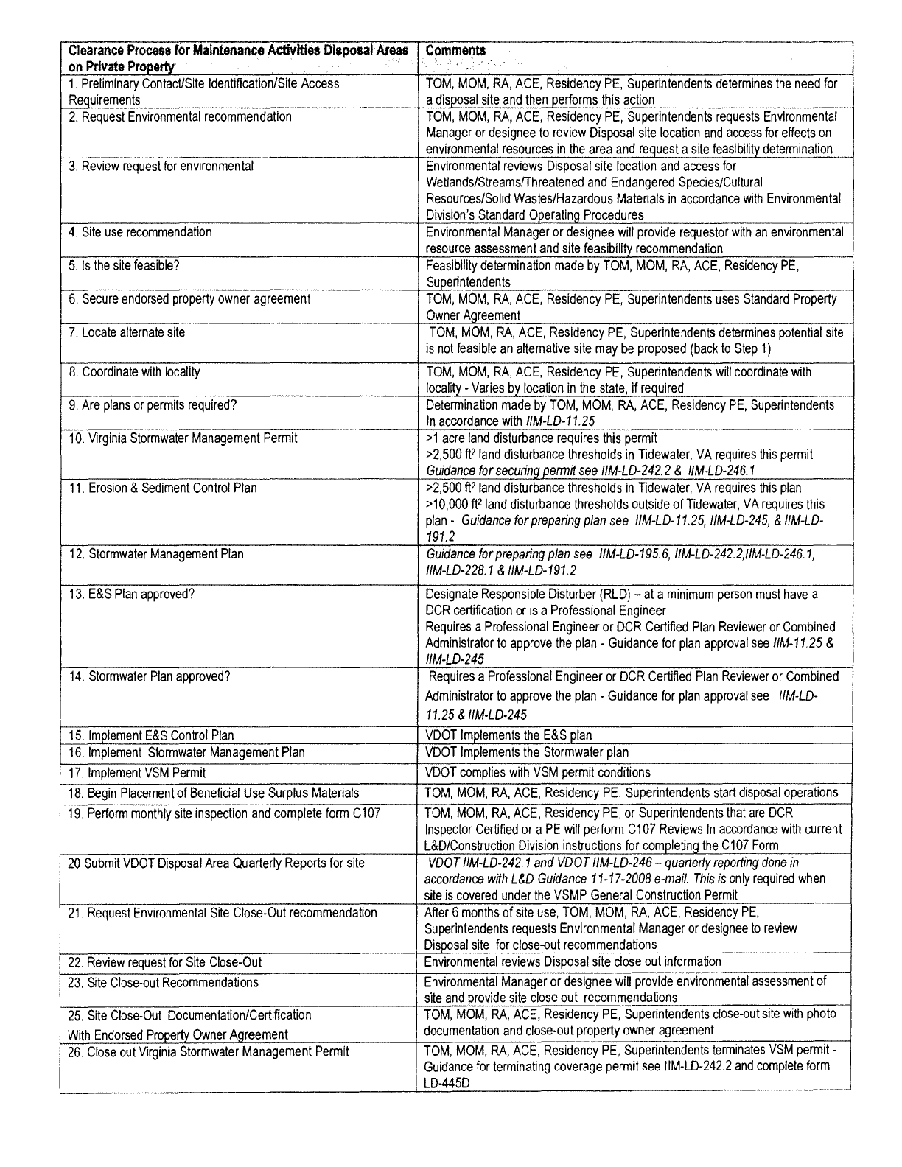

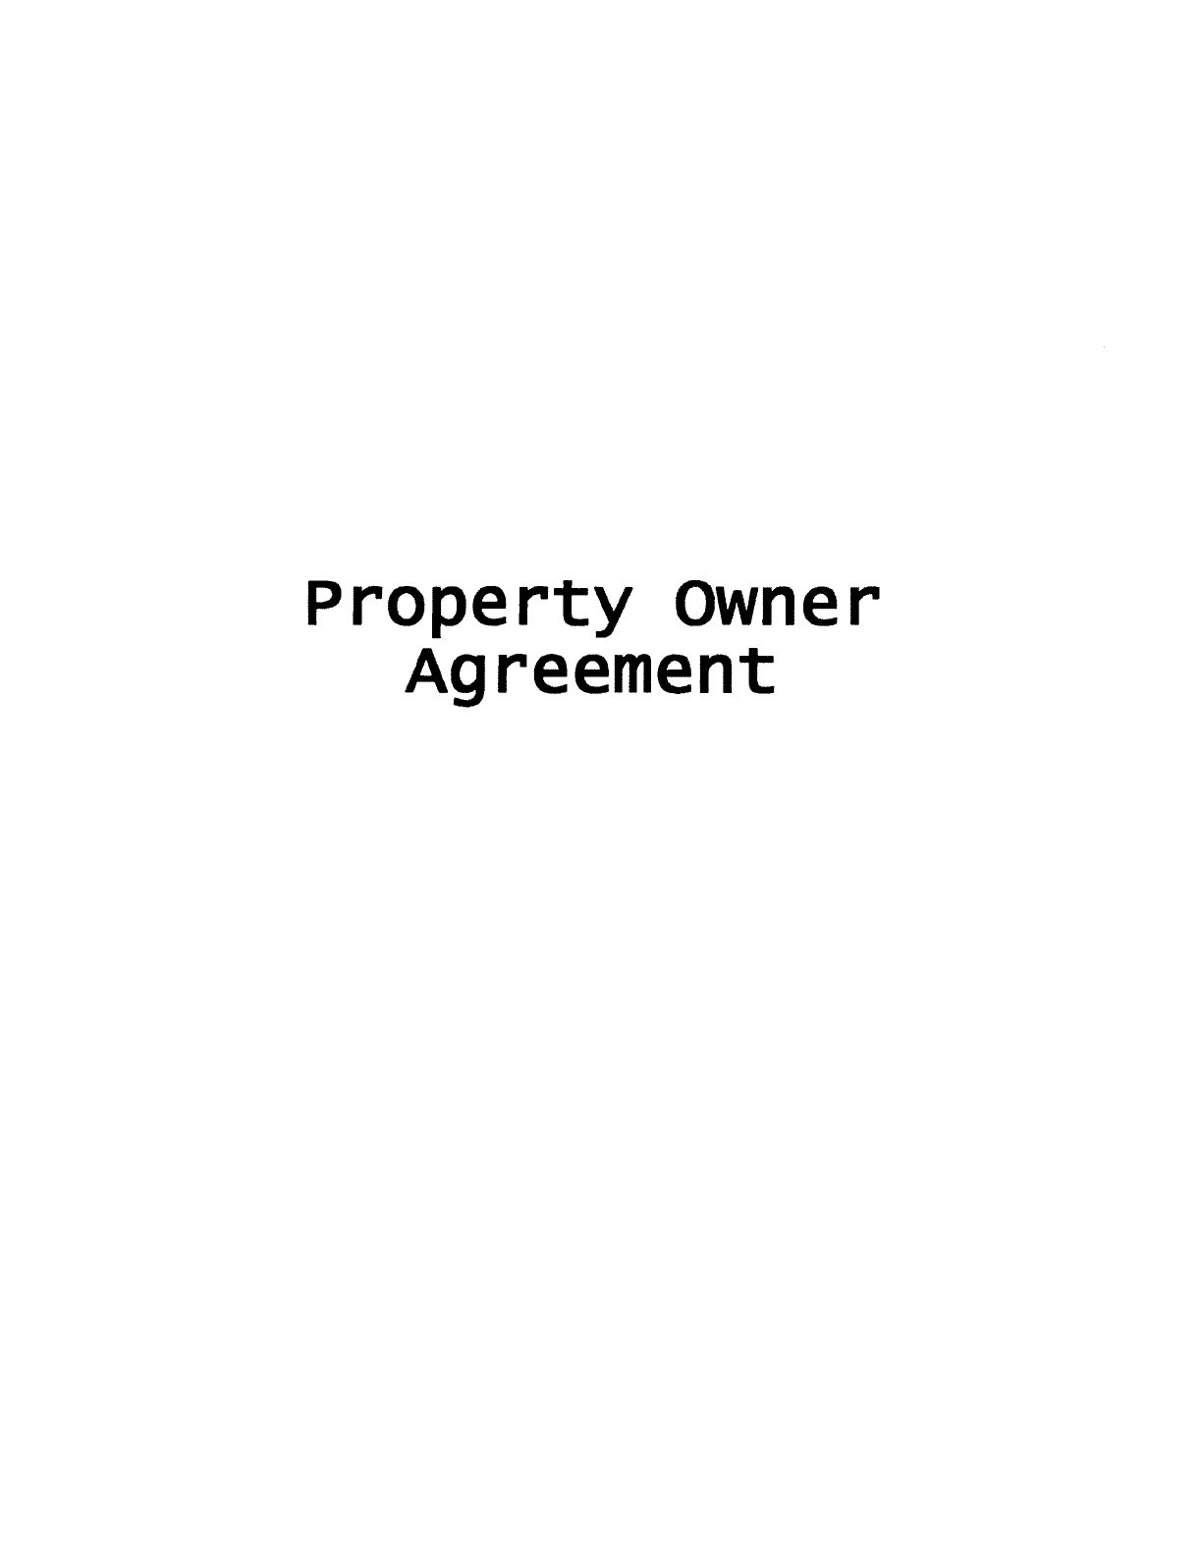

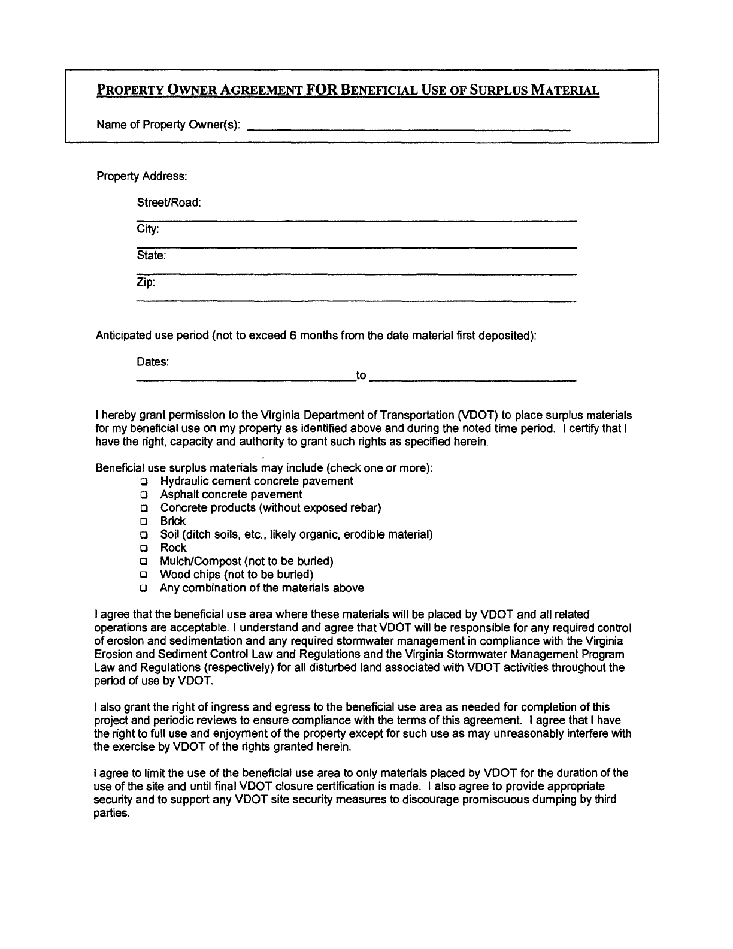
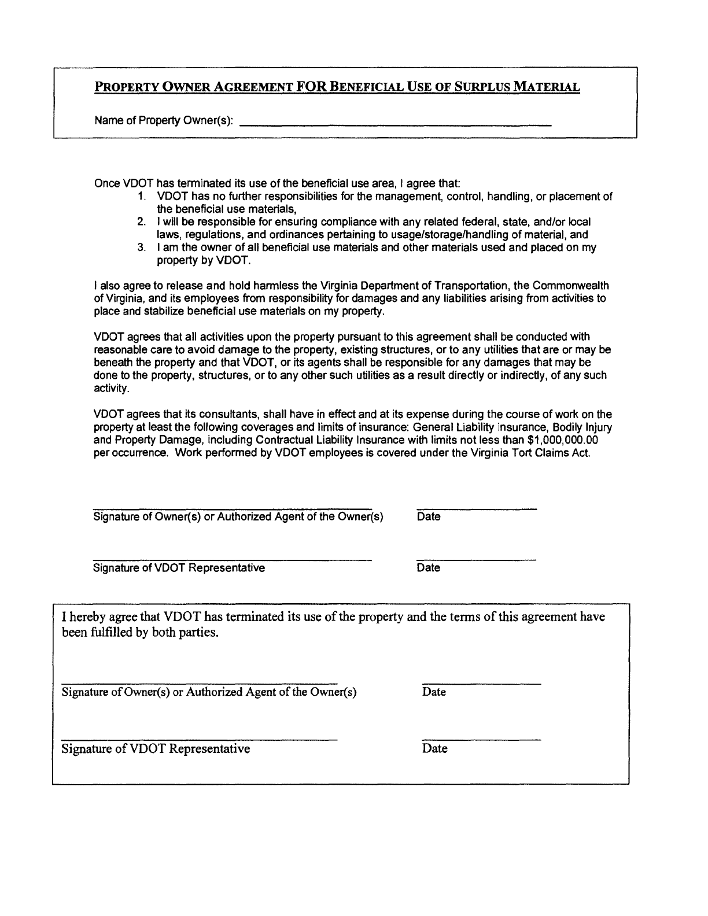

VDOT-VDEQ Solid Waste MOA

Implementation Guide
This guide is intended to provide the VDOT Maintenance staff with a summary of the key
requirements in the “Memorandum of Agreement Virginia Department of Environmental
Quality and Virginia Department of Transportation on Solid Waste” and to assist with
implementation of the requirements on Maintenance Projects.

Non-inert Debris
Animal Carcasses
• Animal carcasses may be buried within the right-of-way, in the vicinity of
where they are found.
• Burial is limited to individual large carcasses (deer) or several small carcasses
(dogs, cats, etc.) and must be conducted at random locations near where they
are found. Mass burial is not permitted.
• Document the location of burial and maintain records for 3-years.
• Burial at VDOT facilities or staging areas is not permitted.
• Burial should be below surface grade but not be within the water table, near a
stream, or near a source of drinking water.
• Adequate cover is required to prevent disinterment by scavengers.
• Lime or other vector stabilizing agents (such as wood ash) may be added to
reduce pathogens.
• Carcass burial within the right-of-way should be the final disposal option after
considering: 1) composting, 2) rendering, 3) landfilling, and 4) incineration.
Vegetative Waste
• On-site burial is the last management option for consideration after: 1)
beneficial reuse (such as mulch and for erosion control), 2) burning per
regulations and MOUs, and 3) landfill disposal.
• On-site burial of vegetative waste is limited to brush, tree prunings, wood chips
etc. It does not include stumps, tree trunks etc.
• On-site burial is limited to highway property, right-of-way, or easements of
the project where the vegetative waste is generated.
• The duration of disposal operations at one site is limited to 180-days. If the
operation is idle for greater than 30-days interim soil cover is required.
Vegetative cover is required when the operation is complete.
• Final grade should be 3:1 or greater.
• In addition to burial, wood chips may be broadcast back onto the area of
vegetation removal.

Inert Debris
• Only the following inert debris may be disposed on VDOT property, right-of-way,
easements, or property of a consenting private property owner: gravel,
sand, broken concrete, asphalt, brick, stone, and soil.
• No cover is required except to control erosion.
• Operation should be conducted in such a manner, and appropriate measures
implemented, so as not to create an open dump, hazard, public nuisance, or
promote illegal dumping.

General Requirements

Illegal Dumping

• VDOT will make reasonable efforts to prevent dumping on its property
• If appropriate or necessary signs, berms, fence, etc. will be erected.
• VDOT will assist DEQ and law enforcement to investigate illegal dumping.
• Contractor use of the MOA
• At VDOT’s discretion, VDOT contractors may be allowed to use provisions of
this MOA during VDOT projects and VDOT will oversee contractor compliance
with the MOA.
• VDOT contractors shall not transport solid waste from one project to another
for disposal.
Corrective Action
• VDOT shall be responsible for any corrective action requirements, if necessary,
resulting from materials disposed of in accordance with the MOA.

References
- Joint VDOT/VDEQ Solid Waste MOA

TMDLs approved prior to 7/1/08 with WLA assigned to VDOT’s MS4

Approved TMDL | Approval Date | Pollutant of Concern | TMDL Size (sq. mi.)** | Urban Area Size (sq. mi.)
Stroubles Creek Watershed | 6/17/2004 | Sediment | 9.5 | 7.2
Goose Creek and Little River Watersheds | 8/31/2004 | Sediment | 386.5 | 12.9
Crab Creek Watershed | 12/2/2004 | E. Coli & General Quality | 19.8 | 7.5
Upper Roanoke River Watershed | 9/7/2006 | E. Coli & Sediment | 571.2 | 116.0
Opequon and Abrams Creek Watersheds, Aquatic Life | 6/28/2005 | E. Coli & Sediment | 146.6 | 30.8
Bull Run | 6/27/2007 | Sediment | 193.9 | 86.7
Popes Head Creek | 6/27/2007 | Sediment | 18.9 | 13.4
Potomac River Watershed PCB* | 4/11/2008 | PCBs | 1561.25 | 451.1
Notes:
* The Potomac River Watershed PCB has not identified a WLA for MS4 permits but includes a statement that MS4s are
expected to complete any appropriate study and implement any minimum control measures for the PCB impairment
** The drainage areas calculated for each TMDL have not been verified by DEQ or DCR for consistency with the
respective TMDL.

VDOT’s WLAs for TMDLs within the MS4

TMDL Project | Basin | City/County | VAHU6 Watershed | Urbanized Area | Co-contributers in Waste Load Allocations | Existing Waste Load | VDOT's Waste Load Allocation |  | Comments
Stroubles Creek Watershed | New River | Montgomery | NE59 | Blacksburg | Blacksburg, Virginia Tech | 421.77 | 210.88
Crab Creek Watershed | New River | Montgomery | NE58 | Blacksburg | Christiansburg | 55.14 | 3.40E+08 cfu/yr 27.57 |  | VDOT-Salem District Rte 81 0081-060-119-C501 (Var100229) and VDOT-Christiansburg 4541 (VAR101126) had stormwater construction permits. VDOT had an MS-4 permit (VAR04006)
Upper Roanoke River Watershed | Roanoke River | Montgomery, Bedford, Roanoke, Franklin, Salem | RU01-14 | Roanoke | N/A | Not identified | 27 (tons/year), 4 (tons/year) |  | VDOT Roanoke Urban Area MS4 Permit VAR040017 & VDOT Montgomery Urban Area MS4 Permit VAR040016
Upper Roanoke River Watershed | Roanoke River | Montgomery, Bedford, Roanoke, Franklin, Salem | RU01-15 | Roanoke | N/A | 2.34 +11 (Wilson Cr) 8.70E+10 (Ore Br.) 8.94E+11 (Roanoke R.) | 1.17E+09 (Wilson Cr) 4.35E+08 (Ore Br.) 1.07E+10 (Roanoke R.) |  | VDOT Montgomery County Urban Area (VAR 040016) and VDOT City of Roanoke Urban Area (VAR 040017) MS-4 Permits
Opequon and Abrams Creek Watersheds, Aquatic Life | Shenandoah River | Frederick, Winchester | PU16-19 | Winchester | City of Windchester | 527.0 (tns/yr) (Abrams C.) 336.3 (tns/yr) (Opequon C.) | 442.7 (Abrams C.) | 269.2 (Opequon | VDOT Permit VAR040032 (Winchester Urban Area)
Opequon and Abrams Creek Watersheds, Bacteria | Shenandoah River | Frederick, Winchester | PU16-19 | Winchester | City of Windchester | 451 +12 | 19.4 +12
Bull Run | Potomac River | Fairfax, Prince William | PL42-46 | Washington | City of Fairfax, Fairfax County, Fairfax County Public Schools, Loudoun County, Manassas, NOVA Manassas Campus, Manassas Park, Prince William County, Prince William County Public Schools | 25,476.5 tons/yr | 5,823.4 tons/yr |  | VDOT Urban Area has MS-4 Permits (VAR 040062)
Popes Head Creek | Potomac River | Fairfax | PL46 | Washington | Fairfax County, Fairfax County Public Schools, City of Fairfax | 2,193.2 (tons/year) | 1,584.7 (tons/year) |  | VDOT Urban Areas (VAR040062) Fairfax County and City of Fairfax have MS-4 Permits
Potomac River Watershed PCB | Potomac River | Virginia, Maryland, Washington D.C. | CB-01, PL24-74 | Washington | MS4 must individually implement BMP | N/A | Best Management Practices (BMPs) rather than as numeric effluent limits |  | Report mentions VDOt MS-4 Permits (VAR040062 & VAR040061)
Goose Creek and Little River Watersheds | Potomac River | Loudoun | PL06-16 | Washington | Leesburg, Loudoun County | Not identified | 1587.2 tons/yr |  | VDOT-Northern has a MS-4 Permit, Erosion & Sediment Oustide MS-4s VDOT has two permits (0733-053-P31-C502) and (0015-053-125PE101-C501)

TMDLs approved by the SWCB after 7/1/2008 with WLA assigned to VDOT's MS4

TMDL Project | SWCB approval date | Basin | City/County | VAHU6 Watershed | Urbanized Area | Pollutant(s) | Co-contributers in Waste Load Allocations | Existing Waste Load | VDOT's Waste Load Allocation | Comments
 |  |  |  |  |  |  | Prince William County, Prince William County
Neabsco Creek Watershed | 4/28/2009 | Potomac River | Prince William | PL49 | Washington | Bacteria | Public Schools, Northern VA Community |  | 1.05 x 10(12) | Northern Urban Area has a MS-4 permit (VAR040062)
 |  |  |  |  |  |  | College
Rivanna River Watershed | 4/27/2009 | Middle James River | Albemarle, Greene, Orange | JR01-15 | Charlottesville | Sediment | None | 180 lbs/day | 73 lbs/day | VDOT has MS-4 permits for Charlottesville major roads and Albemarle roads (permit # 04033)
 |  |  |  |  |  |  |  |  | 2.28E + 11 (James R.), 1.71E+09 (Ivy Cr.),
James River Watershed (Lynchburg) | 7/31/2008 | Middle James River | Amherst, Lynchburg, Bedford, Campbell | JM07-11 | Lynchburg | E. Coli | Lynchburg |  | 2.81E+09 (Fishing Cr.), 8.37E+09 (Blackwater Cr.), 2.29E+09 (Tomahawk Cr.), 2.02E+09 | incorporate expansion. These WLAs did not result in violations of the water quality standard.
 |  |  |  |  |  |  |  |  | (Burton Cr.), 8.48E+08 (Judith Cr.)
Tidal Freshwater Rappahannock River Watershed | 4/28/2009 | Rappahannock River | Caroline, Essex, Stafford, King George, Spotsylvania | RA45-51 | Frederisckburg | Bacteria | City of Fredericksburg, University of Mary Washington, Stafford County, Stafford County Public Schools, Spotsylvania County | 1.05E + 12 | 3.89E + 11 | VDOT- Fredericksburg County and City of Fredericksburg Urban Areas-MS-4 Permits (VAR040061)
Accotink Creek (Lower) | 4/28/2009 | Potomac River | Fairfax | PL30 | Washington | Bacteria | Fairfax County, Fairfax County Public Schools, Northern VA Community College, Fort Belvoir |  | 1.73E+12 | VDOT-North Urban Area has a MS-4 Permit (VAR 040062)
 |  |  |  |  |  |  | Fairfax City, Fairfax County, Town of Vienna,
Difficult Run | 4/27/2009 | Potomac River | Fairfax | PL22 | Washington | Sediment | Public Schools, George Washington Memorial | 5,316.6 tons/yr | 3,595 tons/yr | VDOT has an MS-4 Permit (VAR040062)
 |  |  |  |  |  |  | Parkway
 |  |  |  |  |  |  | Fairfax City, Fairfax County, Town of Vienna,
Difficult Run | 4/28/2009 | Potomac River | Fairfax | PL22 | Washington | Bacteria | Public Schools, George Washington Memorial |  | 9.44E + 12 | VDOT has an MS-4 Permit (VAR040062)
 |  |  |  |  |  |  | Parkway
Occoquan River watershed | 7/31/2008 | Potomac River | Fauquier, Prince William | PL41, 47, 48 | Washington | E. Coli | City of Manassas, Prince William County, Prince William County Schools, Fairfax County, Fairfax County Public Schools, City of Fairfax | 2.94E + 12 (Broad Run) 1.10 + 13 (Popes Head C.) 1.03E + 12 (Bull Run) 3.18E + 12 (Occoquan R.) 2.94E + 12 (Broad Run) | 5.67E + 11 (Broad Run) 6.94E + 11 (Popes Head C.) 1.16E + 11 (Bull Run) 2.01E + 11 (Occoquan R.) 5.67E + 11 (Broad Run) | VDOT urban area- City of Manassas, Prince William County Urban area, Fairfax County, and City of Fairfax all have MS-4 Permits

Slope Erosion Control Selection Chart

SLOPE EROSION CONTROL SELECTION CHART
 |  | Soil Cover No. 1 |  |  |  | Soil Cover No. 2 |  |  | Soil Cover No. 3 |  |  |  | Soil Cover No. 4 |  |  | Soil Cover No. 5
Slope Ratio | Slope Length * | Hydraulic Mulch (HM) | Straw/Hay with HM | EC-2 Ty 1 |  | Stabilized Mulch Matrix (SMM) | EC-2 Ty 2 |  | Compost Soil Blanket | Bonded Fiber Matrix (BFM) | EC-2 Ty 3 |  | Fiber Reinforced Matrix (FRM) | EC-2 Ty 4 |  | Fiber Reinforced Matrix (FRM) | EC-3
4:1 or Flatter | 0'-75' | x | x | x |  | x | x |  | x | x | x |  | x | x |  | x | x
3:1 or Flatter | 0'-75' | x | x | x |  | x | x |  | x | x | x |  | x | x |  | x | x
 | 75' + |  |  | x |  |  | x |  | x | x | x |  | x | x |  | x | x
2.5:1 | 0'-75' |  |  |  |  | x | x |  | x | x | x |  | x | x |  | x | x
 | 75' + |  |  |  |  |  | x |  | x | x | x |  | x | x |  | x | x
2:1 | 0'-75' |  |  |  |  |  |  |  | x | x | x |  | x | x |  | x | x
 | 75' + |  |  |  |  |  |  |  |  |  | x |  |  | x |  |  | x
1.5:1 | 0'-75' |  |  |  |  |  |  |  |  |  |  |  | x | x |  | x | x
 | 75' + |  |  |  |  |  |  |  |  |  |  |  |  | x |  |  | x
1:1 | 0'-75' |  |  |  |  |  |  |  |  |  |  |  |  |  |  | x | x
 | 75' + |  |  |  |  |  |  |  |  |  |  |  |  |  |  |  | x
* Slope Length is total length of slope or distance between approved slope interruption devices for HECP.
Hydraulic Erosion Control Products (HECP's) application rates must follow manufactures recommendations.

