VDOT Storm Sewer Tabulation

The Storm Sewer Tabulation application will read a GEOPAK Drainage file, and populate the Storm Sewer table in Excel format. When the Storm Sewer Table is completed, the LD-229 report will also be completed.
Prior to processing the Storm Sewer Tabulation application, the user must have 2 files created. First, the GEOPAK Drainage (.gdf) file must be created with at least one drainage network completed and saved. If multiple networks are created in the drainage file, the desired network for the table can be selected in the Storm Sewer Tabulation dialog.
The second file is the ASCII form of the GEOPAK Drainage Preferences file used for the GEOPAK Drainage network. Once the preferences have been set, in GEOPAK Drainage the user goes to Project > Export > Preferences to ASCII to create the drainage preferences (.drp) file.
In addition to the GEOPAK Drainage file (.gdf) and the GEOPAK Drainage Preferences file (.drp) the user needs to select the appropriate drainage network, and can provide the road name, project number, county, the name of the network to show on the tabulation, name of the person creating the drainage network and the date it was created, and the name of the person checking the project and the date it was checked.
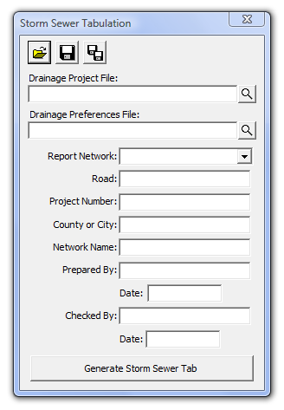
The user has the opportunity to save the dialog settings into a settings file. When the Storm Sewer Tabulation application is opened, it will search the current directory for the settings file. If a settings file is found, the dialog will be populated with the information from the first settings file it finds. If the user desires another set of settings to be used, they can use the Open Settings File on the dialog to search for another settings file. Also available on the dialog are a Save Settings and Save Settings to Another File option. The user will also be prompted when closing the dialog to save the settings file.
When ready to create the tabulation report, the user presses the Generate Storm Sewer Tab button. This will copy the seed report, and populate the table with the current drainage network information. Once the table is complete, the user is prompted that the process is complete, and allows the user to open the created file. The Storm Sewer Tabulation Report is found on the first worksheet. The LD-229 report can be found on the second worksheet tab at the bottom of the Excel window.
