VDOT Spread Analysis Tabulation

The Spread Analysis Tabulation application will read a GEOPAK Drainage file, a GEOPAK Drainage Preferences file, and a GEOPAK Drainage Report file, and populate the Spread Analysis table in Excel format.
Prior to processing the Spread Analysis Tabulation application, the user must have 3 files created. First, the GEOPAK Drainage (.gdf) file must be created with at least one drainage network completed and saved. If multiple networks are created in the drainage file, the desired network for the table can be selected in the Spread Analysis Tabulation dialog.
The second file is the ASCII form of the GEOPAK Drainage Preferences file used for the GEOPAK Drainage network. Once the preferences have been set, in GEOPAK Drainage the user goes to Project > Export > Preferences to ASCII to create the drainage preferences (.drp) file.
The third file is a GEOPAK Drainage Report file. Once a GEOPAK Drainage file is opened (Project > Open), and an active network is set (Network > Active Network), the user can go to Reports > Generate in the GEOPAK Drainage toolbar to create the GEOPAK Drainage Report file. The file SpreadAnalysisReport.drf needs to be selected as the format file. This process will create a .csv file that is used in the Spread Analysis Tabulation application.
In addition to the GEOPAK Drainage file (.gdf), the GEOPAK Drainage Preferences file (.drp), and the GEOPAK Drainage Report file (.csv), the user needs to select the appropriate drainage network, and can provide the road name, project number, name of the person creating the drainage network and the date it was created, and the name of the person checking the project and the date it was checked.
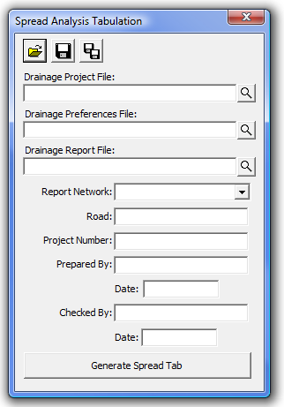

The user has the opportunity to save the dialog settings into a settings file. When the Spread Analysis Tabulation application is opened, it will search the current directory for a settings file. If a settings file is found, the dialog will be populated with the information from the first settings file it finds. If the user desires another set of settings to be used, they can use the Open Settings File on the dialog to search for another settings file. Also available on the dialog are a Save Settings and Save Settings to Another File option. The user will also be prompted when closing the dialog to save the settings file.
When ready to create the tabulation report, the user presses the Generate Spread Tab button. This will copy the seed report, and populate the table with the current drainage network spread information. Once the table is complete, the user is prompted that the process is complete, and allows the user to open the created file.
