VDOT Drainage Summary

The Drainage Summary application reads a GEOPAK Drainage file, and populates the drainage summary spreadsheet in Excel format.
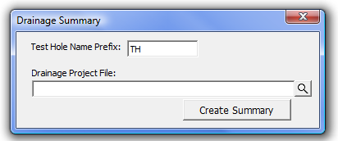
The user selects the GEOPAK Drainage file, and sets the Test Hole Prefix. The Test Hole Prefix allows any drainage nodes or links that are created as a part of the Test Hole Utility application to be excluded from the drainage summary.
Once the GEOPAK Drainage file is selected, and the test hole prefix is set, the user can press the Create Summary button. This will read the GEOPAK Drainage file, and import the data to the Drainage Summary spreadsheet.
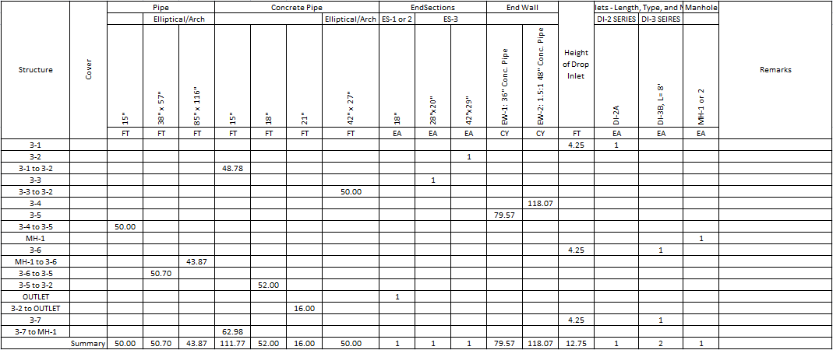
Administrative
There are three files needed for the Drainage Summary to work, DrainageSummary.dat, VDOT_DropInletList.txt, and VDOT_EndWallList.txt. Each of these files needs to be placed in the same folder as the DrainageSummary.mvba file.
The DrainageSummary.dat file sets the path and file to use for the spreadsheet seed file.
The VDOT_DropInletList.txt file contains a list of pay item numbers for the drop inlets, the type of drop inlet, and the description for the pay item.
The VDOT_EndWallList.txt file contains a list of pay item numbers for the end walls, the type of end walls, the description for the pay item, and the quantity of concrete in cubic yards for the end wall.

