VDOT Drainage Descriptions

The Drainage Description application will import the nodes and links from a GEOPAK Drainage file, and plots each item with a standard or user-defined description. The application allows the user to modify the standard descriptions for each drainage item, as well as arrange the drainage items into sheet categories to match the plan sheets.
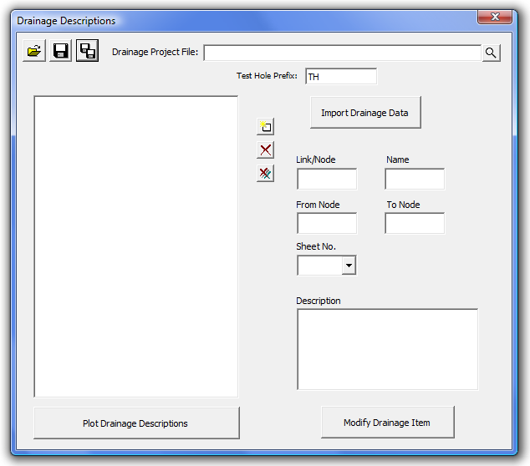
The user must first import the Drainage Project File by selecting the file and pressing the Import Drainage Data button. The drainage nodes and links will be placed in tree on the left side of the dialog. If any items are added to the drainage file, the file can be re-imported. Only the new items will be added to the drainage item list.
If there are test hole nodes or links present in the drainage project, they can be filtered out by specifying the Test Hole Prefix used to create the test hole data.
When the user selects a drainage item, the information for that item will be displayed in the fields to the right. The user can then key-in or select the sheet number. The selection option is only available after the user has created the sheet by either keying in the sheet number, or using the new sheet dialog (see below). The user can also adjust the description by editing or typing a new description in the Description field. Once the sheet and/or description changes have been made, the Modify Drainage Item button must be pressed to save the changes. Once the changes are made, the drainage item will be moved into the given sheet in the tree view.
Drainage items can also be arranged into sheets using the tree view. Once the sheet has been created, drag the drainage items into the desired sheet. The order of the sheets or drainage items can also be changed by dragging the item to the desired location. The item being moved will be placed after the selected item.
In addition to keying-in or selecting a sheet number by editing the drainage items, new sheets can also be created by using the Add New Sheet button. The Add New Sheet button opens a dialog for the user to enter a new sheet number. This creates a new sheet in the tree, and allows drainage items to be placed in the sheet.
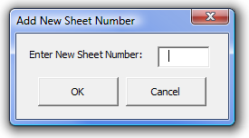
The Delete button will delete the selected item. If the item is a sheet, the user is prompted to confirm the deletion of all elements in the sheet. The Delete All button will delete all entries.
Once the drainage items and sheets are set, the descriptions can be plotted into the active .dgn file by pressing the Plot Drainage Descriptions button. This will delete any existing sheets in the .dgn file, and plot the new description sheets into the .dgn file.
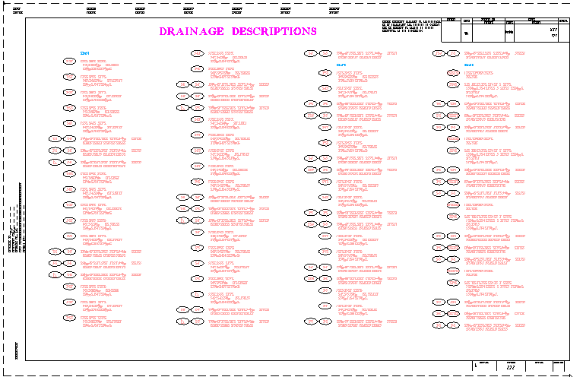
The user has the opportunity to save the dialog settings into a settings file. When the Drainage Descriptions application is opened, it will search the current directory for the settings file. If a settings file is found, the dialog will be populated with the information from the latest settings file it finds. If the user desires another settings file to be used, they can use the Open Settings File on the dialog to search for another settings file. Also available on the dialog are a Save Settings and Save Settings to Another File option. The user will also be prompted when closing the dialog to save the settings file.
Administrative
The Drainage Descriptions Application requires the use of the DrainageDescriptions.dat file. This file must reside in the same folder as the DrainageDescriptions.mvba file.
The DrainageDescriptions.dat file allows the CADD Administrators to define the following items:
Sheet Cell Library – cell library that contains the sheet border cell
Sheet Cell - name of the sheet border cell
Sheet Cell X Origin – X coordinate to place the first sheet
Sheet Cell Y Origin - Y coordinate to place the first sheet
Drainage Description Cell Library – cell library that contains the symbols for the node and link names
Drainage Description Cell – name of the cell to use for the node and link names
Drainage Description Sheet Title Plot Parameters – symbology for the sheet title.
Sheet Indicator Plot Parameters – symbology for the sheet names
Drainage Description Plot Parameters – symbology for the drainage item descriptions

