Draw Drainage in Cross Section
This application draws GEOPAK Drainage elements in cross section at locations obtained from a GEOPAK Drainage project.
In order for this application to run GEOPAK must be activated. If GEOPAK is not activated the user will be notified and the application will not start.
When started, this application will present the following dialog:
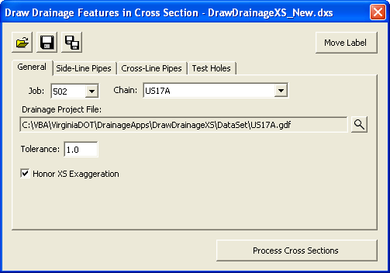
The Job combo box will contain all GEOPAK COGO job files (.gpk) in the active directory (either that of the current design file or that set in GEOPAK Preferences) and the first one will be selected. The Chain combo box will automatically be filled in from all chains in the Job selected. The remainder of the dialog will be filled in automatically from a resource file created the last time the application was used. In addition, the user can open a previously saved resource file other than the most recent.
The user will select the GEOPAK Drainage file (.gdf) they wish to obtain drainage objects from. This is done through a standard Windows file selector presented when the magnifying glass icon is clicked.
The Tolerance field indicates the distance within which a drainage object will be considered to fall on a cross section. If a drainage object is farther away than this from the cross section location (pattern line) it will not be drawn on the cross section. Keep in mind that a cross section must be cut at the pattern line location in order for drainage objects to be drawn on that cross section. A drainage objects proximity to a pattern line in plan view does not necessarily mean it will be drawn in cross section unless a cross section exists for that pattern line.
The Honor XS Exaggeration option will, when turned on, distort the items drawn according to the exaggeration at which the cross section was originally drawn. This most noticeably results in ellipses drawn rather than circles for round pipes.
Three types of drainage objects can be drawn in cross section and are turned on or off through three drawing tabs in the dialog which also allow the user to establish settings for the drawing of those objects:
- The first drawing tab is used to generate Side-Line Pipes (longitudinal pipes) for all Drainage pipes (links) that cross the cross section pattern line.
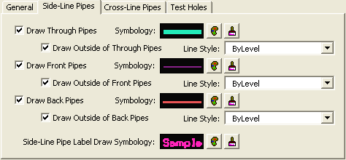

Several options allow the user to draw pipes that intersect the cross section (Through Pipes), begin at the cross section (Front Pipes), or end at the cross section (Back Pipes) with options to draw the outside of the pipe with a different line style.
- The second drawing tab is used to generate Cross-Line Pipes for all Drainage pipes (links) that cross the alignment and have both begin and end node that fall within the tolerance of the cross section pattern line (typically from cross sections created from pattern lines generated using the Drainage Pattern Lines utility).
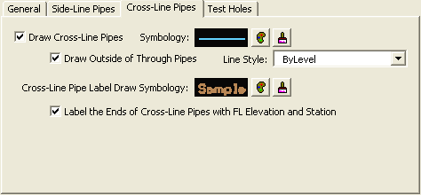
Again, several check boxes allow the user to set options for this type of item including the outside of the pipe and labeling.
- The third drawing tab is used to generate Test Holes for all Drainage pipes (links) added with the Test Hole utility.
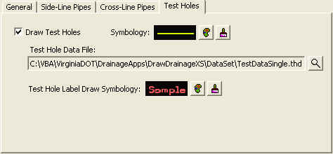
The Test Hole File must be selected by clicking on the magnifying glass icon next to the field which will present a standard Windows file selector for locating the desired file.
In each of the drawing tabs described above there are multiple symbology settings that can be established. This is done through a standard set of tools described as follows:
The example graphic gives an approximation of the resulting look of the drawn object, and hovering over this image results in a pop-up help detailing the symbology currently set for this item.
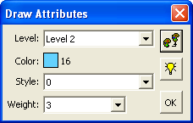
The symbology button allows the user to select symbology from the standard MicroStation options for level, color, line style, and line weight through the use of an auxiliary dialog:
This provides the ability to set the symbology from an element in the active design model. Simply click this button and select and accept an element.
This provides the ability to highlight all elements in the active design model that match the set symbology in order to verify the settings are correct.

The D&C button allows the user to select symbology from the GEOPAK Design and Computation manager items through the use of another auxiliary dialog:
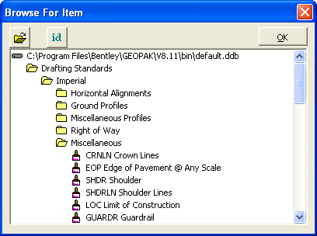
This provides the ability to open a D&C database (.ddb) other than the default one.
This provides the ability to select the D&C item by selecting a MicroStation element that was drawn with a given item.

In order to save the user from having to input all of these settings again the next time they want to draw drainage objects in cross section the application provides icons across the top of the dialog to save and retrieve these settings:
Open a settings file previously saved. A dialog will open asking for the file name to open. The default folder will be the current design file folder.
Save the current settings. If a settings file was opened during this session the same name will be used. Otherwise, a dialog will open asking for the file name to save.
Save the current settings to a different file name. A dialog will open asking for the file name to save.
When the application starts it will automatically open the most recent settings file found in the current design file folder. When the application is closed the user will be asked if they wish to save the settings if they haven’t already done so. The file extension for DrawDrainageXS settings files will be .dxs.
Once all settings have been established and saved, the user will click the “Process Cross Sections” button to begin drawing drainage objects in the cross sections. If the user isn’t in a design file containing cross sections for the indicated chain they will be notified and asked to open the appropriate cross section file before they can continue. If cross sections are found a process dialog will appear:
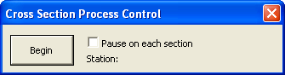
The user will have the option to pause as each cross section is processed so they can review what has been drawn before continuing on to the next one. The Begin button will be clicked when the user is ready to start processing the cross sections. If the Pause option is checked the first cross section will be processed and centered in the view and the dialog will change as follows:
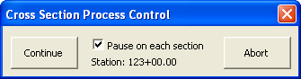
The user can continue to the next cross section or abort processing and return to the main dialog. If the Pause option is not checked every cross section will be processed in order and the user will be notified when it is complete.
One final tool at the top-right corner of the main dialog allows the user to Move a Label once it has been placed. This tool will prompt the user to select a label placed by this tool and enable them to change its location as well as the configuration of its leader lines.

