VDOT Drainage Input

The Drainage Input application will read accept user input, and export the user input to GEOPAK Drainage. The application also allows the LD-229 and LD-204 files to be imported into the application, and then exported to GEOPAK Drainage.
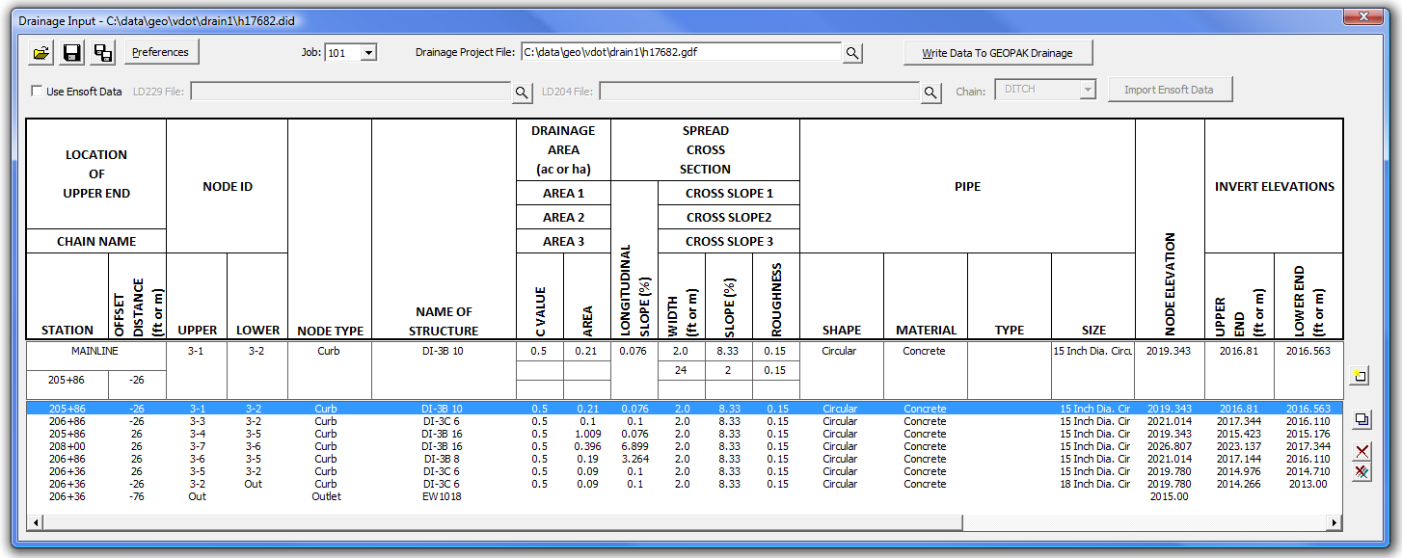
The Drainage Input application requires the job number, and a GEOPAK Drainage file to be selected. Drainage Preferences are set by pressing the Preferences button. This allows the Time of Concentration, the Beginning Pipe Name, and the link minimum and maximum rise, slope and velocity to be set.
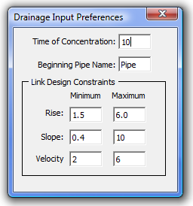
Once the job number, drainage file, and preferences have been selected, enter the drainage data into the appropriate fields for each node/link.
Chain Name - Selected from the provided list.
Station – Entered by the user.
Offset – Entered by the user.
Upper Node ID (required) – Entered by the user. Upper node id is required for all nodes.
Lower Node ID (required) – Entered by the user. Lower node id is required for non-outlet type nodes.
Node Type (required) – Selected from the list Curb, Grate, Slotted Drain, Curb and Grate, Junction, Outlet, Other, Bottom, or Headwall. The node type is required by all nodes.
Name of Structure (required) – Selected from the list based on the Node Type provided. The name of structure is required by all nodes.
Drainage Area C Values (required) – Entered by the user for each sub area. The C value is only required by non-outlet type nodes.
Drainage Area Areas (required) – Entered by the user for each sub area. The drainage area is only required by non-outlet type nodes.
Longitudinal Slope – Entered by the user.
Spread Cross Section Cross Slope – Entered by the user for each section.
Spread Cross Section Width – Entered by the user for each section.
Spread Roughness – Mannings N value entered by the user for each section.
Pipe Shape – Selected from the list Arch, Box, Circular, Ellipse, or Pipe – Arch.
Pipe Material – Selected from the list based on the pipe shape, Aluminum, Concrete, Plastic, or Steel.
Pipe Type – Selected from the list based on the pipe shape.
Pipe Size (required) – Selected from the list based on the pipe shape, pipe material, and pipe type. The pipe size is only required by non-outlet type nodes.
Node Elevation (required) – Entered by the user. The node elevation is required by all node types.
Invert Elevations Upper/Lower (required) – Entered by the user. The upper/lower invert elevations are only required by non-outlet type nodes.
Once all of the pertinent data is entered, press the Add button to the right if the data fields to add it to the list. Additional nodes/links can be added to the list as needed. Each lower node must have a matching upper node for the project to be imported.
The project outlet nodes can be stored by entering just the upper node information. No pipe or drainage area information will be used for the outlet nodes. The outlet node elevation is required.
To modify an entry in the list, select the entry in the list. This displays the entry in the entry fields. Make the desired changes. Press the Modify button to make the changes in the list.
The Delete button or the Delete All button will delete the selected entry or all of the entries from the list respectively.
To import the data from the LD-229 and LD-204 spreadsheets, toggle on the Use Ensoft Data toggle. This will activate the required fields. Select the LD229 file and the LD204 file respectively. Select the chain name. Press the Import Ensoft Data button to import the data to the list. The list entries can then be modified to complete any missing data.
NOTE: GEOPAK Drainage requires some data that is currently not available from the Ensoft spreadsheets. This data will need to be manually entered.
Once all data has been entered, press the Write Data to GEOPAK Drainage button to import the data to GEOPAK Drainage. The drainage project file (.gdf) must be opened in GEOPAK Drainage prior to pressing the Write Data to GEOPAK Drainage button.
The user has the opportunity to save the dialog settings into a settings file. When the Drainage Input application is opened, it will search the current directory for the settings file. If a settings file is found, the dialog will be populated with the information from the first settings file it finds. If another settings file is desired, the Open Settings File icon on the dialog is used to search for another settings file. Also available on the dialog are a Save Settings and Save Settings to Another File option.
Administrative
The Drainage Input uses several resource files found. These files should be placed in the same location as the DrainageInput.mvba file.
DrainageInputDefault.rsc – Sets the default preferences for the Time of Concentration and the Beginning Pipe name.
VDOT_NodeList.txt – Contains the list of structure names for each node type.
Format:
### TYPE = Curb - Lists the node type.
DI-10G TY 1 - List of the structure names for each node type.
DI-10G TY 2
DI-10H TY 1 L 10
DI-10H TY 1 L 12
If no structure names exist for the node type, just list the next node type.
### TYPE = Curb and Grate
### TYPE = Junction
MH-1
MH-12
MH-2
VDOT_LinkList.txt – Contains the list of pipe material, type and size for each pipe shape.
Format:
### SHAPE = Ellipse - Lists the pipe shape
### MATERIAL = Aluminum - Lists the pipe material for the give shape
### TYPE = Horizontal - Lists the pipe type for the given shape and material
### TYPE = Vertical
### MATERIAL = Concrete
### TYPE = Horizontal
19" x 30";0.026 - Lists the pipe size and Mannings n value for the given shape,
22" x 34";0.026 material, and type
24" x 38";0.026
27" x 42";0.026
29" x 45";0.026
If no material or type exists, use a blank entry. If no size exists for the shape, type, or material, list the next node type.

### SHAPE = Box
### MATERIAL = Aluminum
### TYPE =
### MATERIAL = Concrete
### TYPE =
2ft x 4ft
3ft x 3ft
3ft x 4ft

