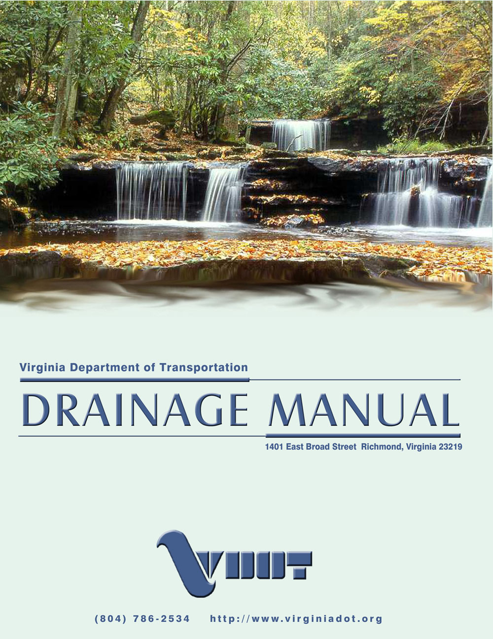

DRAINAGE MANUAL

TABLE OF CONTENTS

Chapter 1 Introduction
Chapter 2 Policy
Chapter 3 Documentation
Chapter 4 Legal
Chapter 5 Planning and Location
Chapter 6 Hydrology
Chapter 7 Ditches and Channels
Chapter 8 Culverts
Chapter 9 Storm Drains
Chapter 10 Erosion and Sediment Control
Chapter 11 Stormwater Management
Chapter 12 Bridge and Structure Hydraulics
Chapter 13 Shore Protection
Chapter 14 Subdivisions
Chapter 15 Drainage Design Instructions

DRAINAGE MANUAL

Prepared by

LOCATION AND DESIGN DIVISION

HYDRAULICS SECTION

Adopted April 2002

Virginia Department of Transportation

Recommended for Approval: Mohammad Mirshahi, P.E. Location and Design Engineer

Approved: C. Frank Gee Acting Chief Engineer

Copyright Commonwealth of Virginia, April 2002

