Appendix 13C-6 Nomograph for Riprap Size

to Resist Wave Action
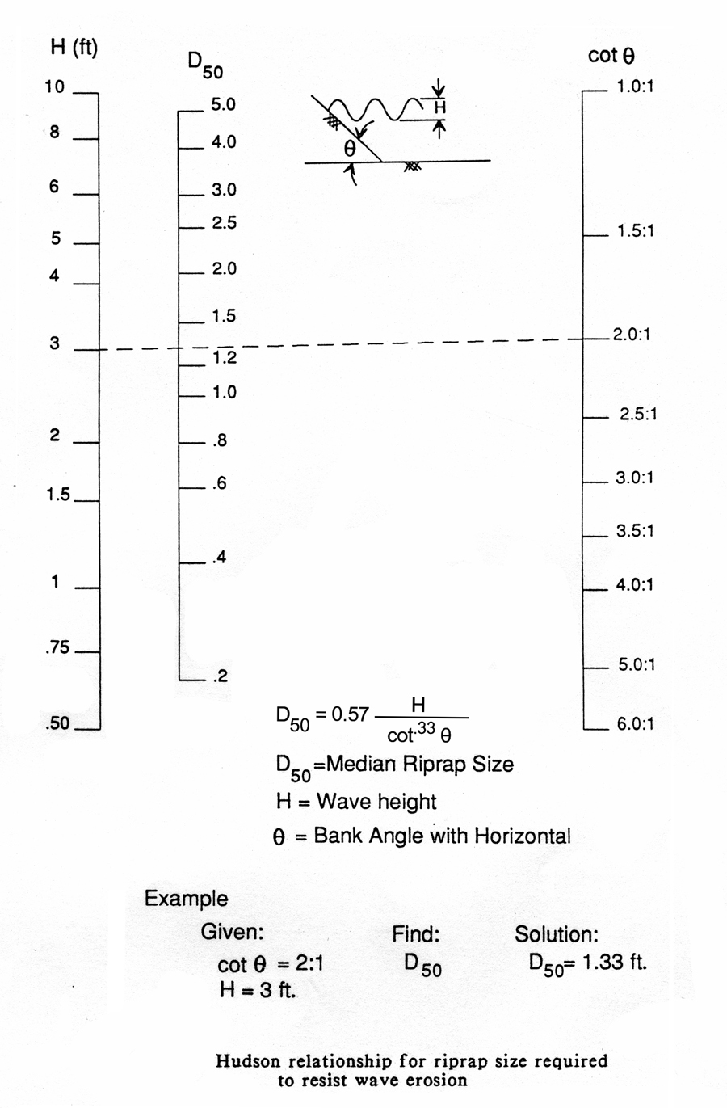
Source: HEC-11

