Appendix 13C-5 Nomographs for Design of

Rock Slope Shore Protection

(For Deep Water)
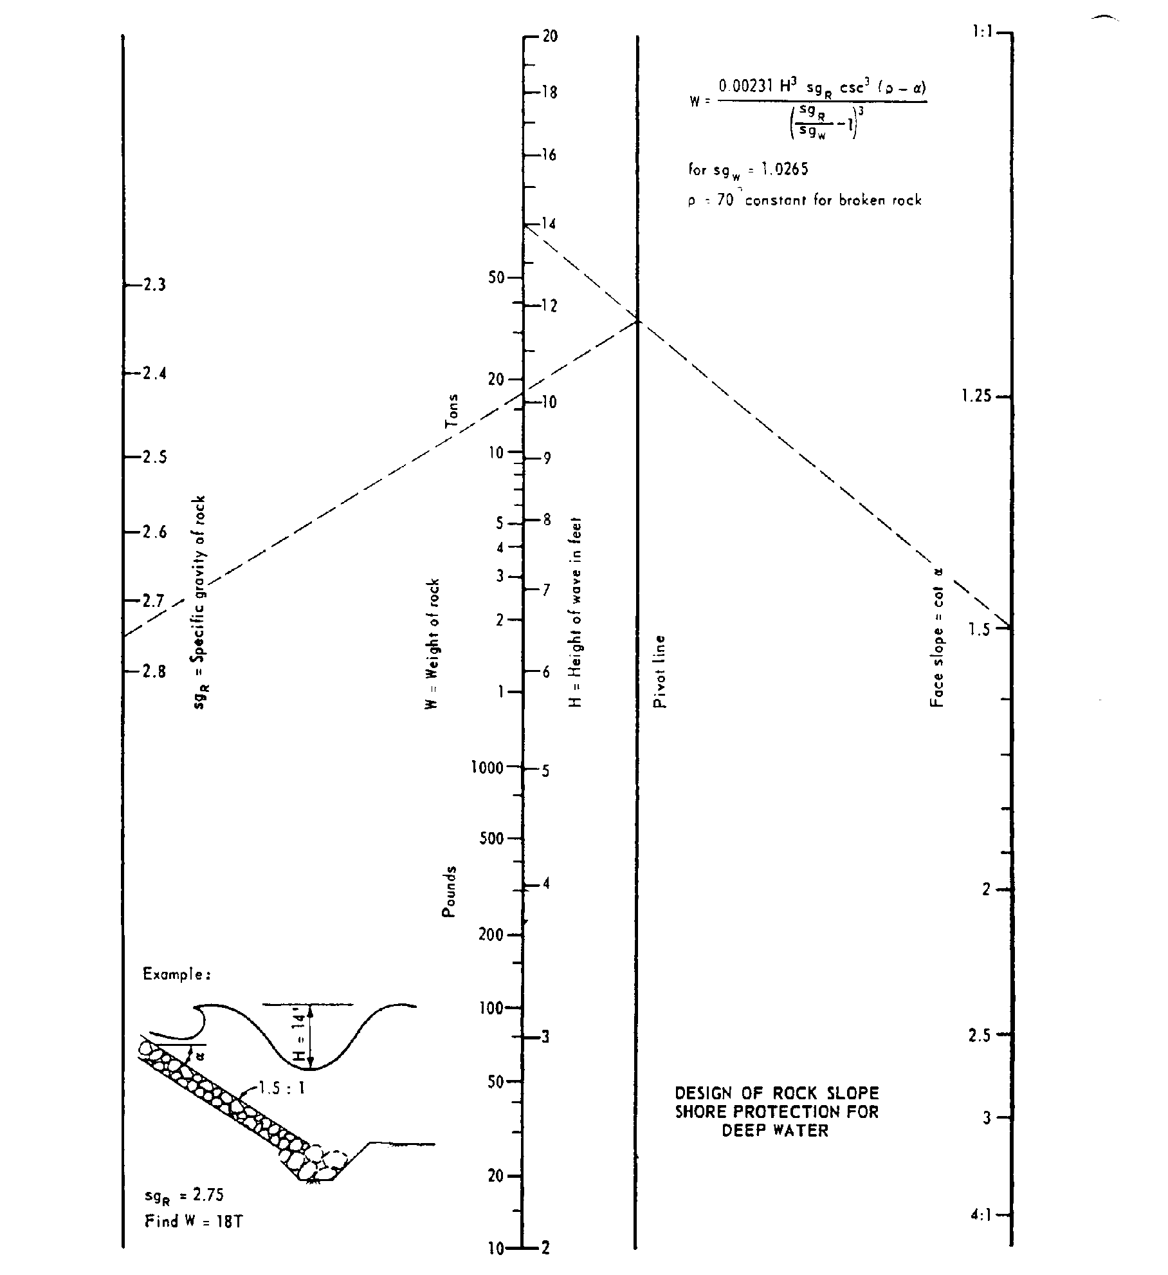

Source: Bank and Shore Protection in California Highway Practice

