Appendix 13C-2 Design Breaker Wave

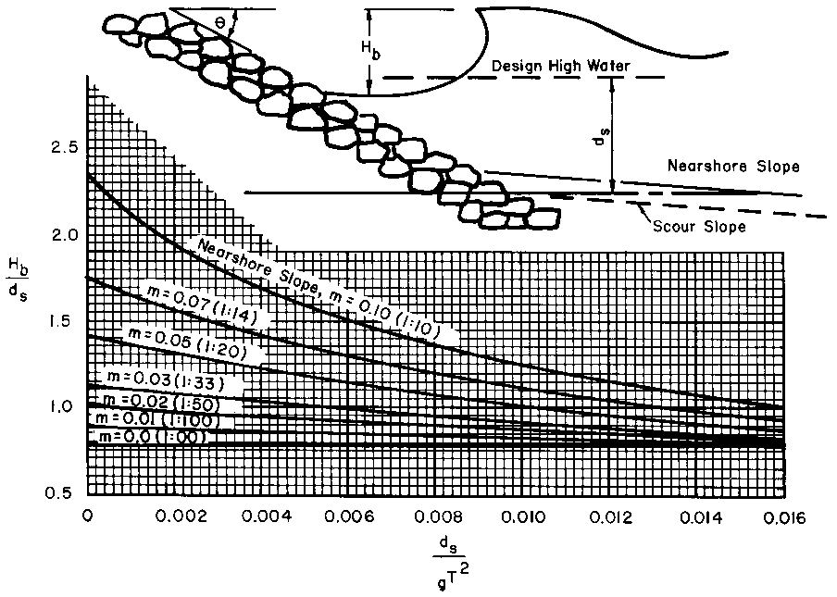

Source:

