Appendix 13B-2 Tidal Differences and Other Constants

The publication of full daily tide predictions is necessarily limited to a comparatively small number of stations. These stations are referred to as "reference stations". Tide predictions for other locations can be obtained by applying certain differences to the daily tide predictions for the reference stations.
These pages provide a listing of the "subordinate stations" in Virginia for which such predictions can be made, the differences or ratios to be used, and a link to the appropriate reference station. The stations in the listing are arranged in geographical order to make it possible to find stations which are available for a specific area.
Caution: The time and height differences and ratios are derived from a comparison of simultaneous tide observations at the subordinate station and its reference station. Because these figures are constant, they may not always provide for the daily variations of the actual tide, especially if the subordinate station is some distance from the reference station. Therefore, although the application of time and height differences will generally provide reasonably accurate approximations, they cannot result in predictions as accurate as those listed for the reference stations which are based on much larger periods of analysis.
Time Differences: To determine the time of high and low tide at any station listed in this table, refer to the columns headed "Time Differences" in which the hours and minutes to be added or subtracted from the time of high or low tide of the reference stations. A plus sign (+) indicates that the tide at the subordinate station occurs later than at the reference station and the difference should be added; a minus sign (-) indicates that it is earlier and should be subtracted.
To obtain the tide at a subordinate station on any date, apply the difference to the tide at the reference station for that same date. In some cases, however, to obtain an AM tide it may be necessary to use the preceding day's PM tide at the reference station or to obtain a PM tide it may be necessary to use the following day's AM tide. For example, if a high tide at a reference station occurs at 0200 on July 17, and the tide at the subordinate station occurs 5 hours earlier, the high tide at the subordinate station will occur at 900 PM on July 16. For the second case, if the high water at a reference station occurs at 1000 PM on July 2, and the tide at the subordinate station occurs 3 hours later, then high tide will occur at 100 AM on July 3 at the subordinate station.
The results obtained by application of the time differences will be in local time for the subordinate station. The necessary allowances for the change in date when crossing the international date line, or for different time zones have been included in the time differences listed.

Appendix 13B-2 Tidal Differences and Other Constants

Height Differences: The height of the tide, referred to the datum of nautical charts, is obtained by means of the height difference or ratios. A plus sign (+) indicates that the difference should be added to the height at the reference station, and a minus sign (-) indicates that it should be subtracted. For most stations, use of a predicted height difference would give unsatisfactory predictions. In such cases they have been omitted and one or two ratios, indicated by an asterisk (*), are given. To obtain the height of tide at the subordinate station in these cases, multiply the height of tide at the reference station by the ratio listed. The result is normally rounded to the nearest 0.1-foot.
For some subordinate stations there is given, in parentheses, a ratio as well as a correction. In those instances, each predicted high and low water at the reference station should be first multiplied by the ratio and then the correction is added or subtracted from each product.
Example Tide Calculations
For Port Royal on the Rappahannock River, the time and height adjustments listed in the tables are:
-2 21 -2 49 *0.68 *0.68
and the reference station is Washington. If the times in column 1 are the tides for a day at Washington, column 2 are the time corrections and column 3 are the height corrections, column 4 will be the predicted tides at Port Royal.
(1) (2) (3) (4)
403am L -0.1 -2 49 *0.68 114am -0.1ft
919am L 2.4 -2 21 *0.68 658am 1.6ft
401pm H -0.1 -2 49 *0.68 112pm -0.1ft
930pm L 2.6 -2 21 *0.68 709pm 1.7ft

Appendix 13B-2 Tidal Differences and Other Constants
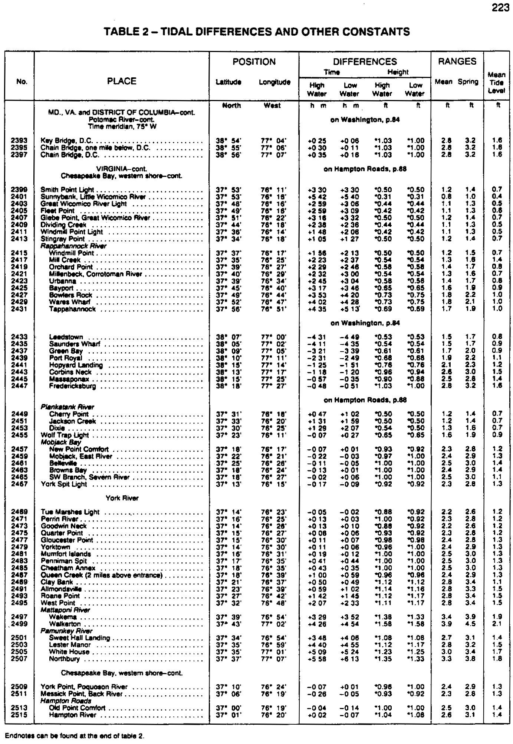

Appendix 13B-2 Tidal Differences and Other Constants
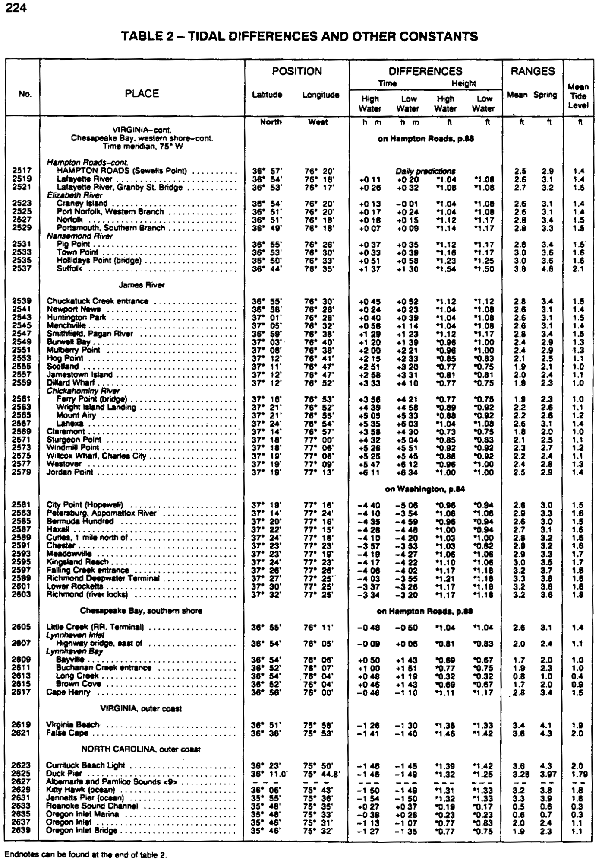

Appendix 13B-2 Tidal Differences and Other Constants

