Appendix 9D-2 P-1-1/8 Grate – FHWA Classification

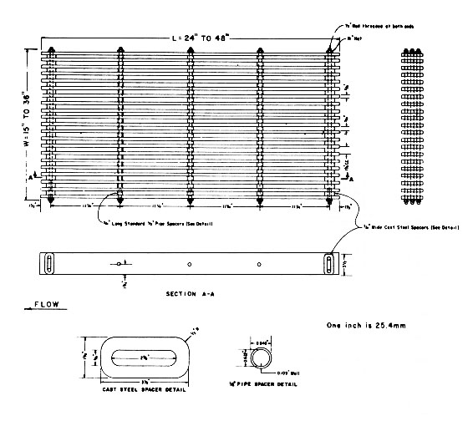

Source: HEC-12

