Appendix 9C-25 Concrete Pipe Flow Nomograph

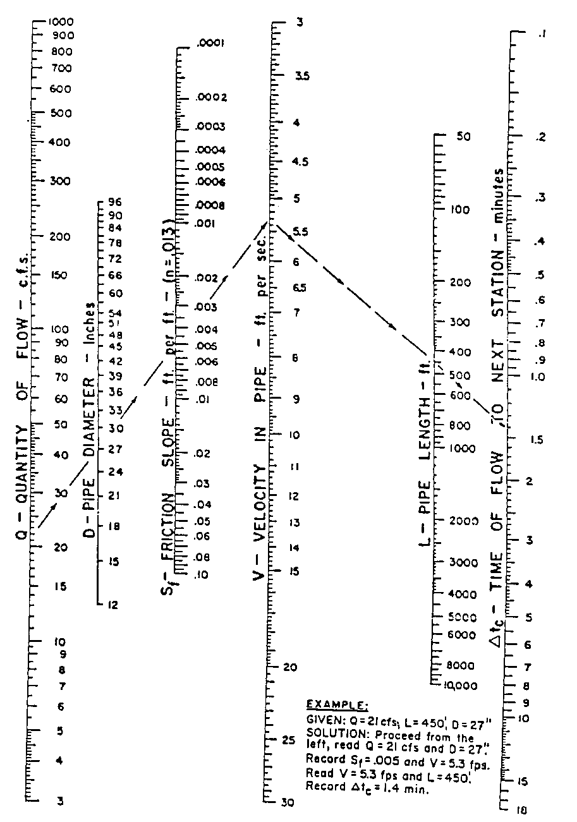

Source:

