Appendix 9C-20 Curb-Opening Inlet Capacity in

Sump Locations

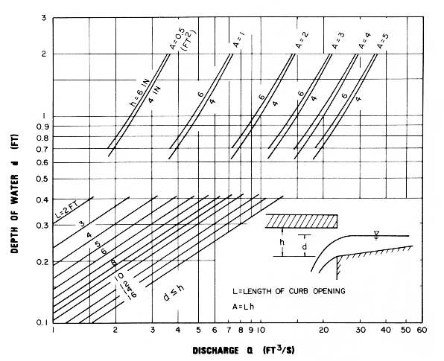

Source: HEC No. 12, FHWA

