Appendix 9C-19 Depressed Curb-Opening Inlet Capacity

in Sump Locations

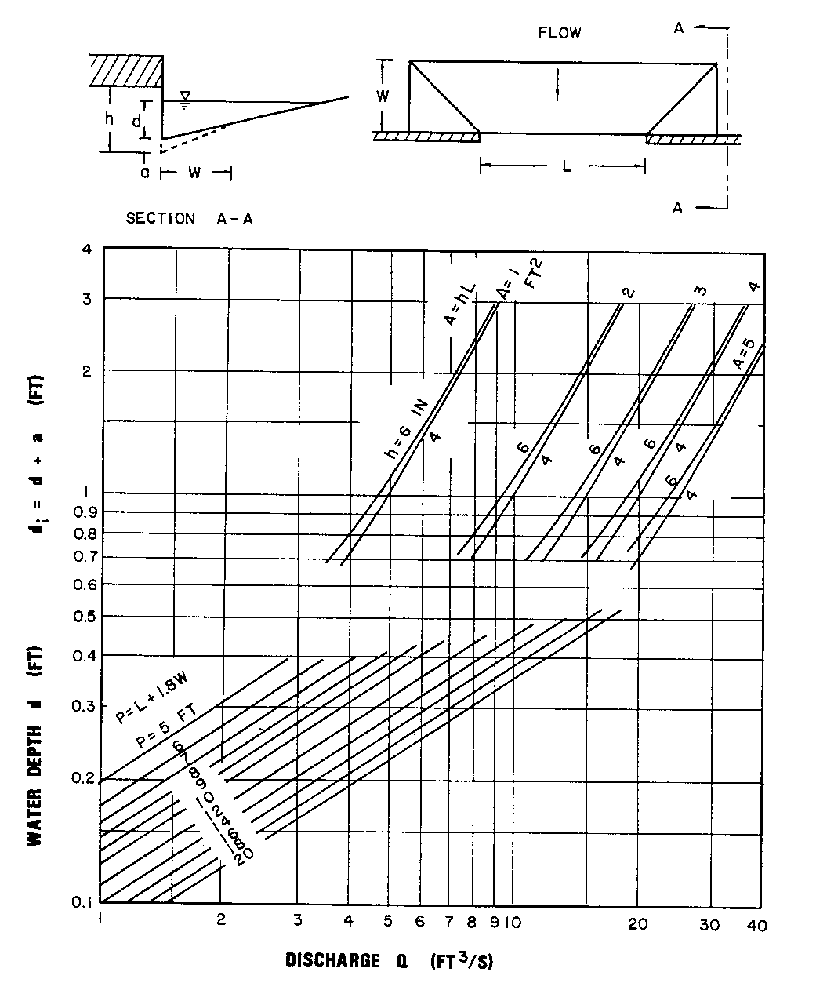

Source: HEC No. 12, FHWA

