Appendix 9C-14 Performance Curve DI-7 in a Sump

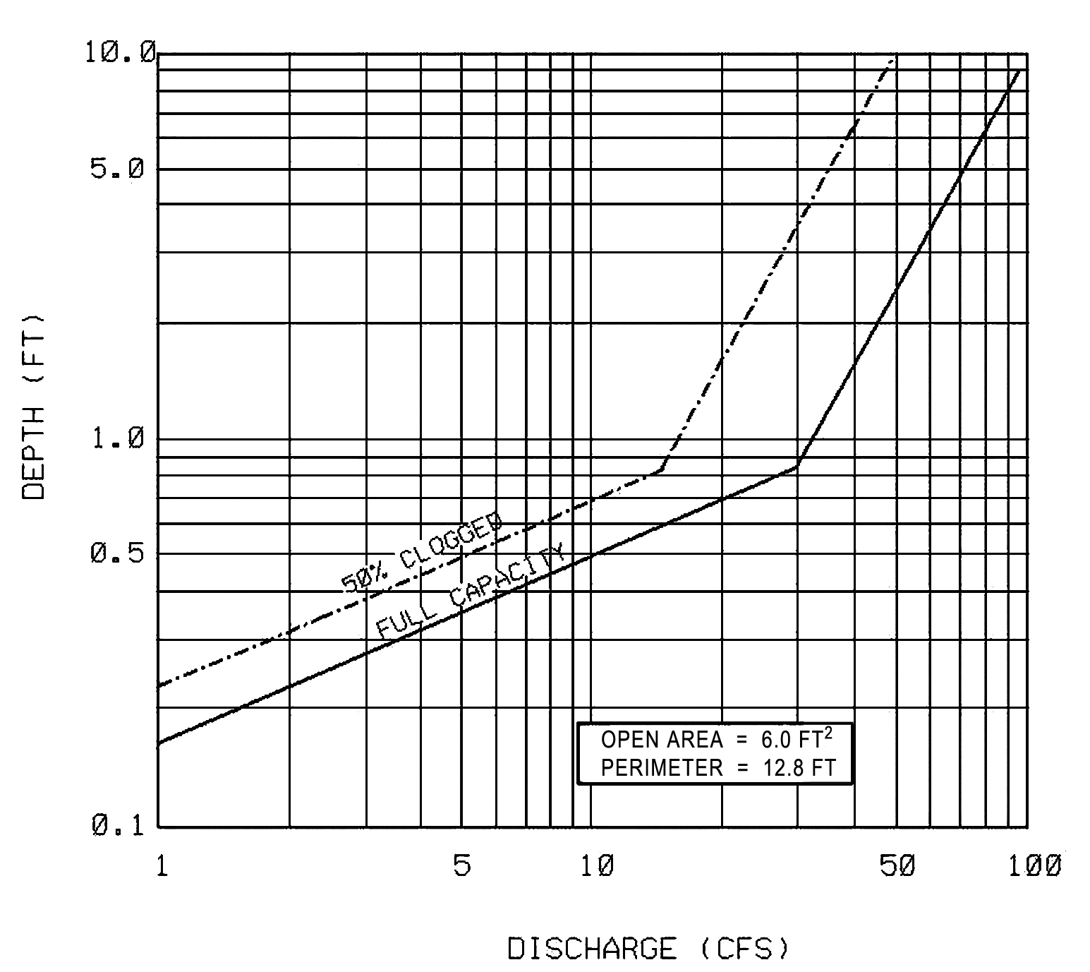

Source: VDOT

