Appendix 9C-12 Grate Inlet Capacity in

Sump Conditions (VDOT Version)
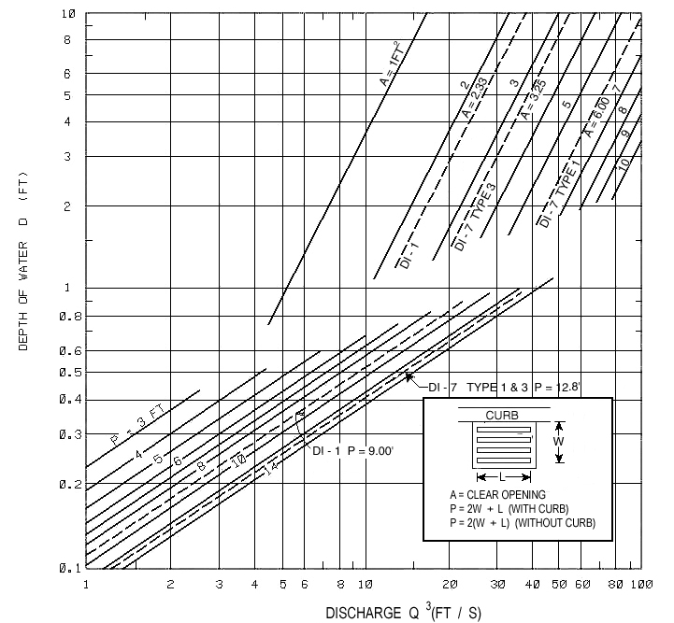
DISCHARGE Q ³ (FT / S)

VDOT STANDARD GRATE DROP INLETS

INLET TYPE | GRATE TYPE | AREA  SQ-FT | PERIMETER  FT | INLET TYPE | GRATE TYPE | AREA  SQ-FT | PERIMETER  FT
DI-1 |  | 2.33 | 9.00 | DI-12 L=8’ | TYPE I | 9.00 | 20.50
 |  |  |  |  | TYPE II | 6.67 | 20.50
DI-7 & DI-5 | TYPE ! | 6.00 | 12.80
 | TYPE III | 3.25 | 12.80 | DI-12 L=10’ | TYPE I | 11.24 | 24.50
 |  |  |  |  | TYPE II | 8.34 | 24.50
DI-9 |  | 0.36 | 3.66
 |  |  |  | DI-12 L=12’ | TYPE I | 13.50 | 28.50
DI-12 L=4’ | TYPE I | 4.50 | 12.50 |  | TYPE II | 10.00 | 28.50
 | TYPE II | 3.33 | 12.50
 |  |  |  | DI-12 L=14’ | TYPE I | 15.75 | 32.50
DI-12 L=6’ | TYPE I | 6.75 | 16.50 |  | TYPE II | 11.68 | 32.50
 | TYPE II | 5.00 | 16.50
Source: VDOT

