Appendix 9C-10 Grate Inlet Frontal Flow

Interception Efficiency
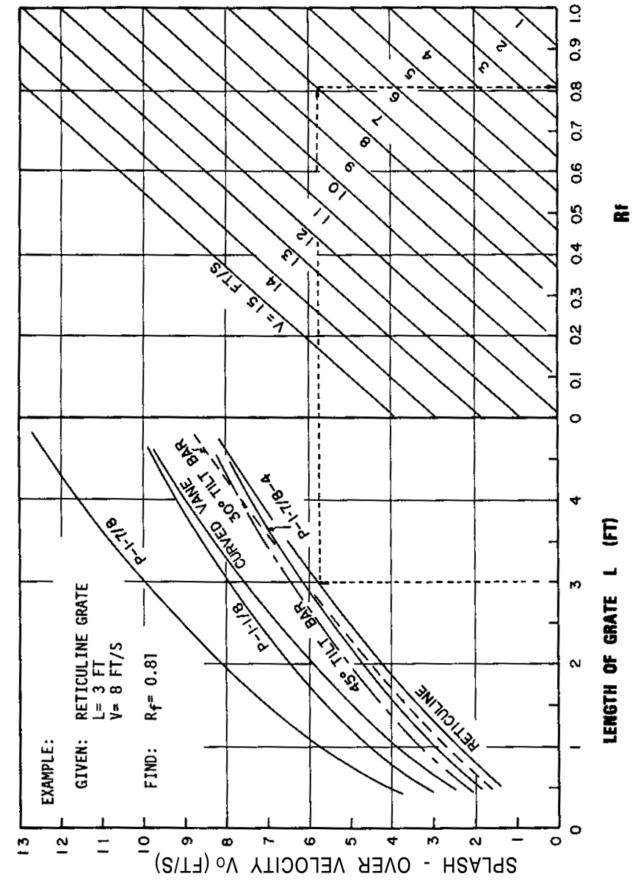

Source: HEC No. 12, FHWA

