Appendix 9C-9 Velocity in Triangular Gutter Sections

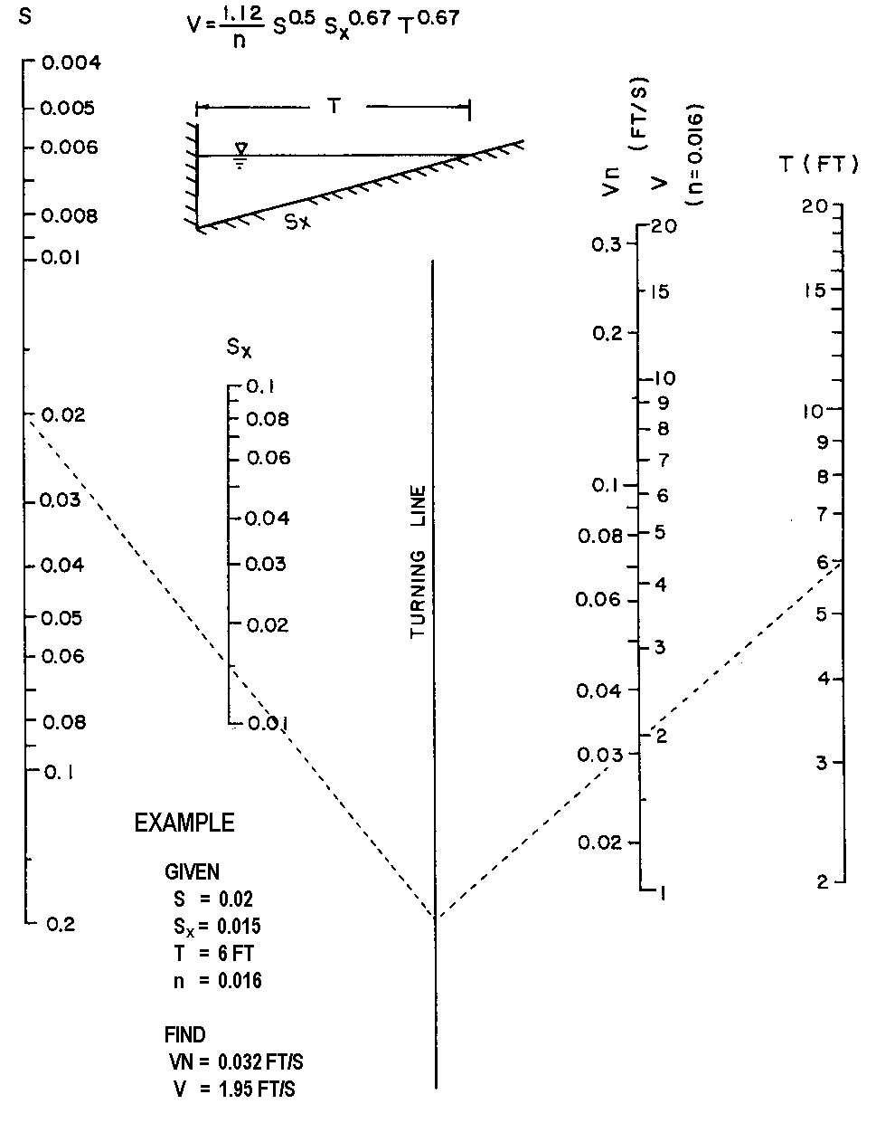

Source: HEC No. 12, FHWA

