- Culverts
TABLE OF CONTENTS
Chapter 8 - Culverts 8-1
8.1 Introduction 8-1
8.1.1 Objective 8-1
8.2 Design Policy 8-2
8.2.1 Federal and VDOT Policy 8-2
8.3 Design Criteria 8-3
8.3.1 Site Criteria 8-3
8.3.1.1 Structure Type Selection 8-3
8.3.1.2 Topography 8-3
8.3.1.3 Debris Control 8-3
8.3.2 Hydraulic Criteria 8-4
8.3.2.1 Flood Frequency 8-4
8.3.2.2 Allowable Headwater 8-5
8.3.2.3 Review Headwater 8-5
8.3.2.4 Tailwater Relationship – Channel 8-5
8.3.2.5 Tailwater Relationship - Confluence or Large Water Body 8-6
8.3.2.6 Maximum Outlet Velocity 8-6
8.3.2.7 Minimum Velocity 8-7
8.3.2.8 Storage Routing - Temporary or Permanent 8-7
8.3.2.9 Roadway Overtopping 8-7
8.3.3 Geometric Criteria 8-8
8.3.3.1 Culvert Size and Shape 8-8
8.3.3.2 Multiple Barrels 8-8
8.3.3.3 Culvert Skew 8-9
8.3.3.4 End Treatment (Inlet or Outlet) 8-9
8.3.3.4.1 Projecting Inlets or Outlets 8-9
8.3.3.4.2 Prefabricated End Sections 8-9
8.3.3.4.3 Headwalls with Bevels 8-9
8.3.3.4.4 Improved Inlets 8-10
8.3.3.4.5 Wingwalls 8-10
8.3.3.4.6 Aprons 8-10
8.3.3.4.7 Cut-off Walls 8-10
8.3.3.4.8 Trash Racks or Debris Deflectors 8-10
8.3.4 Safety Considerations 8-11
8.3.5 Allowable Pipe Materials 8-11
8.3.6 Other Design Considerations 8-11
8.3.6.1 Buoyancy Protection 8-11
8.3.6.2 Relief Opening 8-11
8.3.6.3 Land Use Culverts 8-12
8.3.6.4 Erosion and Sediment Control 8-12
8.3.6.5 Environmental Considerations and Fishery Protection 8-12
8.4 Design Concepts 8-13
8.4.1 General 8-13
8.4.2 Design Methods 8-13
8.4.2.1 Hydrologic Methods 8-13
8.4.2.1.1 Constant Discharge 8-13
8.4.2.1.2 Hydrograph and Storage Routing 8-13
8.4.2.2 Computational Methods 8-14
8.4.2.2.1 Hand Methods 8-14
8.4.2.2.2 Computer Solution 8-14
8.4.3 Culvert Hydraulics 8-14
8.4.3.1 Control Section 8-15
8.4.3.2 Minimum Performance 8-15
8.4.3.3 Inlet Control 8-15
8.4.3.3.1 Headwater Factors - Inlet Control 8-15
8.4.3.3.2 Flow Conditions – Inlet Control 8-15
8.4.3.3.2.1 Unsubmerged - Inlet Control 8-18
8.4.3.3.2.2 Submerged - Inlet Control 8-18
8.4.3.3.2.3 Transition Zone - Inlet Control 8-18
8.4.3.3.2.4 Special Condition - Inlet Control 8-18
8.4.3.3.2.5 Inlet Control Nomographs 8-18
8.4.3.4 Outlet Control 8-18
8.4.3.4.1 Headwater Factors - Outlet Control 8-20
8.4.3.4.2 Flow Condition - Outlet Control 8-20
8.4.3.4.2.1 Losses 8-20
8.4.3.4.2.2 Velocit 8-21
8.4.3.4.2.3 Velocity Head 8-21
8.4.3.4.2.4 Entrance Loss 8-21
8.4.3.4.2.5 Friction Loss 8-21
8.4.3.4.2.6 Exit Loss 8-22
8.4.3.4.2.7 Other Losses 8-22
8.4.3.4.2.8 Barrel Losses 8-22
8.4.3.4.2.9 Energy Grade Line - Outlet Control 8-23
8.4.3.4.2.10 Hydraulic Grade Line - Outlet Control 8-23
8.4.3.4.2.11 Outlet Control Nomographs (Full-flow) 8-25
8.4.3.4.2.12 Outlet Control (Partly Full-flow) 8-25
8.4.3.4.2.13 Outlet Control Nomographs (Partly full-flow) Approximate Method 8-25
8.4.3.5 Outlet Velocity 8-26
8.4.3.5.1 Inlet Control 8-26
8.4.3.5.2 Outlet Control 8-26
8.4.3.6 Roadway Overtopping 8-27
8.4.3.6.1 Length of Roadway Crest 8-27
8.4.3.6.2 Total Flow 8-27
8.4.3.6.3 Performance Curves 8-28
8.4.4 Special Design Considerations 8-29
8.4.4.1 General 8-29
8.4.4.2 Tapered Inlets 8-29
8.4.4.2.1 Side-Tapered Inlets 8-30
8.4.4.2.2 Slope-Tapered Inlets 8-30
8.4.4.3 Buoyancy Protection 8-32
8.5 Design Procedures and Examples 8-33
8.5.1 Documentation Requirements 8-33
8.5.2 VDOT Culvert Design Procedure 8-33
8.5.2.1 Culvert Design Sample Problems 8-38
8.5.3 Buoyancy Protection Procedure 8-41
8.5.3.1 Hydrostatic Uplift and Resistance 8-41
8.5.3.2 Buoyancy Protection Sample Problem 8-43
8.6 References 8-49

List of Tables
Table 8-1. Required Culvert End Treatment Based on Outlet Velocity 8-7

List of Figures
Figure 8-1. Performance Curves - Unsubmerged, Transition, and Submerged 8-16
Figure 8-2. Types of Inlet Control Flow 8-17
Figure 8-3. Types of Outlet Control Flow 8-19
Figure 8-4. Full Flow Energy and Hydraulic Grade Lines 8-23
Figure 8-5. Outlet Control Energy and Hydraulic Grade Lines 8-24
Figure 8-6. Outlet Velocity - Inlet Control 8-26
Figure 8-7. Outlet Velocity - Outlet Control 8-27
Figure 8-8. Overall Culvert Performance Curve 8-28
Figure 8-9. Side-Tapered Inlet 8-30
Figure 8-10. Slope-Tapered Inlet 8-31
Figure 8-11. Completed Culvert Design Form, Sample Problem 8-41
Figure 8-12. Hydrostatic Uplift Forces and Effects on Pipe 8-42
Figure 8-13. Buoyant Forces Acting on Pipe 8-43
Figure 8-14. Weight of Fill, Section 1 8-44
Figure 8-15. Weight of Fill Material, Section 2 8-45
Figure 8-16. Surcharge/Buoyancy along Length of Pipe 8-46
Figure 8-17. Counterweight Details for Pipes Subject to Uplift Forces 8-48
List of Appendices
Appendix 8A-1 Definitions and Abbreviations
Appendix 8A-2 Symbols
Appendix 8B-1 Culvert Design Form, LD-269
Appendix 8C-1 Inlet Control, Circular Concrete
Appendix 8C-2 Inlet Control, Circular Corrugated Metal
Appendix 8C-3 Inlet Control, Circular with Beveled Ring
Appendix 8C-4 Critical Depth, Circular
Appendix 8C-5 Outlet Control, Circular Concrete
Appendix 8C-6 Outlet Control, Circular Corrugated Metal
Appendix 8C-7 Outlet Control, Circular Structural Plate Corrugated Metal
Appendix 8C-8 Inlet Control, Concrete Box
Appendix 8C-9 Inlet Control, Concrete Box, Flared Wingwalls at 18° to 33.7° and 45°, Beveled Top Edge
Appendix 8C-10 Inlet Control, Concrete Box, 90° Headwall, Chamfered or Beveled Edges
Appendix 8C-11 Inlet Control, Single Barrel Concrete Box, Skewed Headwalls, Chamfered or Beveled Edges
Appendix 8C-12 Inlet Control, Concrete Box, Flared Wingwalls, Normal and Skewed Inlets, Chamfered Top Edge
Appendix 8C-13 Inlet Control, Concrete Box with Offset Flared Wingwalls, Beveled Top Edge
Appendix 8C-14 Critical Depth, Concrete Box
Appendix 8C-15 Outlet Control, Concrete Box
Appendix 8C-16 Inlet Control, Corrugated Metal Box, Rise/Span < 0.3
Appendix 8C-17 Inlet Control, Corrugated Metal Box, 0.3 <= Rise/Span < 0.4
Appendix 8C-18 Inlet Control, Corrugated Metal Box, 0.4 <= Rise/Span < 0.5
Appendix 8C-19 Inlet Control, Corrugated Metal Box, 0.5 <= Rise/Span
Appendix 8C-20 Critical Depth, Corrugated Metal Box
Appendix 8C-21 Outlet Control, Corrugated Metal Box, Concrete Bottom, Rise/Span < 0.3
Appendix 8C-22 Outlet Control, Corrugated Metal Box, Concrete Bottom, 0.3 <= Rise/Span < 0.4
Appendix 8C-23 Outlet Control, Corrugated Metal Box, Concrete Bottom, 0.4 <= Rise/Span < 0.5
Appendix 8C-24 Outlet Control, Corrugated Metal Box, Concrete Bottom, 0.5 <= Rise/Span
Appendix 8C-25 Outlet Control, Corrugated Metal Box, Corrugated Metal Bottom,
Rise/Span < 0.3
Appendix 8C-26 Outlet Control, Corrugated Metal Box, Corrugated Metal Bottom,
0.3 <= Rise/Span < 0.4
Appendix 8C-27 Outlet Control, Corrugated Metal Box, Corrugated Metal Bottom,
0.4 ≤ Rise/Span < 0.5
Appendix 8C-28 Outlet Control, Corrugated Metal Box, Corrugated Metal Bottom,
0.5 <= Rise/Span
Appendix 8C-29 Inlet Control, Oval Concrete, Long Axis Horizontal
Appendix 8C-30 Inlet Control, Oval Concrete, Long Axis Vertical
Appendix 8C-31 Critical Depth, Oval Concrete, Long Axis Horizontal
Appendix 8C-32 Critical Depth, Oval Concrete, Long Axis Vertical
Appendix 8C-33 Outlet Control, Oval Concrete, Long Axis Horizontal or Vertical
Appendix 8C-34 Inlet Control, Corrugated Metal Pipe-Arch
Appendix 8C-35 Inlet Control, Structural Plate Pipe-Arch, 18” Corner Radius
Appendix 8C-36 Inlet Control, Structural Plate Pipe-Arch, 31” Corner Radius
Appendix 8C-37 Critical Depth, Standard Corrugated Metal Pipe-Arch
Appendix 8C-38 Critical Depth, Structural Plate Corrugated Metal Pipe-Arch,
18” Corner Radius
Appendix 8C-39 Outlet Control, Standard Corrugated Metal Pipe-Arch
Appendix 8C-40 Outlet Control, Structural Plate Corrugated Metal Pipe-Arch,
18” Corner Radius
Appendix 8C-41 Inlet Control, Corrugated Metal Arch, 0.3 <= Rise/Span < 0.4
Appendix 8C-42 Inlet Control, Corrugated Metal Arch, 0.4 <= Rise/Span < 0.5
Appendix 8C-43 Inlet Control, Corrugated Metal Arch, 0.5 <= Rise/Span
Appendix 8C-44 Critical Depth, Corrugated Metal Arch
Appendix 8C-45 Outlet Control, Corrugated Metal Arch, Concrete Bottom,
0.3 <= Rise/Span < 0.4
Appendix 8C-46 Outlet Control, Corrugated Metal Arch, Concrete Bottom,
0.4 <= Rise/Span < 0.5
Appendix 8C-47 Outlet Control, Corrugated Metal Arch, Concrete Bottom, 0.5 <= Rise/Span
Appendix 8C-48 Outlet Control, Corrugated Metal Arch, Earth Bottom, 0.3 <= Rise/Span < 0.4
Appendix 8C-49 Outlet Control, Corrugated Metal Arch, Earth Bottom, 0.4 <= Rise/Span < 0.5
Appendix 8C-50 Outlet Control, Corrugated Metal Arch, Earth Bottom, 0.5 <= Rise/Span
Appendix 8C-51 Inlet Control, Structural Plate Corrugated Metal, Circular or Elliptical
Appendix 8C-52 Inlet Control, Structural Plate Corrugated Metal Arch, High and Low Profile
Appendix 8C-53 Critical Depth, Structural Plate Ellipse, Long Axis Horizontal
Appendix 8C-54 Critical Depth, Structural Plate Arch, Low and High Profile
Appendix 8C-55 Throat Control, Circular Section, Side-Tapered
Appendix 8C-56 Face Control, Non-Rectangular Section, Side-Tapered to Circular
Appendix 8C-57 Throat Control, Box Section, Tapered Inlet
Appendix 8C-58 Face Control, Box Section, Side-Tapered
Appendix 8C-59 Face Control, Box Section, Slope-Tapered
Appendix 8C-60 Discharge Coefficients for Roadway Overtopping
Appendix 8C-61 Circular Pipe Flow Chart (Diameter = 12”)
Appendix 8C-62 Circular Pipe Flow Chart (Diameter = 15”)
Appendix 8C-63 Circular Pipe Flow Chart (Diameter = 18”)
Appendix 8C-64 Circular Pipe Flow Chart (Diameter = 21”)
Appendix 8C-65 Circular Pipe Flow Chart (Diameter = 24”)
Appendix 8C-66 Circular Pipe Flow Chart (Diameter = 27”)
Appendix 8C-67 Circular Pipe Flow Chart (Diameter = 30”)
Appendix 8C-68 Circular Pipe Flow Chart (Diameter = 33”)
Appendix 8C-69 Circular Pipe Flow Chart (Diameter = 36”)
Appendix 8C-70 Circular Pipe Flow Chart (Diameter = 42”)
Appendix 8C-71 Circular Pipe Flow Chart (Diameter = 48”)
Appendix 8C-72 Circular Pipe Flow Chart (Diameter = 54”)
Appendix 8C-73 Circular Pipe Flow Chart (Diameter = 60”)
Appendix 8C-74 Circular Pipe Flow Chart (Diameter = 66”)
Appendix 8C-75 Circular Pipe Flow Chart (Diameter = 72”)
Appendix 8C-76 Circular Pipe Flow Chart (Diameter = 84”)
Appendix 8C-77 Circular Pipe Flow Chart (Diameter = 96”)
Appendix 8C-78 Rectangular Channel Flow Chart (B = 2’)
Appendix 8C-79 Rectangular Channel Flow Chart (B = 3’)
Appendix 8C-80 Rectangular Channel Flow Chart (B = 4’)
Appendix 8C-81 Rectangular Channel Flow Chart (B = 5’)
Appendix 8C-82 Rectangular Channel Flow Chart (B = 6’)
Appendix 8C-83 Rectangular Channel Flow Chart (B = 7’)
Appendix 8C-84 Rectangular Channel Flow Chart (B = 8’)
Appendix 8C-85 Rectangular Channel Flow Chart (B = 9’)
Appendix 8C-86 Rectangular Channel Flow Chart (B = 10’)
Appendix 8C-87 Rectangular Channel Flow Chart (B = 12’)
Appendix 8C-88 Rectangular Channel Flow Chart (B = 14’)
Appendix 8C-89 Rectangular Channel Flow Chart (B = 16’)
Appendix 8C-90 Rectangular Channel Flow Chart (B = 18’)
Appendix 8C-91 Rectangular Channel Flow Chart (B = 20’)
Appendix 8D-1 Recommended Manning's n-Values
Appendix 8D-2 Entrance Loss Coefficients (K_{e}), Outlet Control, Full or Partly Full
Appendix 8E-1 Energy Dissipation
List of Figures:
8E-1 Details of Riprap Basin Energy Dissipator
8E-2 Riprap Basin Depth of Scour
8E-3 Riprap Basin Design Checklist
8E-4 Riprap Basin Design Worksheet, Sample Problem
8E-5 Distribution of Centerline Velocity for Flow from Submerged Outlets
8E-6 Riprap Size Versus Exit Velocity
Appendix 8F-1 Handling Weight for Corrugated Steel Pipe (2-⅔” x ½” Corrugations)
Appendix 8F-2 Handling Weight for Corrugated Steel Pipe,
(3” x 1” or 125 mm x 25 mm Corrugations)
Appendix 8F-3 Dimension and Weight of Minimum Size Counterweight
Appendix 8F-4 Diameter Dimensions and D^{2.5} Values for Structural Plate Corrugated Circular Pipe (9” x 2-½” Aluminum Corrugations)
Appendix 8F-5 Geometric Properties and Critical Flow Factors for Circular Conduits Flowing Full and Partly Full
Appendix 8F-6 Velocity Head and Resistance Computation Factors for Circular Conduits Flowing Full and Party Full
Appendix 8G-1 Low Flow Diversion for Multiple Line Culvert Installations

Culverts

Introduction
Culverts are usually defined as short conduits used to convey flow through a highway fill. The flow types that occur in culverts are many and varied. In this chapter, culvert design considerations are presented from the planning stage through the design stage. Design should consider hydraulic and structural capacity, erosion and debris control, environmental impacts, safety concerns, and legal aspects. Design concepts are covered and design procedures are summarized along with sample problems. Sources of additional information on culvert design are provided.
For additional details on culvert design, refer also to Chapter 15, Drainage Design Instructions (DDM 2).
The FHWA web sites for specific publications may be used for additional information on the following topics:
HDS-5, Hydraulic Design Of Highway Culverts <http://isddc.dot.gov/OLPFiles/FHWA/009342.pdf>
HEC-20, Stream Stability At Highway Structures, <http://www.fhwa.dot.gov/bridge/hec20.pdf>
Highways In The River Environment (HIRE),
<http://www.fhwa.dot.gov/bridge/hire1990.pdf>

Objective
The objective of this chapter is to provide the user with the information needed to select, plan, and design highway culverts based on VDOT methods. Using the information provided, the user will be able to design conventional culverts. The chapter also provides references, which will enable the user to apply special culvert designs for unusual circumstances.

Design Policy

Federal and VDOT Policy
The following policies will guide the selection, planning, and design of highway culverts:
- All culverts should be hydraulically designed
- The overtopping flood selected should be consistent with the class of highway and commensurate with the risks at the site
- Survey information should include topographic features, channel characteristics, aquatic life, highwater information, existing structures and other related site-specific information
- Culvert location in both plan and profile should be investigated to consider sediment build-up in the barrels, upstream, or downstream of the culvert
- The cost savings of multiple use culverts (utilities, stock and wildlife passage, land access and fish passage) should be weighed against the advantages of separate facilities
- Culverts should be designed to accommodate debris or proper provisions should be made for debris maintenance
- Material selection should consider service life, which includes abrasion and corrosion
- Culverts should be located and designed to present a minimum (reasonable) hazard to traffic and people
- The detail of documentation for each culvert site should be commensurate with the risk and importance of the structure.
- Where practicable, some means should be provided for personnel and equipment access to facilitate maintenance
- Culverts should be regularly inspected and maintained

Design Criteria
Criteria for the planning and design of culverts are discussed in this section. These criteria should be considered for all culvert designs.

Site Criteria
The following criteria relate to site conditions, which affect the selection of a particular culvert type, geometry, and debris protection.

Structure Type Selection
Often, a choice must be made between a culvert and a bridge at a given site. In making that decision, the following criteria should be considered.
Culverts are used:
- Where bridges are not hydraulically required or feasible
- Where debris and ice are tolerable
- Where a culvert is more economical than a bridge
- Where environmentally acceptable
Bridges are used:
- Where culverts cannot be used
- Where a bridge is more economical than a culvert
- To satisfy land use requirements
- To mitigate environmental impacts caused by a culvert
- To avoid floodway encroachments
- To accommodate ice and large debris
- To avoid cost and impact of channel diversions necessary for culvert construction

Topography
The culvert length and slope should be chosen to fit the existing topography, to the degree practicable:
- The culvert invert should be aligned with the channel bottom and the skew angle of the stream, except in instances where countersinking one or more culvert barrels is needed to satisfy environmental requirements

Debris Control
Debris control should be designed using the FHWA's Hydraulic Engineering Circular No. 9, "Debris-Control Structures" and should consider:
- Where experience or physical evidence indicates the watercourse will transport a heavy volume of debris
- Culverts located in mountainous or steep regions of the state
- Culverts that are under high fills
- Where clean-out access is limited. (However, access must be available to clean out and otherwise maintain the debris control device)

Hydraulic Criteria
These criteria relate to the hydraulic design of culverts based on flood flows, upstream and downstream water surface elevations, allowable velocities, and flow routing.

Flood Frequency
Culverts should be designed to accommodate the following minimum flood frequencies where the primary concern is the maintenance of traffic flow and the convenience of the highway user:
Roadway Flood Frequency (Annual Risk)

Interstate 50-year (2%)
Primary & Arterial 25-year (4%)
Secondary 5 to 10 (20 to 10%)
The above requirements are minimum, and deviation requires approval from VDOT. Culverts should be designed to pass floods greater than those noted above where warranted by potential damage to adjacent property, loss of human life, injury, or heavy financial loss.
Future development of contributing watersheds and floodplains that have been zoned or delineated should be considered in determining the design flood. For the Interstate System, development during a period 20 years in the future should be considered. Adopted regional plans and approved zoning will be considered in determining the design discharge on all systems.
In compliance with the National Flood Insurance Program (NFIP) it is necessary to consider the 100-year frequency flood at all locations where construction will encroach on a floodplain. The 100-year floodplains and the 100-year water surface profiles are delineated and established for the Federal Emergency Management Agency (FEMA), the administrator of NFIP. The NFIP prohibits any construction in floodplains, when combined with all other existing and anticipated uses, which would increase the water surface elevation of the 100-year flood more than one foot at any given point. It should be noted that it is VDOT's policy not to allow any increase in the level of the 100-year flood. This does not necessarily require that the culvert be sized to pass the 100-year flood, provided the capacity of the culvert plus flow bypassing the culvert is sufficient to accommodate the 100-year flood without raising the water surface elevation excessively. An example of this may be where the culvert is designed to keep the roadway free from inundation during the 10-year design storm and the road grade is held down such that the culvert capacity plus flow over the roadway is sufficient to pass the 100-year flood without raising the upstream water surface elevation. In instances where a NFIP floodplain is involved, the same procedure used to establish the floodplain and water surface elevations (usually a step-backwater computer model such as HEC-RAS, HEC-2, WSPRO, etc.) should be used to design the proposed culvert.

Allowable Headwater
The allowable headwater is the depth of water that can be ponded at the upstream end of the culvert during the design flood, measured from the culvert inlet invert. The headwater depth or elevation may also be limited by giving due consideration to inlet and outlet velocities and the following upstream water surface elevation controls:
- Not higher than an elevation that is 18 inches below the outer edge of the shoulder at its lowest point in the grade
- Upstream property damage
- Elevations established to delineate NFIP or other floodplain zoning
- HW/D is at least 1.0 and not to exceed 1.5 where HW is the headwater depth from the culvert inlet invert and D is the height of the barrel
- Low point in the road grade which is not necessarily at the culvert location
- Elevation of terrain or ditches that will permit flow to divert around the culvert

Review Headwater
The review headwater is the flood depth that:
- Does not increase the existing 100-year flood elevation in the NFIP mapped floodplains, or in the vicinity of insurable buildings
- Has a level of inundation that is tolerable to upstream property and roadway for the frequency of the check storm

Tailwater Relationship – Channel
When the tailwater relationship is developed for the receiving channel, the designer should:
- Evaluate the hydraulic conditions of the downstream channel to determine tailwater depths for a range of discharges which include the check storm (see Chapter 6, Hydrology)
- For minor drainage installations with a 100-year discharge of less than 500 cfs, calculate the tailwater using a single cross section analysis
- For sensitive locations and for major drainage installations with a 100-year discharge equal to or greater than 500 cfs, calculate the tailwater depth using backwater methods (such as HEC-2, HEC-RAS, or WSPRO) or other step methods as appropriate. (Step backwater methods yield the most accurate tailwaters)
- When using backwater methods to define barrel losses for subcritical flow in the culvert barrel, use critical depth at the culvert outlet if it is greater than the channel depth
- When using full flow nomographs to define barrel losses, use a calculated tailwater based on critical depth (d_{c}) and the height of the barrel (D) when that term [TW = (d_{c} + D)/2] is greater than the depth of flow in the outlet channel
- Use the headwater elevation of a downstream culvert if it is greater than the channel depth

Tailwater Relationship - Confluence or Large Water Body
When the tailwater relationship is developed from the confluence of a large body of water, the designer should:
- Use the highwater elevation that has the same frequency as the design flood if events are known to occur concurrently (statistically dependent)
- If events are statistically independent, evaluate the joint probability of flood magnitudes and use a likely combination resulting in the greater tailwater depth. Guidelines are provided in Joint Probability Analysis, Chapter 6, Appendix 6I.
- If tidal conditions are present at the site, use the mean high tide

Maximum Outlet Velocity
The outlet velocity of a culvert is the velocity computed at the downstream end of the culvert. It is usually higher than the maximum natural stream velocity.
Variations in the shape and size of a culvert barrel seldom have a significant effect on the outlet velocity. The slope and roughness of the culvert barrel are the principal factors affecting the outlet velocity.
If the outfall channel consists of material that will be subject to erosion, the following criteria should apply (refer to Table 8-1):
- The outlet velocities should be computed for the design discharge and the 25-year discharge. Whichever velocity is less should be used to ensure that the channel is stable.
- Erosion Control Stone, Class I or II should be in accordance with Standard EC-l
- Special design energy dissipators should consist of heavy riprap or other structures designed to provide protection for the specific site conditions (see Appendix 8E-1). The FHWA's HEC-14 publication provides analysis and design information on energy dissipators.
Table 8-1. Required Culvert End Treatment Based on Outlet Velocity
Outlet Velocity¹ (ft/s) | Culvert End Treatment (Type)
Outlet Velocity¹ (ft/s) | End Sections | Endwall or Headwall With Curtain Walls
0-6  6-10  10-14  14-19  19+ | None  EC - 1 Class I  EC - 1 Class I  EC - 1 Class II  Special Design | None  None  EC - 1 Class I  EC - 1 Class II  Special Design
¹Based on Q₂₅ or design Q, whichever is less.

Minimum Velocity
The minimum velocity in a culvert barrel should be adequate to prevent siltation at low flow rates. When the streambed material size is unknown, use three (3) feet per second.

Storage Routing - Temporary or Permanent
It is VDOT practice to design culverts without recognizing or calculating the available upstream storage. If unusual circumstances require the consideration of upstream storage, the following concerns should be addressed:
- Limit the total area of flooding
- Limit the average time that bankfull stage is exceeded for the design flood to 48 hours in rural areas or 6 hours in urban areas
- Ensure that the storage area will remain available for the life of the culvert through the purchase of additional right-of-way or easements
- Consider environmental impacts
- Consider sediment deposition
- Consider the impacts of the delayed peak coinciding with downstream peak discharges

Roadway Overtopping
Roadway overtopping should not be allowed for discharges equal to or less than the design discharge for new culvert installations. Overtopping can occur and is sometimes encouraged, for higher discharges. Roadway overtopping may occur:
- When evaluating existing culvert installations for current design flows
- When performing check flood calculations
- When the design flood has less than a 100-year return period, and the roadway is held down so that the total flow through the culvert and over the roadway is sufficient to pass the 100-year storm without raising the 100-year water surface elevation upstream of the culvert
- Due to a flood event which exceeds the design storm and check storm
If roadway overtopping is indicated, it is necessary to consider the risk to highway users of loss of life, injury, and property damage. The highway embankment may be at risk based on:
- The depth of flow across the roadway
- The velocity of flow across the roadway
- The duration of roadway overtopping
- The resistance of the embankment to scour
Storage routing may be useful in evaluating the impacts of roadway overtopping.

Geometric Criteria
Design criteria related to the culvert geometry, including the inlet structure, the barrel, and the outlet structure are summarized in this section.

Culvert Size and Shape
The culvert size and shape selected should be based on engineering and economic criteria related to site conditions.
- For the Interstate System, the minimum size of main line culverts will generally be 24 inches due to maintenance considerations
- For other systems, 15 inches will generally be the minimum culvert diameter, except that hydraulically adequate 12-inch diameter culverts may be used if the culvert length is less than 50 feet or if it is located under an entrance
- Use arch or elliptical shapes only if required by hydraulic limitations, site characteristics such as cover, structural criteria, or environmental criteria

Multiple Barrels
Multiple barrel culverts should be designed to utilize the natural dominant channel with minimal or preferably no widening of the channel so as to avoid conveyance loss through sediment deposition in some of the barrels. Multiple barrels should be avoided where:
- The approach flow is high velocity, particularly if supercritical. (These sites require either a single barrel or special inlet treatment to avoid adverse hydraulic jump effects.)
- Fish passage is required unless special treatment is provided to ensure adequate low flow. When fish passage is required, all barrels are laid 6 inches below the streambed and a low flow diversion should be used to maintain the necessary depth in the appropriate barrel(s).
- A high potential exists for debris clogging the culvert inlet

Culvert Skew
The culvert skew should not exceed 45 degrees as measured from a line perpendicular to the roadway centerline without the approval of VDOT.

End Treatment (Inlet or Outlet)
The culvert inlet type should be selected from the following categories based on the considerations given and the inlet entrance loss coefficient, K_{e}. Appendix 8D-2 provides recommended values of K_{e}. Consideration should also be given to safety since some end treatments can be hazardous to errant vehicles. All culverts 48 inches in diameter and larger should employ VDOT's standard headwalls, where available, or a comparable special design end treatment where a standard treatment does not apply. The following sections present pros and cons for each type of end treatment.

Projecting Inlets or Outlets
Projecting inlets or outlets extend beyond the roadway embankment. These structures:
- Are susceptible to damage during roadway maintenance and from errant vehicles
- Have low construction cost
- Have poor hydraulic efficiency for thin materials such as corrugated metal
- Should not be used for culverts 48 inches in diameter and larger
- Are subject to buoyancy

Prefabricated End Sections
Prefabricated end sections are available for both corrugated metal and concrete pipes. These sections:
- Should not be used for culverts 48 inches in diameter or larger
- Retard embankment erosion and incur less damage from maintenance
- May improve projecting pipe entrances by increasing hydraulic efficiency, reducing the accident hazard, and improving their appearance
- Are hydraulically equivalent to a headwall, but can be equivalent to a beveled or side- tapered entrance if a flared, enclosed transition takes place before the barrel
- Are susceptible to buoyancy and may need concrete anchor blocks to resist hydrostatic uplift forces

Headwalls with Bevels
Headwalls with bevels are the standard VDOT design. These headwalls:
- Increase culvert efficiency
- Provide embankment stability and embankment erosion protection
- Provide protection from buoyancy
- Shorten the required structure length
- Reduce maintenance damage

Improved Inlets
Improved inlets are special designs which:
- Should be considered for exceptionally long culverts which will operate in inlet control or widening projects with increased flow to eliminate replacing existing culvert barrel(s)
- Can increase the hydraulic performance of the culvert, but may also increase total culvert cost
- If slope-tapered, should not be considered where fish passage is required
- Can increase outlet velocity

Wingwalls
Wingwalls are generally used in conjunction with headwalls and:
- Are used to retain the roadway embankment to avoid a projecting culvert barrel
- Are used where the side slopes of the channel are unstable
- Are used where the culvert is skewed to the normal channel flow
- Provide the best hydraulic efficiency if the flare angle is between 30° and 60°
- Are governed by VDOT height of embankment guidelines

Aprons
Aprons are special designs that can be used at culvert inlets and outlets and:
- Are used to reduce scour from high headwater depths or from high approach velocities in the channel
- Should extend at least one pipe diameter upstream
- Should not protrude above the normal streambed elevation

Cut-off Walls
Cut-off walls may be used at the entrance or the outlet of a culvert, and:
- Are used to prevent piping along the culvert barrel and undermining at the culvert ends
- Are an integral part of all of VDOT's standard endwalls
- Should be included (a minimum of 1.5 ft. in depth) when other than VDOT standard endwalls are employed

Trash Racks or Debris Deflectors
Trash racks or debris deflectors may be necessary at sites where large amounts of detritus are produced. Such structures:
- May create clogging problems
- Require maintenance
- Should only be used where there is an established need

Safety Considerations
Each site should be inspected periodically to determine if safety problems exist for traffic or for the structural safety of the culvert and embankment.
Culvert headwalls and endwalls should be located outside the clear zone distance of the highway. The clear zone distance from the edge of pavement is a function of the design speed of the roadway. The typical clear zone distance for a high-speed highway is 30-feet. The designer is referred to the VDOT Road Design Manual for further information and to AASHTO for additional guidance. An exception to this clear zone requirement occurs if traffic is separated from the walls by guardrail that is required due to obstacles other than the walls.
Where feasible, grate drop inlets or load-carrying grates may be substituted for culvert headwalls or endwalls, and thereby reducing safety hazards. However, in making this substitution, consideration must be given to the possibility of creating a greater safety hazard by increasing the potential for flooding if the grates clog. The drainage designer should continuously coordinate roadway related issues and information with the roadway design team.

Allowable Pipe Materials
Refer to I&IM LD- (D) 121

Other Design Considerations

Buoyancy Protection
When water is displaced by embankment material or by a culvert, a buoyant or upward force exists. If the buoyant force is greater than the weight of the object displacing the water, flotation will occur. Pipe flotation (or hydrostatic uplift) can be a problem where the following conditions exist:
- Lightweight pipe is used (i.e., corrugated metal or plastic)
- Pipe is on a steep grade (usually inlet control)
- There is little or no weight on the end of the pipe (i.e., flat embankment slopes, minimal cover and/or no endwalls)
- High headwater depths (HW/D> 1.0)

Relief Opening
Where multiple-use culverts or culverts serving as relief openings have their outlet set above the normal stream flow line, special precautions should be provided to prevent headcuts or erosion from undermining the culvert outlet.

Land Use Culverts
Land use culverts are installations where storm drainage requirements are combined with other land based uses, such as farm or pedestrian crossings. For such installations:
- The land use is temporarily forfeited during the design flood, but is available during lesser floods
- Two or more barrels may be required, with one situated to be dry during floods less than the selected design flood
- The outlet of the higher land use barrel may need protection from headcutting
- The culvert should be sized so as to ensure that it can serve its intended land use function up to and including a 2-year flood
- The height and width constraints should satisfy the hydraulic or land use requirements, whichever use requires the larger culvert

Erosion and Sediment Control
Temporary erosion and sediment control measures should be included in the construction plans. These measures include the use of the following: sediment basins and traps, silt barriers, dewatering basins, filter cloth, temporary silt fence and rock check dams. These measures should be utilized as necessary during construction to minimize pollution of streams and damage to wetlands. For more information, see Chapter 10, Erosion and Sediment Control.

Environmental Considerations and Fishery Protection
In addition to controlling erosion, siltation and debris at the culvert site, care must be exercised in selecting the location of the culvert. Where compatible with good hydraulic engineering a site should be selected that will permit the culvert to be constructed in the "dry" or that will cause the least impact to the stream or wetlands. This selection must consider the entire site involvement, preferably eliminating or at least minimizing the need for entrance and exit channels.
Where there is a live stream, or where the protection of fish habitat warrants, as determined by the Environmental Division, the invert of a proposed culvert will be set 6 inches lower than the normal flow line of the stream in order to provide for the re-establishment of the streambed and low flow depth in the culvert that will facilitate fish passage. Where the culvert is a multiple barrel or multiple cell structure, all barrels or cells are to be lowered 6 inches below stream grade and a low flow diversion should be used to maintain low flow in the appropriate barrel(s) as shown in Appendix 8G-1. The grade of a culvert located to facilitate fish passage should never be steeper than the grade of the natural stream in the site area. Preferably, the culvert barrel should be flattened as necessary to limit the velocity of flow in the culvert.

Design Concepts

General
The design of a culvert system for a highway crossing should consider: roadway requirements, planning and location, hydrology, ditches and channels, and erosion and sediment control. Each of these chapters should be consulted as appropriate. The discussion in this section is focused on alternative analyses and design methods.
For economy and hydraulic efficiency, culverts should be designed to operate with the inlet submerged during design flood flows. At many sites, either a bridge or a culvert will fulfill the structural and hydraulic requirements; therefore, the structure choice should be based on construction and maintenance costs, risk of failure, risk of property damage, traffic safety, and environmental considerations.

Design Methods
The designer should choose whether:
- To assume a constant discharge or to route a hydrograph
- To use hand methods (nomographs or equations) or computer software solutions, such as FHWA's HY8

The FHWA's Hydraulic Design Series No. 5, "Hydraulic Design of Highway Culverts," is the primary reference on culvert design.

Hydrologic Methods
Hydrologic methods are either steady state (constant discharge over time) or unsteady (flow varies with time, as in a hydrograph).

Constant Discharge
The constant discharge method:
- Is the typical method used for most culvert designs
- Is usually assumed to be the peak discharge
- Will yield a conservatively sized structure where temporary storage is available but is not considered

Hydrograph and Storage Routing
Hydrograph and storage routing method:
- Is used when unusual circumstances exist
- Considers the storage capacity behind a highway embankment which attenuates a flood hydrograph and reduces the peak discharge
- May reduce the required culvert size, given adequate storage
- Is checked by routing the design hydrographs through the culvert to determine the outflow hydrograph and upstream water surface elevation
- Procedures are in Chapter 11, Stormwater Management, and in HDS-5, Section V

Computational Methods
Computational methods include hand methods (LD-269) and computer solutions. Hand methods usually employ design nomographs, provided in Appendix 8C. However, the design equations may also be applied. Computer solutions are usually employed for larger installations; however, they can be used for all situations.

Hand Methods
Hand methods using design equations and nomographs through design form LD-269 (Appendix 8B-1):
- Require a trial and error solution that is straightforward and easy using design nomographs
- Provide reliable designs for many applications
- Require additional computations for tailwater, outlet velocity, hydrographs, routing and roadway overtopping
- Nomographs for a variety of barrel shapes are included in Appendix 8C

Computer Solution
One example of culvert analysis software is HY8, FHWA’s Culvert Analysis Microcomputer Program, which:
- Is an interactive program
- Uses the theoretical basis for the nomographs
- Can compute tailwater, improved inlets, road overtopping, hydrographs, routing and multiple independent barrels, and irregular shaped conduits
- Calculates backwater profiles in the culvert barrel(s)
- Develops and plots tailwater rating curves
- Develops and plots performance curves

Culvert Hydraulics
An exact theoretical analysis of culvert flow is extremely complex because the following are required:
- Analysis of non-uniform flow with regions of both gradually varying and rapidly varying flow
- Determination of how the flow type changes as the flow rate and tailwater elevations change
- Application of backwater and drawdown calculations and energy and momentum balances
- Incorporation of the results of hydraulic model studies
- Determination of whether hydraulic jumps occur and whether they are inside or downstream of the culvert barrel
- Analysis of flows under subatmospheric pressure in the culvert barrel
The design procedures described in this chapter incorporate the following concepts:

Control Section
- The control section is the location where there is a unique relationship between the flow rate and the upstream water surface elevation
- The control section may be located at or near the culvert inlet (inlet control) or the culvert outlet (outlet control)
- Inlet control is governed by the inlet geometry
- Outlet control is governed by the culvert inlet geometry, as well as the barrel characteristics, and tailwater elevation(s)
- Tailwater control may be located downstream of the culvert

Minimum Performance
Minimum performance is determined by analyzing both inlet and outlet control and using the highest resultant headwater. The culvert may operate more efficiently than minimum performance at times (more flow for a given headwater level), but it will not operate at a lower performance level than the one calculated using this concept.

Inlet Control
For inlet control, the control section is at, or near, the upstream end of the barrel (the inlet). The flow passes through critical depth near the inlet and becomes shallow, high velocity (supercritical) flow in the culvert barrel. Depending on the tailwater elevation, a hydraulic jump may occur downstream of the inlet.

Headwater Factors - Inlet Control
The following factors are considered when calculating the inlet control headwater.
- Headwater depth is measured from the inlet invert of the inlet control section to the surface of the upstream pool
- Inlet area is the cross-sectional area of the face of the culvert. The inlet face area is the same as the barrel area, except for tapered improved inlets
- Inlet edge configuration describes the entrance geometry. Some typical inlet edge configurations are thin edge projecting, mitered, square edges in a headwall, and beveled edge
- Inlet shape is usually the same as the shape of the culvert barrel except for some improved inlets. Typical shapes are rectangular, circular, elliptical, and arch. Carefully check for additional control sections for special culvert designs.

Flow Conditions – Inlet Control
Three regions of inlet control flow are shown in Figure 8-1. They are unsubmerged, transition, and submerged. Generally, as the flow rate increases, inlet control flow passes through an unsubmerged condition (water surface below the crown of the control section), transition (between partly full and full flow), and submerged (water surface above the crown of the control section). The transition region is poorly defined and tends to be unstable. Its curve is usually drawn tangent to the unsubmerged and submerged performance curves.
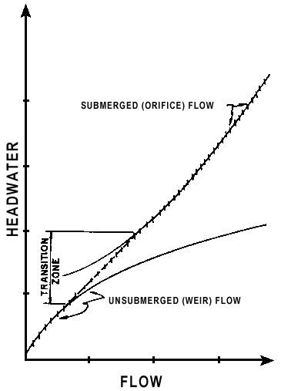
Figure 8-1. Performance Curves - Unsubmerged, Transition, and Submerged
Four types of inlet control flow profiles within culverts are shown in Figure 8-2.

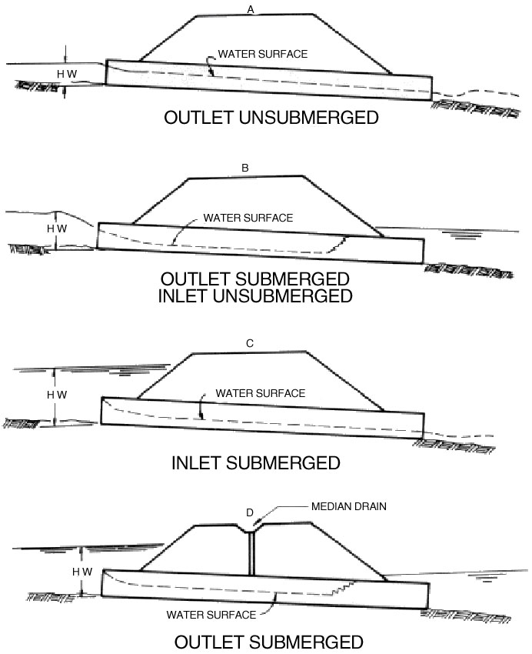
Figure 8-2. Types of Inlet Control Flow

Unsubmerged - Inlet Control
For headwaters below the inlet crown, the entrance operates as a weir, as shown in Figure 8-2, diagrams A and B. As shown, the outlet of the culvert may be unsubmerged or submerged.
- A weir is a flow control section where the upstream water surface elevation can be predicted for a given flow rate
- The relationship between flow and water surface elevation must be determined by model tests of the weir geometry or by measuring prototype discharges
- Such tests are then used to develop equations. Appendix A of HDS-5 contains the equations, which were developed from model test data.

Submerged - Inlet Control
For headwaters above the inlet crown, the culvert operates as an orifice as shown in Figure 8-2, diagram C.

- An orifice is a submerged opening flowing freely on the downstream side, which functions as a control section
- The relationship between flow and headwater can be defined based on results from model tests. Appendix A of HDS-5 contains flow equations, which were developed from model test data.

Transition Zone - Inlet Control
The transition zone is located between the unsubmerged and the submerged flow conditions where the relationship between flow and headwater depth is poorly defined. This zone is approximated by plotting the unsubmerged and submerged flow equations and connecting them with a line tangent to both curves.

Special Condition - Inlet Control
Figure 8-2, diagram D illustrates a special case of inlet control, where both the entrance and the outlet are submerged. To maintain this condition, a source of air must be supplied to the barrel; otherwise the barrel will tend to surge and alternate between full flow and partly full flow.

Inlet Control Nomographs
The inlet control flow versus headwater curves, which are established using the above procedure, are the basis for constructing the inlet control design nomographs in Appendix 8C. Note that in the inlet control nomographs, headwater (HW) is measured from the inlet invert to the total upstream energy grade line, including the approach velocity head.

Outlet Control
Culverts operating in outlet control have subcritical or full flow in their barrels. The control of the flow is at the downstream end of the culvert (the outlet) or further downstream. The tailwater depth is assumed to be a function of either critical depth at the culvert outlet or the downstream channel depth, whichever is higher. In outlet control, the type of flow is dependent on the entire culvert, including the inlet configuration, the barrel, and the tailwater.
Five types of outlet control flow profiles within culverts are depicted in Figure 8-3. Note that both the inlet crown and the outlet crown may be submerged or unsubmerged.
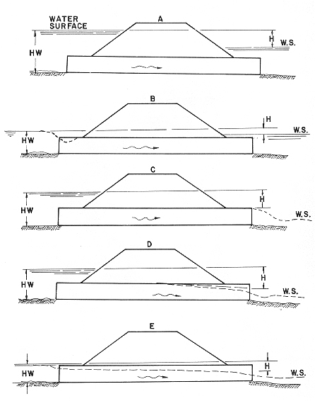
Figure 8-3. Types of Outlet Control Flow
Figure 8-3; diagram A represents full flow throughout the culvert barrel. Both the entrance and the outlet are submerged.
Figure 8-3; diagram B shows the barrel inlet flowing partly full, but the rest of the barrel under full flow. The entrance is unsubmerged due to the inlet contraction, and the outlet is submerged.
Figure 8-3, diagram C represents full flow in the culvert barrel. The entrance is submerged and the outlet is unsubmerged.
Figure 8-3, diagram D represents full flow in the upper section of the barrel and partly full flow (subcritical) in the lower section of the barrel. The entrance is submerged and the outlet is unsubmerged.
Figure 8-3, diagram E depicts partly full flow (subcritical) over the length of the barrel. Both the entrance and the outlet are unsubmerged.

Headwater Factors - Outlet Control
The following factors are considered when calculating the headwater from outlet control.
- Barrel Roughness is a function of the barrel material and geometry. Typical materials include concrete and corrugated metal. The roughness is represented by a hydraulic resistance coefficient such as Manning's n-value. Typical Manning's n-values are presented in Appendix 8D-1.
- Barrel Area is the full flow cross-section measured perpendicular to the flow.
- Barrel Length is the total culvert length from the entrance crown to the exit crown of the culvert. Because the design height of the barrel and the embankment slope influence the actual length, an approximation of barrel length is usually necessary to begin the design process.
- Barrel Slope is the actual slope of the culvert barrel, and is often the same as the natural stream slope. However, when the culvert inlet or outlet is raised or lowered, the barrel slope is different from the stream slope.
- Tailwater Elevation is based on the downstream water surface elevation. Backwater calculations from a downstream control, single section approximation, downstream lake levels, tidal elevations, or field observations are used to define the tailwater elevation. Tailwater elevations are normally calculated for different flood frequencies.

Flow Condition - Outlet Control
Full flow in the culvert barrel is assumed for the analysis of outlet control hydraulics. Outlet control flow conditions can be calculated based on an energy balance from the tailwater pool to the headwater pool. The outlet control headwater can be computed using the following equations:

Losses
The total headloss through the culvert is defined by Equation 8.1.
(8.1)
Where:
H_{L} = Total energy loss, ft
H_{e} = Entrance loss, ft
H_{f} = Friction losses, ft
H_{o} = Exit loss, ft (equals velocity head if K_{e} = 1.0)
H_{b} = Bend losses, ft (see HDS-5)
H_{j} = Losses at junctions, ft (see HDS-5)
H_{g} = Losses at grates, ft (see HDS-5)
H_{v} = Velocity head, ft

Velocity
Velocity is computed using the continuity equation.
(8.2)
Where:
V = Average full barrel velocity, fps
Q = Flow rate, cfs
A = Cross sectional area of flow with the barrel full, sq. ft.

Velocity Head
The velocity head represents the kinetic energy of full flow in the culvert barrel. It is used in calculating the losses in the culvert (inlet, barrel, outlet, etc.).
(8.3)
Where:
g = Acceleration due to gravity, 32.2 ft/s²

Entrance Loss
The losses at the culvert entrance are a function of the velocity head. The more efficient the inlet, the lower the K_{e} value.
(8.4a)
Where:
K_{e} = Entrance loss coefficient, see Appendix 8D-2

Friction Loss
Friction loss in the culvert barrel is due to wall friction. It is a function of barrel roughness, size, shape, and velocity head, and is calculated using Manning's Equation.
(8.4b)
Where:
n = Manning's roughness coefficient, see Appendix 8D-1
L = Length of the culvert barrel, ft
R = Hydraulic radius of the full culvert barrel = , ft
A = Cross section area of pipe, sq. ft.
P = Wetted perimeter of the barrel, ft

Exit Loss
The exit loss is a function of the velocity head in the barrel and the velocity head in the downstream channel. The latter is often neglected.
(8.4c)
Where:
V_{d} = Channel velocity downstream of the culvert, fps (if downstream velocity is neglected, use Equation 8.4d).
(8.4d)

Other Losses
Other possible losses in the culvert include junctions, bends, grates, etc. If present, these losses are functions of the velocity head multiplied by a loss coefficient. The loss coefficients are found in HDS-5.

Barrel Losses
The various culvert losses are totaled to obtain the total headloss in the barrel. Losses for bends, junctions, grates, etc., should be added to Equation 8.5.
(8.5)

Energy Grade Line - Outlet Control
The energy grade line represents the total energy at any point along the culvert barrel. Equating the total energy at sections 1 and 2, upstream and downstream of the culvert barrel in Figure 8-4, the following relationship results:
(8.6)
Where:
HW_{o} = Headwater depth above the outlet invert, ft
V_{u} = Approach velocity, fps
TW= Tailwater depth above the outlet invert, ft
V_{d} = Downstream velocity, fps
H_{L} = Sum of all losses (Equation 8.1)
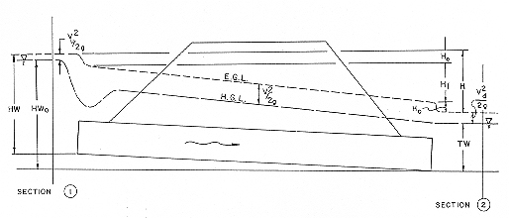
Figure 8-4. Full Flow Energy and Hydraulic Grade Lines

Hydraulic Grade Line - Outlet Control
The hydraulic grade line is the depth to which water would rise in vertical tubes connected to the sides of the culvert barrel. In full flow, the energy grade line and the hydraulic grade line are straight, parallel lines separated by the velocity head except at the inlet and the outlet.
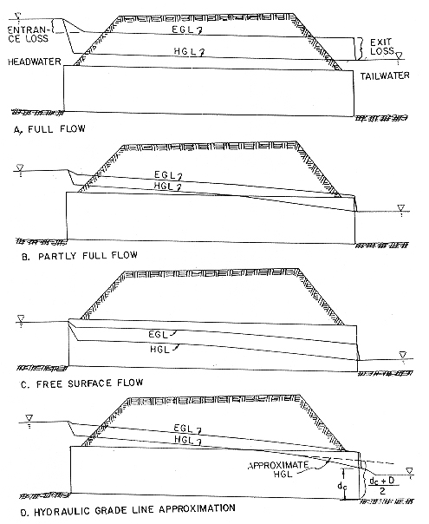
Figure 8-5. Outlet Control Energy and Hydraulic Grade Lines

Outlet Control Nomographs (Full-flow)
The outlet control nomographs were developed assuming that the culvert barrel is:
- Flowing full (See Figure 8-5, diagrams A and B)
- d_{c} ≥ D, (See Figure 8-5, diagram C)
- V_{u} is small and its velocity head can be considered to be a part of the available headwater (HW) used to convey the flow through the culvert
- V_{d} is small and its velocity head can be neglected
For these conditions, Equation 8.6 becomes:
(8.7)
Where
HW= Depth from the inlet invert to the energy grade line, ft
H = Headloss read from the nomograph (Equation 8.5), ft
S_{o} = Slope of culvert barrel, ft/ft
L = Length of culvert barrel, ft

Outlet Control (Partly Full-flow)
Equations 8.1 through 8.7 were developed for full barrel flow. The equations also apply to the flow situations which are effectively full flow conditions, if TW < d_{c} (Figure 8-5, diagrams C and D), backwater calculations may be required which begin at the downstream water surface and proceed upstream. If the depth intersects the top of the barrel (Figure 8-5, diagram D), the full flow hydraulic grade line extends from that point upstream to the culvert entrance.

Outlet Control Nomographs (Partly Full-flow) - Approximate Method
Based on numerous backwater calculations performed by the FHWA staff, it was found that the full flow hydraulic grade line, extended from the upstream end of the barrel to the outlet, pierces the plane of the culvert outlet at a point about one-half way between critical depth and the top of the barrel, or (d_{c}+D)/2 above the outlet invert. TW based on the downstream channel depth should be used if it is higher than (d_{c}+D)/2.
The following equation should be used for headwater (HW):
(8.8)
Where:
h_{o} = The larger of TW or , ft
Adequate results are obtained down to about HW = 0.75D. For lower headwaters, backwater calculations are required.

Outlet Velocity
Culvert outlet velocities should be calculated to determine the need for erosion protection at the culvert exit (See Table 8-1). Culverts usually have outlet velocities that are higher than the natural stream velocities. These outlet velocities may require flow readjustment or energy dissipation to prevent downstream erosion. If outlet erosion protection is necessary, the flow depth and the Froude number may also be needed.

Inlet Control
The velocity is calculated using Equation 8.2 with the flow area (A) equal to the cross section of the flow prism at the culvert outlet. First, the outlet depth must be determined. Either of the following methods may be used.
- Calculate the water surface profile through the culvert. Begin the computation at d_{c} at the entrance and proceed downstream to the exit. Determine the depth and flow prism area at the exit
- Assume normal depth and velocity in the culvert barrel. This approximation may be used since the water surface profile approaches normal depth if the culvert is long enough. This outlet velocity may be slightly higher than the actual velocity at the outlet. Normal depths may be obtained from design aids in Appendix 8C.

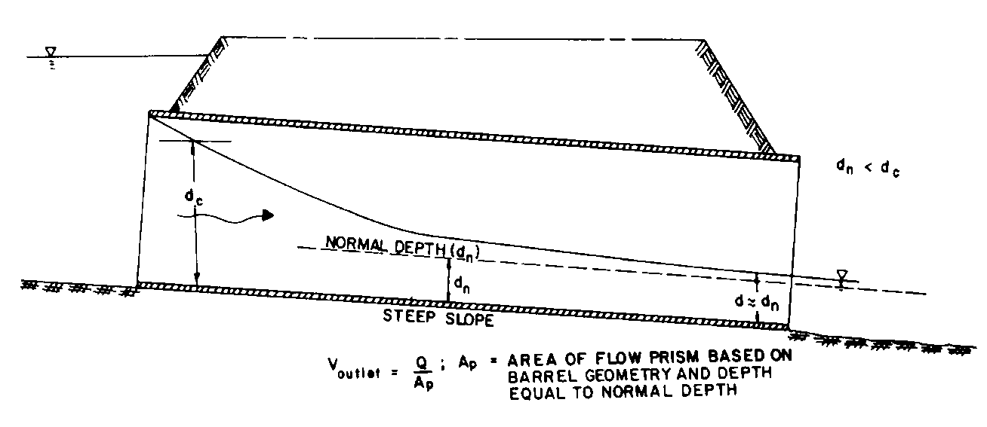
Figure 8-6. Outlet Velocity - Inlet Control

Outlet Control
The cross sectional area of the flow is defined by the geometry of the outlet and either critical depth, tailwater (downstream channel) depth, or the height of the conduit.
- Critical depth is used when the tailwater is less than critical depth
- Tailwater depth is used when tailwater is greater than critical depth, but below the top of the barrel
- The total barrel area is used when the tailwater level exceeds the top of the barrel
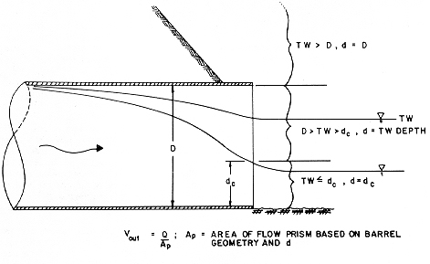
Figure 8-7. Outlet Velocity - Outlet Control

Roadway Overtopping
Roadway overtopping will begin when the culvert headwater rises to the elevation of the roadway. The overtopping will usually occur at the low point of a sag vertical curve on the roadway. The flow will be similar to flow over a broad crested weir. Flow coefficients for flow overtopping roadway embankments are found in the FHWA's HDS No. 1, Hydraulics of Bridge Waterways. Curves for discharge coefficients are also included in Appendix 8C-60.

Length of Roadway Crest
The length of the roadway (weir) crest is difficult to determine when the crest is defined by a roadway sag vertical curve. It is recommended that the sag vertical curve be subdivided into a series of segments. The flow over each segment is then calculated for a given headwater. The flows for each segment are then added together to determine the total flow. Alternatively, the entire length can be represented by a single horizontal line (one segment). The length of the weir is the horizontal length of this segment. The depth is the average depth (area/length) of the upstream pool above the roadway. The computer program HY8 allows input of the actual road surface x and y coordinates.

Total Flow
The flow over the roadway is calculated for a given upstream water surface elevation using Equation 8.9.

(8.9)
Where:
Q_{r} = Overtopping flow rate, cfs
C_{d} = Overtopping discharge coefficient (weir coefficient) = k_{t} C_{r}
k_{t} = Submergence coefficient
C_{r} = Discharge coefficient
L = Length of the roadway crest, ft
HW_{r} = Headwater depth, measured above the roadway crest, ft
- Roadway overflow plus culvert flow must equal the total design flow
- A trial-and-error process is necessary to determine the flow passing through the culvert and the amount flowing across the roadway for various headwater elevations
- Performance curves for the culvert and the road overflow may be summed to yield an overall performance curve
Computer programs such as HY8 are recommended for design when evaluating roadway overtopping.

Performance Curves
Performance curves are plots of flow rate versus headwater depth or water surface elevation. The culvert performance curve is made up of the controlling portions of the individual performance curves for each of the following control sections as shown in Figure 8-8:
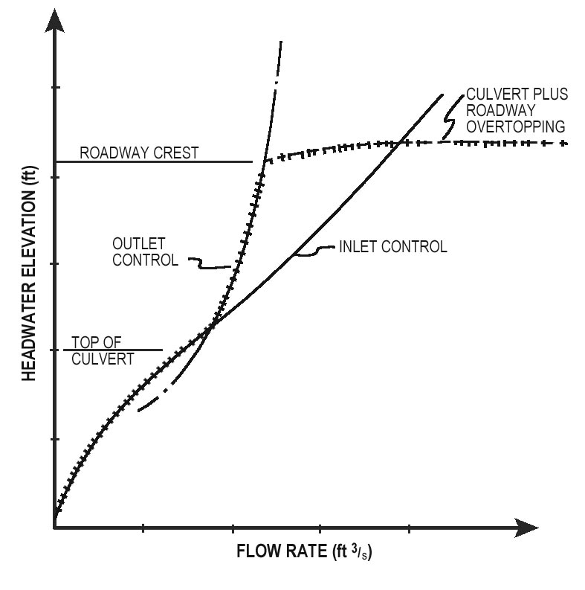
Figure 8-8. Overall Culvert Performance Curve
- Inlet control performance curve is developed using the inlet control nomographs in Appendix 8C
- Outlet control performance curve is developed using Equations 8.1 through 8.7, the outlet control nomographs in Appendix 8C, or backwater calculations
- Roadway overtopping performance curve is developed using Equation 8.9
- Overall performance curve is the sum of the flow through the culvert and the flow across the roadway and can be determined by performing the following steps
Step 1. Select a range of flow rates and determine the corresponding headwater elevations for the culvert flow alone. These flow rates should fall above and below the design discharge and cover the entire flow range of interest. Both inlet and outlet control headwaters should be calculated.
Step 2. Combine the inlet and outlet control performance curves to define a single performance curve for the culvert.
Step 3. When the culvert headwater elevations exceed the roadway crest elevation, overtopping will occur. Calculate the upstream water surface depth above the roadway for each selected flow rate. Use these water surface depths and Equation 8.9 to calculate flow rates across the roadway.
Step 4. Add the culvert flow and the roadway overtopping flow at the corresponding headwater elevations to obtain the overall culvert performance curve, as shown in Figure 8-8.

Special Design Considerations

General
The following sections describe and discuss special culvert design considerations. References are provided for the detailed design methods.

Tapered Inlets
A tapered inlet is a flared culvert inlet with an enlarged face section and a hydraulically efficient throat section. A tapered inlet with additional depression at the upstream end also improves performance by increasing the head applied to the throat section.
- Tapered inlets are not recommended for use on short culverts or culverts flowing in outlet control because the simple beveled edge is of equal hydraulic benefit
- Design criteria and methods have been developed for two basic tapered inlet designs: the side-tapered inlet and the slope-tapered inlet
- Tapered inlet design charts from FHWA's HDS-5 for both rectangular box culverts and circular pipe culverts are included in Appendix 8C.
Tapered inlets have several possible control sections including the face, the bend (for slope-tapered inlets), and the throat. The headwater depth for each control section is referenced to the invert of that section.

Side-Tapered Inlets
The side-tapered inlet has an enlarged face section with the transition to the culvert barrel accomplished by tapering the sidewalls (Figure 8-9). The face section is about the same height, as the barrel height and the inlet floor is an extension of the barrel floor. The inlet roof may slope upward slightly, provided that the face height does not exceed the barrel height by more than 10 percent (1.1D). The intersection of the tapered sidewalls and the barrel is defined as the throat section. There are two possible control sections, the face and the throat. HW_{f}, shown in Figure 8-9, is the headwater depth measured from the face section invert and HW_{t} is the headwater depth measured from the throat section invert. The throat of a side-tapered inlet is a very efficient control section. The flow contraction is nearly eliminated at the throat.
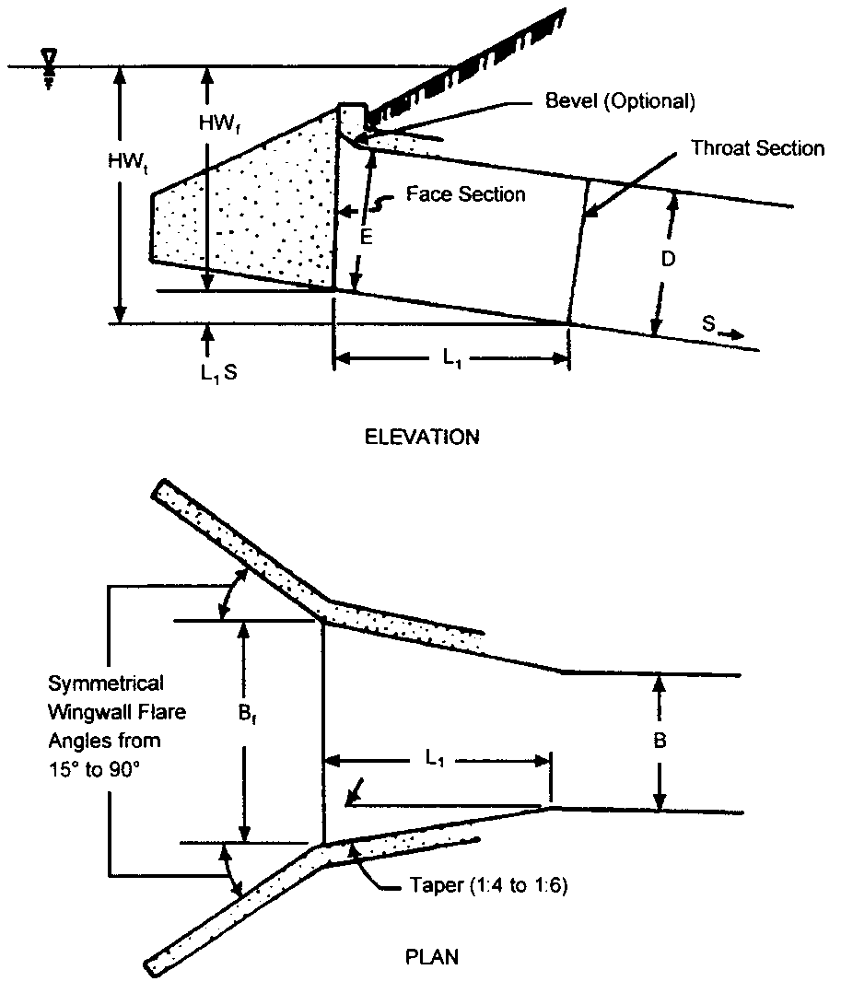
Figure 8-9. Side-Tapered Inlet

The side-tapered inlet throat should be designed to be the primary control section for the design range of flows and headwaters.

Slope-Tapered Inlets
The slope-tapered inlet, like the side-tapered inlet, has an enlarged face section with tapered sidewalls meeting the culvert barrel walls at the throat section as shown in Figure 8-10). In addition, a vertical FALL is incorporated into the inlet between the face and throat sections. This FALL concentrates more head on the throat section. At the location where the steeper slope of the inlet intersects the flatter slope of the barrel, a third section, designated the bend section, is formed. Therefore, a slope-tapered inlet has three possible control sections, the face, the bend, and the throat.
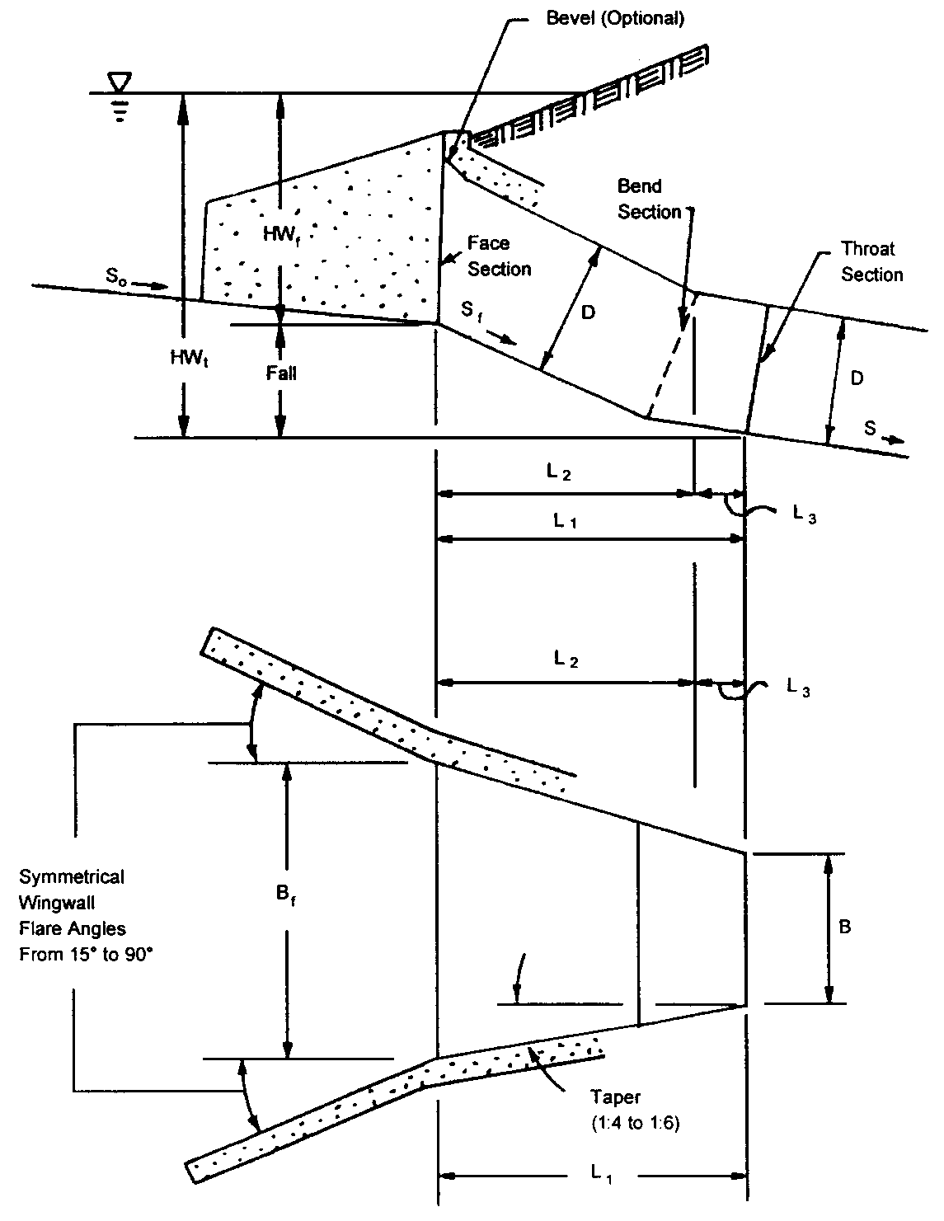
Figure 8-10. Slope-Tapered Inlet

The slope-tapered inlet combines an efficient throat section with additional head exerted on the throat. The face section does not benefit from the FALL between the face and throat; therefore, the face sections of these inlets are larger than the face sections of equivalent depressed side-tapered inlets. The required face size can be reduced by the use of bevels or other favorable edge configurations. The slope-tapered inlet is the most complex inlet improvement recommended in this drainage manual. Construction difficulties are inherent, but the benefits in increased performance can be significant. With proper design, a slope-tapered inlet passes more flow at a given headwater elevation than any other configuration. Slope-tapered inlets can be applied to both box culverts and circular pipe culverts. The slope-tapered inlet throat should be the primary control section in a slope-tapered inlet design.
HDS-5, Hydraulic Design of Highway Culverts, contains complete design methodology and design charts and forms for culverts with improved inlets. Most of the design charts have been included in Appendix 8C.

Buoyancy Protection
The buoyancy of a pipeline depends upon the weight of the pipe, the weight of the volume of water displaced by the pipe, the weight of the liquid load carried by the pipe and the weight of the backfill over the pipe. Lighter weight pipe materials are generally more susceptible to uplift forces than heavier materials.
If the summation of the weight of the pipe, weight of the water in the pipe (based on normal depth) and the weight of the fill over the pipe is less than the hydrostatic uplift (buoyant) forces acting upon the pipe, additional weight must be added to the pipe in order to stabilize it for the design conditions. The normal depth for determining buoyancy protection should be either the Q₁₀₀ headwater depth of the depth of overtopping, whichever is less.
A concrete endwall will usually provide sufficient weight to counteract potential buoyant forces. However, in low fill situations it is usually more desirable and economical to use end sections in lieu of endwalls or, in the case of secondary roadways, pipes are often installed projecting beyond the embankment slopes with no end treatment. In these situations, a concrete anchor block (counterweight) must be designed for each installation where it is determined that flotation may be a potential problem.
In Section 8.5.3, a procedure is outlined (with example) showing how to analyze a pipe installation for flotation potential and, where it is determined that there is a potential problem, how to determine the amount of counterweight needed.

Design Procedures and Examples

Documentation Requirements
These items establish a minimum documentation requirement for culvert design. The following items used in the design or analysis should be included in the documentation file:
- Allowable headwater elevation and basis for its selection
- Cross section(s) used in the design highwater determinations
- Roughness coefficient assignments (n-values)
- Observed highwater, dates and discharges
- Stage discharge curve at outlet for undisturbed, existing and proposed conditions to include the depth and velocity measurements or estimates and locations for the design, and check floods
- Documentation showing the calculated backwater elevations, outlet velocities, scour for the design storm, check storm and any available historical floods
- Type of culvert entrance condition
- Culvert outlet appurtenances and energy dissipation calculations and designs
- Copies of all computer analyses, such as HY8 output, and VDOT Form LD-269 (Appendix 8B-1) if the culvert was designed manually
- Roadway geometry (plan and profile)
- Potential flood hazard to adjacent properties
All hydrologic and hydraulic design computations and all maps, studies, reports, comments and interviews pertinent to the culvert design must be concisely and legibly recorded in a form that can be easily filed and microfilmed for ready recall. This data must remain easily accessible for reference when filing for permits and when future changes or designs are made.
In most cases, the design flood, the overtopping flood, and the 100-year flood should be shown in the culvert design documentation. The use of the VDOT culvert form (LD-269) in Appendix 8B-1 provides a convenient form on which to record the pertinent data.

VDOT Culvert Design Procedure
The following design procedure provides a convenient and organized method for designing culverts for a constant discharge, considering inlet and outlet control. The procedure does not address the effect of storage, which is discussed in Chapter 11, Stormwater Management.
- The designer should be familiar with all of the equations in Section 8.4 before using these procedures
- Following the design method without an understanding of culvert hydraulics can result in an inadequate, unsafe, or overly costly structure
- The culvert calculation form has been provided in Appendix 8B-1 to guide the user. It contains blocks for the project description, designer's identification, hydrologic data, culvert dimensions and elevations, roadway controls and property elevations, trial culvert description, inlet and outlet control HW, culvert barrel selected, and comments.
Step 1 Assemble site data and project file
a. The minimum site data are:
- USGS, site and location map
- Embankment cross section
- Roadway profile
- Photographs
- Field visit (sediment, debris)
- Design data at nearby structures
- Existing utilities
b. Studies by other agencies including:
- Small dams — NRCS, USCOE, TVA, BLM
- Canals — NRCS, USCOE, TVA, USBR
- Floodplain — NRCS, USCOE, TVA, FEMA, USGS, NOAA
- Storm drain - local or private
c. Environmental constraints including:
- Commitments contained in review documents
- Commitments contained in permits or permit applications
- Fish migration
- Wildlife passage
- Wetlands resources
d. Design criteria:
- Review Section 8.3 for applicable criteria
- Prepare risk assessment or analysis, if needed
Step 2 Determine hydrology
- See Chapter 6, Hydrology
- Minimum data are drainage area map and a discharge-frequency plot
Step 3 Design downstream channel
- See Chapter 7, Ditches and Channels
- Minimum data are geometry and the rating curve for the channel that provides tailwater elevations for various flood frequencies
Step 4 Summarize data on design form
- Enter data from steps 1-3

Step 5 Select design alternative
- See Section 8.3.3, Geometric Criteria
- Choose culvert material, shape, and entrance type
- Consider flow line, cover, and utilities

Step 6 Select design discharge (Q_{d})
- See Section 8.3.2 Hydraulic Criteria
- Determine flood frequency from criteria
- Determine Q from discharge-frequency plot (Step 2)
- Divide Q by the number of barrels
- Select trial size

Step 7 Determine inlet control headwater depth (HW_{i})
- Use the appropriate inlet control nomographs in Appendix 8C

Step 8 Determine outlet control headwater depth at inlet (HW_{oi}):
- Calculate the tailwater depth (TW) using the design flow rate and normal depth (single section), using a water surface profile, or obtain it from other sources
- Calculate critical depth (d_{c}) using the appropriate chart in Appendix 8C
- Locate flow rate and read d_{c}
- d_{c} cannot exceed D
- If d_{c}>0.9D, consult Handbook of Hydraulics (King and Brater) for a more accurate d_{c}, if needed, since curves are truncated where they converge
- Calculate
- Determine h_{o}
h_{o} = the larger of TW or
- Determine K_{e}
- Entrance loss coefficient from Appendix 8D-2
- Determine losses through the culvert barrel (H)
- Use the nomographs in Appendix 8C or Equation 8.5 or 8.6 if outside range of nomograph scales

h. Calculate outlet control headwater (HW_{oi})
- Use Equation 8.8, if V_{u} and V_{d} are neglected:
- Add other losses (bends, grates, etc.) to right side of equation.
- Use Equation 8.1, 8.4c and 8.6 to include V_{u} and V_{d}.
- If HW_{oi} is less than 1.2D and control is outlet control:

- The barrel may flow partly full
- The approximate method of using the greater of tailwater or may not be applicable
- Backwater calculations should be used to check the result
- If the headwater depth falls below 0.75D, the approximate nomograph should not be used
Step 9 Determine controlling headwater (HW_{c})
a. Compare HW_{i} and HW_{oi}, and use the higher
b. Compare HW to allowable HW criteria (cover, , shoulder)
Step 10 Compute discharge over the roadway (Q_{r}) if applicable (See Section 8.4.3.6)
Step 11 Compute total discharge (Q_{t})
Step 12 Calculate outlet velocity (V_{o}) and normal depth (d_{n})
If inlet control is the controlling headwater:
- Calculate flow depth at culvert exit
- Use normal depth (d_{n}), or
- Use water surface profile

- Calculate flow area (A).
- Calculate exit velocity,
If outlet control is the controlling headwater:
a. Calculate flow depth at culvert exit
- Use (d_{c}) if d_{c} > TW
- Use (TW) if d_{c} < TW < D
- Use (D) if D < TW

b. Calculate flow area (A)
c. Calculate exit velocity,
Step 13 Review results
Compare alternative design with constraints and assumptions. If any of the following are exceeded, repeat steps 5 through 12:
- The barrel must have adequate cover
- The length should be close to the approximate length
- The headwalls and wingwalls must fit the site
- The allowable headwater should not be exceeded and should be at least 1.0 and not exceed 1.5
- The allowable overtopping flood frequency should not be exceeded
Step 14 Select and analyze check storm discharge
Step 15 Related designs
Consider the following options (See Sections 8.3.6 and 8.4.4 and Chapter 11, Stormwater Management):
- Tapered inlets if culvert is extremely long, in inlet control, and has limited available headwater
- Flood routing if a large upstream headwater pool exits
- Energy dissipators or standard EC-1, as needed, in accordance with Table 8-1. Special design energy dissipators may be required. Appendix 8E-1 contains procedures and discussion for a riprap basin
- Weirs, if needed to maintain low flow through multiple barrel culverts

Culvert Design Sample Problems
The following example problem follows the Design Procedure Steps described in Section 8.5.2.
Step 1. Assemble Site Data and Project File
a. Site survey project file contains:
- USGS, site, and location maps
- Roadway profile, and
- Embankment cross-section

b. Site visit notes indicate:
- No sediment or debris problems
- No nearby structures
- Studies by other agencies - none

c. Environmental, risk assessment shows:
- No buildings near floodplain
- No sensitive floodplain values
- No FEMA involvement
- Convenient detours exist

d. Design criteria:
- 50-year frequency for design, and
- 100-year frequency for check storm
- Allowable headwater depth for design flood = 8.5 ft.
- 100-year floodplain depth = 10.0 ft.

Step 2. Determine Hydrology
USGS Regression equations yield:
Q₅₀ = 400 cfs
Q₁₀₀ = 500 cfs
Step 3. Account for tailwater
Slope = 0.05 ft./ft.
Length = 100 ft.
The predetermined depths and velocities for the downstream channel are:

Q  (cfs) | TW  (ft) | V  (ft/s)
400 | 2.8 | 18
500 | 3.1 | 19
Step 4. Summarize data on design form
(See Figure 8-11)
Step 5. Select trial design structure
Shape: Box
Size: 7.0 ft (B) by 6.0 ft (D)
Material: Concrete
Entrance: Wingwalls with 30º-75º flare
Step 6. Select design discharge
Q_{d} = Q₅₀ = 400 cfs
Step 7. Determine inlet control headwater depth (HW_{i})
Use inlet control nomograph - Appendix 8C-8
a. D = 6.0 ft
b. cfs
c.
d. (Neglect the approach velocity.)
Step 8. Determine outlet control headwater depth at inlet (HW_{oi}):
a. TW = 2.8 ft. for Q₅₀ = 400 cfs
b. d_{c} = 4.6 ft. from Appendix 8C-14
c.
d. h_{o} = the larger of TW or = 5.3 ft.
e. K_{e} = 0.4 from Appendix 8D-2 (for 30º-75º wingwalls)
f. Determine (H) - use Appendix 8C-15
- K_{e} scale = 0.4
- Culvert length, L = 100 ft.
- n = 0.012 (same as on Appendix 8C-15)
- Area = 42 sq. ft.
- H = 2.3 ft.
g.

Step 9. Determine controlling headwater (HW_{c})
HW_{i} = 7.80 ft.
HW_{oi} = 2.5 ft.
HW_{c} = The greater of HW_{i} or HW_{oi}
HW_{c} = HW_{i} = 7.80 ft.
The culvert is in inlet control
Step 10. Compute discharge over the roadway (Q_{r} )
Not applicable
Step 11. Compute total discharge (Q_{r})
Q_{t} = 400 cfs
Step 12. Determine outlet velocity (V_{o})
- Use Appendix 8C-83
- Enter 400 cfs on the horizontal, “Discharge” scale
- Read vertically to the “Slope” curve of 0.05
- Read horizontally to the “Velocity" scale and find a value of 27 fps
Step 13. Repeat steps 5-10 for check flood (100-yr.):
- Compare design with constraints and assumptions. If any of the following are exceeded, repeat steps 5 through 12:
- 100-year floodplain depth = 10.0 ft.>9.6 ft.
- Overtopping flood frequency > 50-yr.

Step 14. Design Considerations (None)
Step 15. Complete any additional necessary documentation
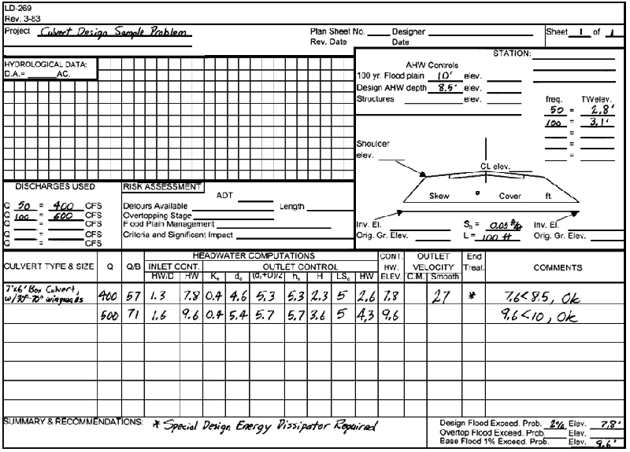
Figure 8-11. Completed Culvert Design Form, Sample Problem

Buoyancy Protection Procedure
Note: A software program is available from VDOT that performs this procedure.

Hydrostatic Uplift and Resistance
- Resistance = Weight of pipe + Weight of water (in pipe) + Weight of fill (over pipe), lbs/ft.
- Hydrostatic Uplift (Buoyant) Force = Weight of water displaced by the pipe, lbs. per ft.
- The following average values can be used in the analysis:
Weight of Pipe - See manufacturer's weight tables for type and size of pipe specified.
Weight of Fill (Dry) - 100 lbs. per cubic foot
Weight of Fill (Saturated) - 37.6 lbs. per cubic foot
Weight of Water - 62.4 lbs. per cubic foot
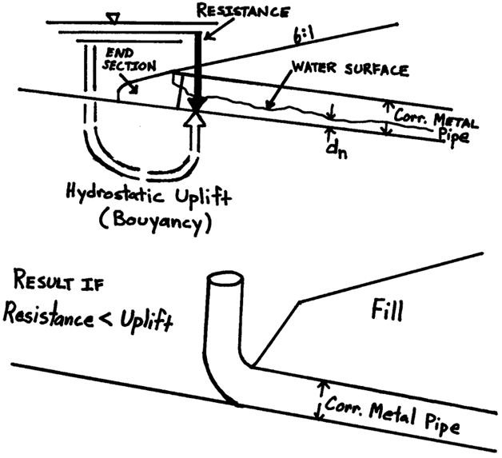
Figure 8-12. Hydrostatic Uplift Forces and Effects on Pipe

If Resistance < Hydrostatic Uplift:
Increase weight on end of pipe by adding concrete endwall or concrete anchor blocks.

Buoyancy Protection Sample Problem
Given:
48-inch Corrugated Metal Pipe, 12 gage
Fully Coated with Paved Invert
Std. ES-2 End Section
Q = 96 cfs
Computed Values:
HW/D = 1.25
HW= 5 ft.
d_{n}= 2.5 ft.
d_{c}= 2.8 ft.
Assumed Values:
Weight of Fill (Dry) = 100 lbs. per cu. ft.
Weight of Fill (Saturated) = 37.6 lbs. per cu. ft.
Weight of Water = 62.4 lbs. per cu. ft.
Weight of Pipe = 84 lbs. per L.F.
(Handling weight of corrugated steel pipe available
in Appendix 8F-1 and 8F-2)

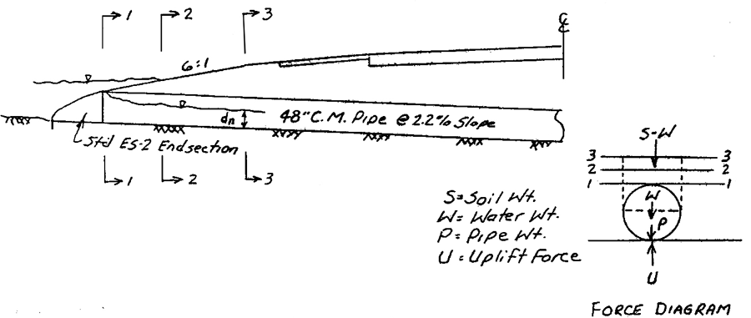
Figure 8-13. Buoyant Forces Acting on Pipe

Step 1: Compute buoyant force acting on pipe
(At any section along length of pipe)

Buoyant force (lbs./ft.) = Weight of water displaced by pipe (lbs./cu. ft.)
Buoyant force =

Where:
L = Unit length of pipe, ft
A = Cross sectional area of pipe, sq. ft.
γ = Unit weight of water = 62.4 lbs/ft³

Step 2: Compute total surcharge at section 1
(Located at inlet end of pipe)
Surcharge (lbs./ft.) = Wt. of Fill + Wt. of Water + Wt. of Pipe
Compute weight of fill material (Hatched Area, Figure 8-14)
Weight of Fill = Area x 1 ft. x 37.6 lbs./cu. ft. (saturated fill)
Area =
Weight of Fill = 1.7 (1)(37.6)
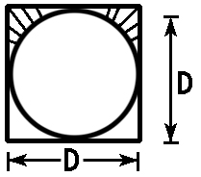
Figure 8-14. Weight
of Fill, Section 1

Weight of Fill = 64 lbs/ft
Compute weight of water (inside pipe)
Weight of Water = Area of flow x 1 ft. x 62.4 lbs./cu. ft.
Assume depth of water, d = d_{n} = 2.5 ft.
(From Appendix 8F-5)
Area of flow = 0.516 x 4 ft.² = 8.26 ft²
Weight of Water = 8.26 ft.² x 1 ft x 62.4 lbs/ft^{3.}
Weight of Water = 515 lbs/ft.

- Determine weight of pipe

84 lbs/ft.

- Compute total surcharge at section 1

Surcharge = Wt. of Fill + Wt. of Water + Wt. of Pipe
Surcharge = 64 + 515 + 84
= 663 lbs/ft.

- Section 1 Summary
Surcharge (663 lbs./ft.) < Buoyant Force (784 lbs./ft.)
Therefore, pipe is unstable at Section 1
Step 3: Compute total surcharge at Section 2
(Section 2 is located where headwater elevation intercepts the fill slope 6 ft from the inlet end of the pipe)
Surcharge (lbs./ft.) = Wt. of Fill + Wt. of Water + Wt. of Pipe
- Compute weight of fill material (Hatched Area, Figure 8-15)

Weight of Fill = Area ft² x 1 ft. x 37.6 lbs./ft³ (saturated fill)
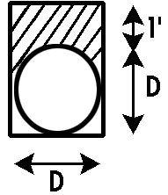
Weight of Fill = 5.7 ft.² x 1 ft. x 37.6 lbs./ft³
Weight of Fill = 214 lbs/ft.
- Compute weight of water (Inside Pipe)
Assume depth of water, d = d_{n} = 2.5 ft.
Weight of Water = 515 lbs./ft.
(Same as Section 1)
Figure 8-15. Weight of Fill Material, Section 2

- Determine weight of pipe
84 lbs./ft. (Same as Section 1)
- Compute total surcharge at Section 1
Surcharge (lbs./ft.) = Wt. Fill + Wt. Water + Wt. Pipe
Surcharge = 214 + 515 + 84 = 813 lbs./ft.
- Section 2 Summary
Surcharge (813 lbs./ft.) > Buoyant Force (784 lbs./ft.)
Therefore, pipe is stable at Section 2
Step 4: Determine minimum weight required to counteract buoyant force
a. Plot a graph of length along the pipe (from inlet end) versus total surcharge buoyancy (weight). Let the horizontal axis represent the length along the pipe (ft.) and the vertical axis represent the surcharge/buoyancy (lbs./ft) as shown in Figure 8-16.
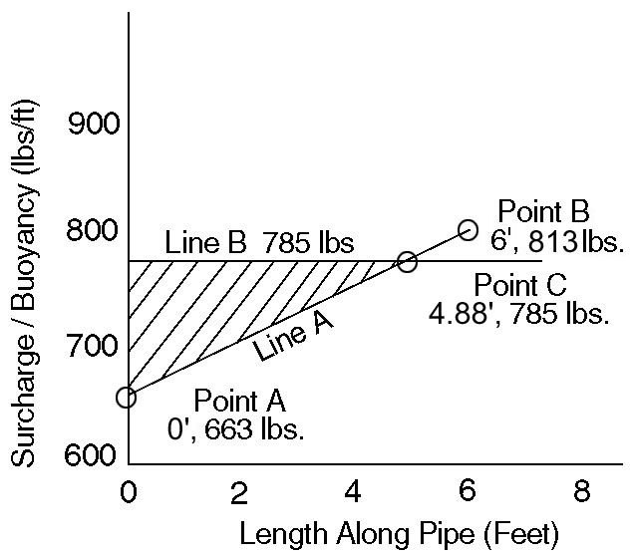
Figure 8-16. Surcharge/Buoyancy along Length of Pipe
b. Plot the values of length along pipe and total surcharge for Section 1 (from Step 2) and Section 2 (from Step 2) on the graph (Points A and B) and connect them with a straight line (Line A).

c. Plot horizontal line (Line B) on the graph representing the buoyant force computed in Step 1.

d. The area of the triangle formed by Line A, Line B and the vertical axis of the graph (hatched area) represents the minimum weight required to balance the uplift (buoyant) force.

e. Determine minimum required weight (area of triangle).
1) Using ratio and proportion analysis, determine length along horizontal axis where Line A and Line B intersect (Point C).
Find intersection (Point C) at 4.88 ft.
2) Weight (Area) = (Vertical side x Horizontal side)/2.
3) Weight = (122 lbs./ft. x 4.88 ft.) / 2 = 298 lbs.
f. Determine minimum weight of required anchor block. Set minimum weight of anchor block equal to the greater of:
1) The required additional weight (Step 4e) plus 100 lbs. or
2) 1.5 times the required additional weight (Step 4e).
g. Determine size of required anchor block.
1) Use minimum size anchor block if its weight is equal to or greater than minimum weight required (Step f).
    - If minimum weight required (Step f) is greater than weight of minimum size anchor block, increase dimensions of minimum size anchor block to provide weight equal to or greater than minimum required weight (Step f).
Typical counterweight details are shown in Figure 8-17. Dimensions for the weight of minimum size counterweight can be found in Appendix 8F-3.
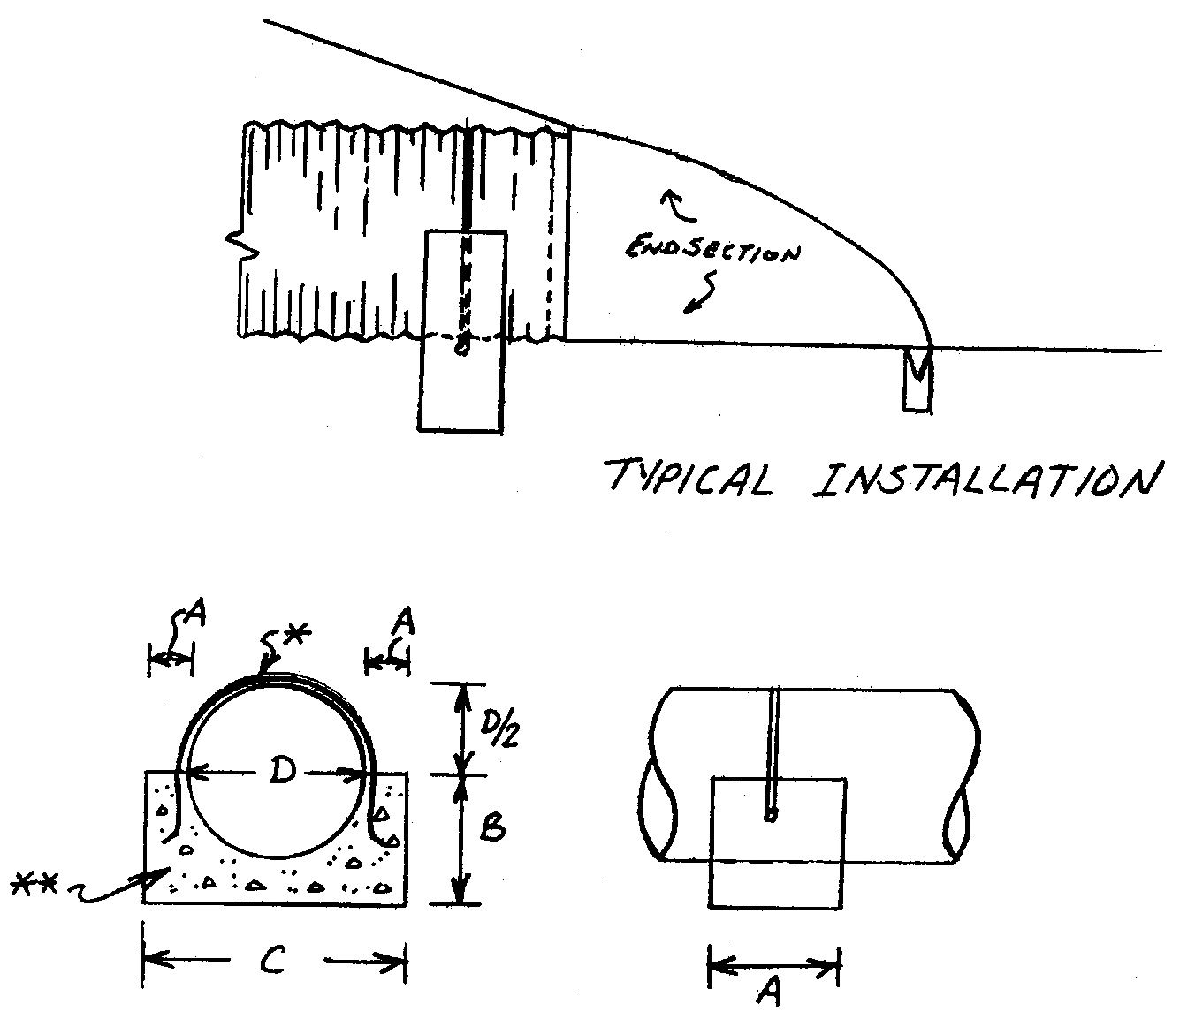
Figure 8-17. Counterweight Details for Pipes Subject to Uplift Forces
*1/2-inch diameter steel rod to be field bent as necessary and embedded in fresh concrete
** Class A-3 concrete

Dimensions:
A=Variable as needed, 6-inch minimum
B=D/2+12 inch
C=Variable as needed, D+12 inch minimum
D=Pipe diameter

References
Normann, J.M., R.J. Houghtalen, and W.J. Johnston. Hydraulic Design of Highway Culverts, HDS No. 5, FHWA-IP-85-15, FHWA, Washington, D.C. 20590. 1985.
Young, G.K., and J.S. Krolak. HYDRAIN — Integrated Drainage Design Computer System, Volumes 1-6, FHWA-RD-88-120, FHWA. 1987.
Ginsberg, A. HY8 — Culvert Analysis Microcomputer Program, Applications Guide, FHWA-EPD-87-101, and software available from McTrans Center, 512 Weil Hall, University of Florida, Gainesville, Florida.
Task Force on Hydrology and Hydraulics, Subcommittee on Design, American Association of State Highway and Transportation Officials. Guidelines for the Hydraulic Design of Culverts, 341 National Press Bldg., Washington, D.C. 20045. 1975.
Bodhaine, G.L. Measurement of Peak Discharge at Culverts by Indirect Methods, Techniques of Water-Resources Investigations of the USGS, Chapter A3. 1982.
Reihsen, G., and L. J. Harrison. Debris Control Structures, HEC No. 9, Hydraulics Branch, Bridge Division, Office of Engineering, FHWA, Washington, D.C. 20590. August 1971.
Hydraulic Engineering Circular No. 13, "Hydraulic Design of Improved Inlets and Culverts."
Hydraulic Engineering Circular No. 14, "Hydraulic Design of Energy Dissipators for Culverts and Channels."
Jens, S.W. Design of Urban Highway Drainage - The State of the Art, FHWA-TS-79-225, Hydraulics Branch, Bridge Division, Office of Engineering, FHWA, Washington, D.C. 20590. August 1979.
Bureau of Reclamation. Design of Small Canal Structures, Denver, Co. 1974.
Culvert Design System. FHWA-TS-80-245, Hydraulics Section, Wyoming Highway Department, Cheyenne, Wyoming 82001. December 1980.
Design Charts For Open Channel Flow. HDS No. 3, Hydraulics Branch, Bridge Division, Office of Engineering, FHWA, Washington, D.C. 20590. 1973.
Bradley, J.N. Hydraulics of Bridge Waterways, HDS No. 1, Second Edition, Hydraulics Branch, Bridge Division, Office of Engineering, FHWA, Washington, D.C. 20590. September 1973.
Shearman, J.O., W.H. Kirby, V.R. Schneider, and H.N. Flippo. Bridge Waterways Analysis Model, FHWA-RD-86-108, FHWA, Washington, D.C.
King, H.W., and E.F. Brater. Handbook of Hydraulics, Sixth Edition, McGraw-Hill Book Co., 1976.
Policy Memorandum 3-78, "Flood Plain Management Program for State Agencies."
VDOT I&IM LD-01 (D) 121.14.
VDOT Road Designs and Standards - Latest Edition.
VDOT Road and Bridge Specifications - 1982.
VDOT Survey Instructions Manual.

This value of 1.0 foot is to be considered maximum and local conditions may require a lesser value for the particular site'. Also see The Governor of Virginia's Policy Memorandum 3-78 (1)

