Appendix 8F-2 Handling Weight for Corrugated Steel Pipe

(3”x1” or 125 mm x 25 mm Corrugations)

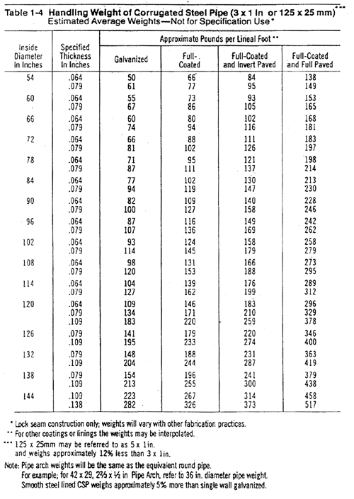

Source:

