Appendix 8C-75 Circular Pipe Flow Chart (Diameter = 72”)
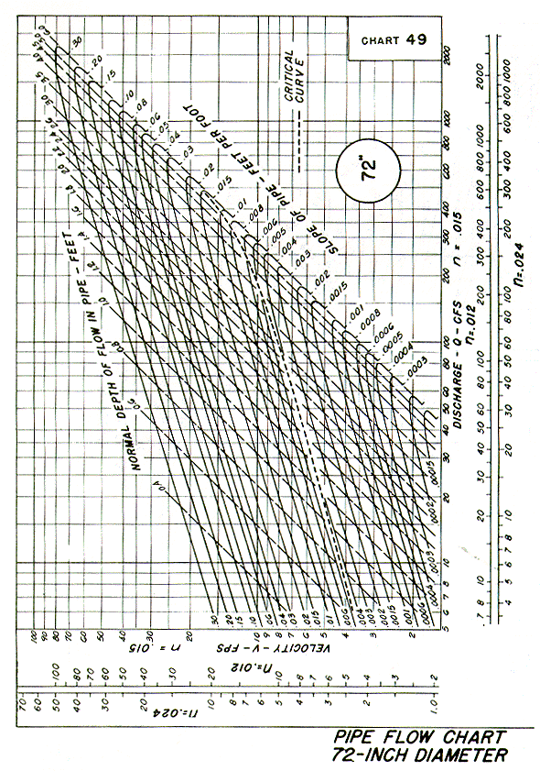
Source: HDS-3

