Appendix 8C-74 Circular Pipe Flow Chart (Diameter = 66”)
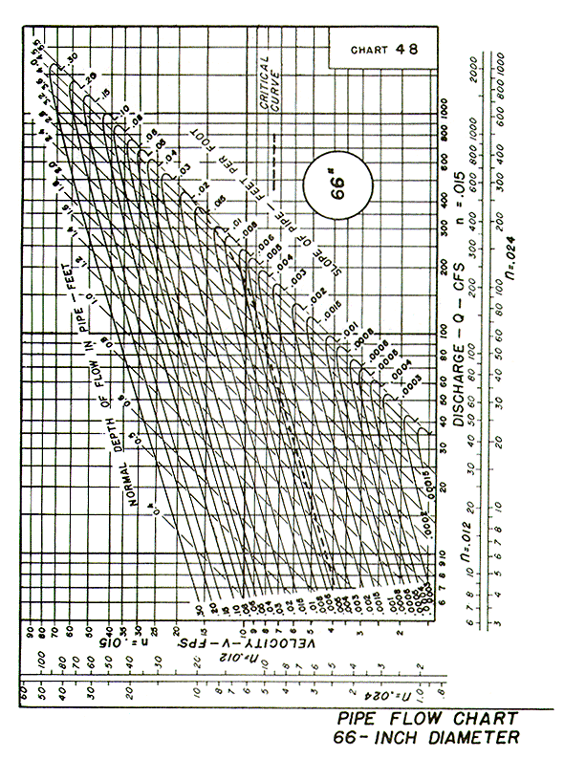

Source: HDS-3

