Appendix 8C-71 Circular Pipe Flow Chart (Diameter 48”)
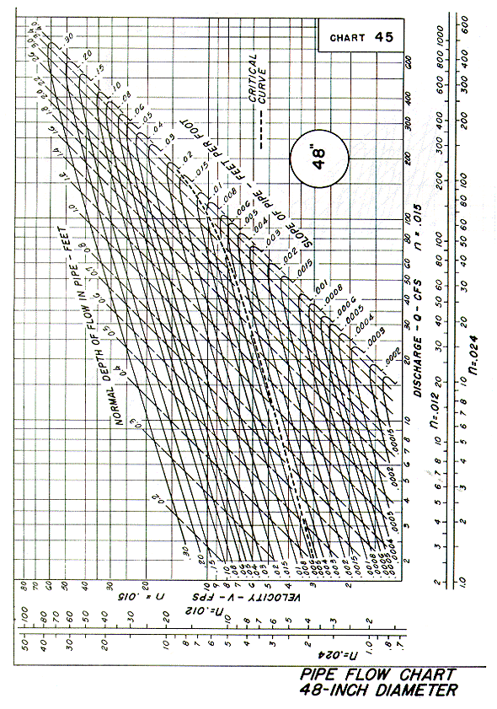
Source: HDS-3

