Appendix 8C-64 Circular Pipe Flow Chart (Diameter = 21”)

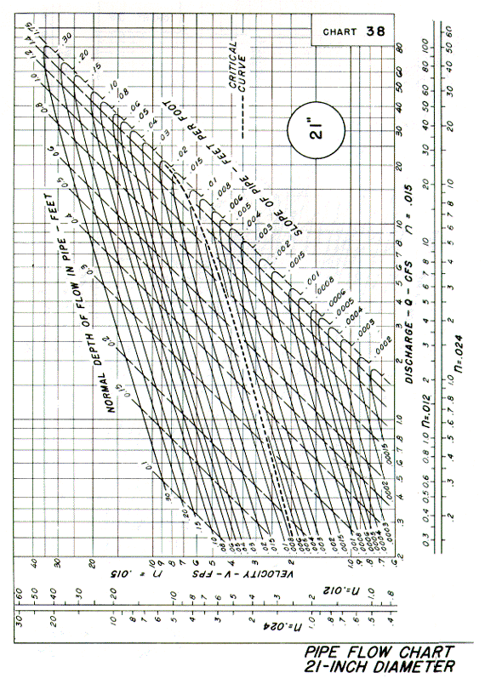
Source: HDS-3

