Appendix 8C-58 Face Control, Box Section, Side-Tapered
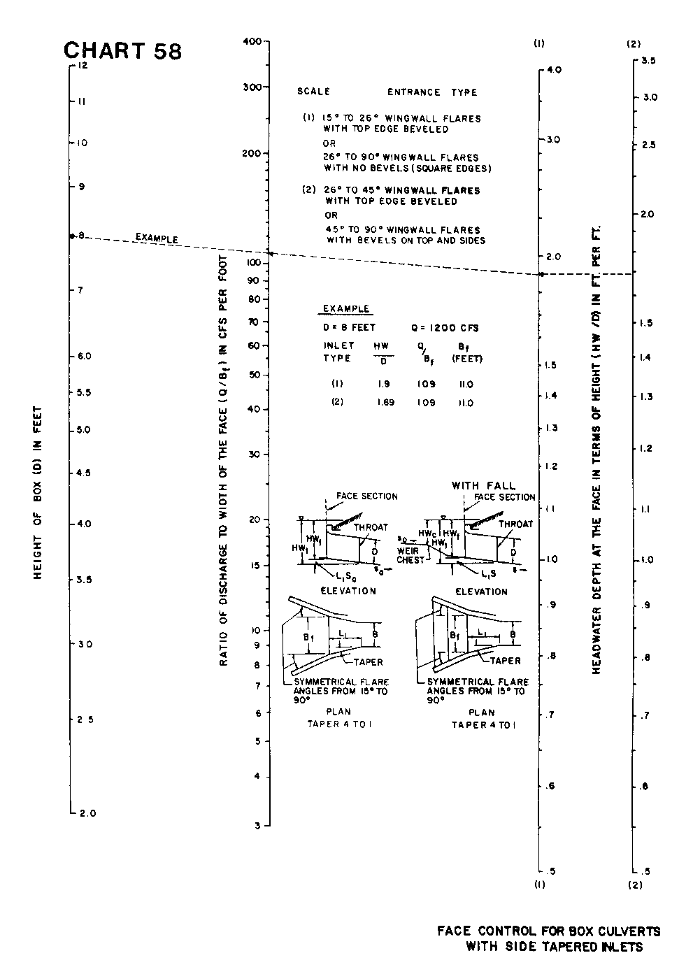

Source: HDS-5

