Appendix 8C-40 Outlet Control,

Structural Plate Corrugated Metal

Pipe-Arch, 18” Corner Radius
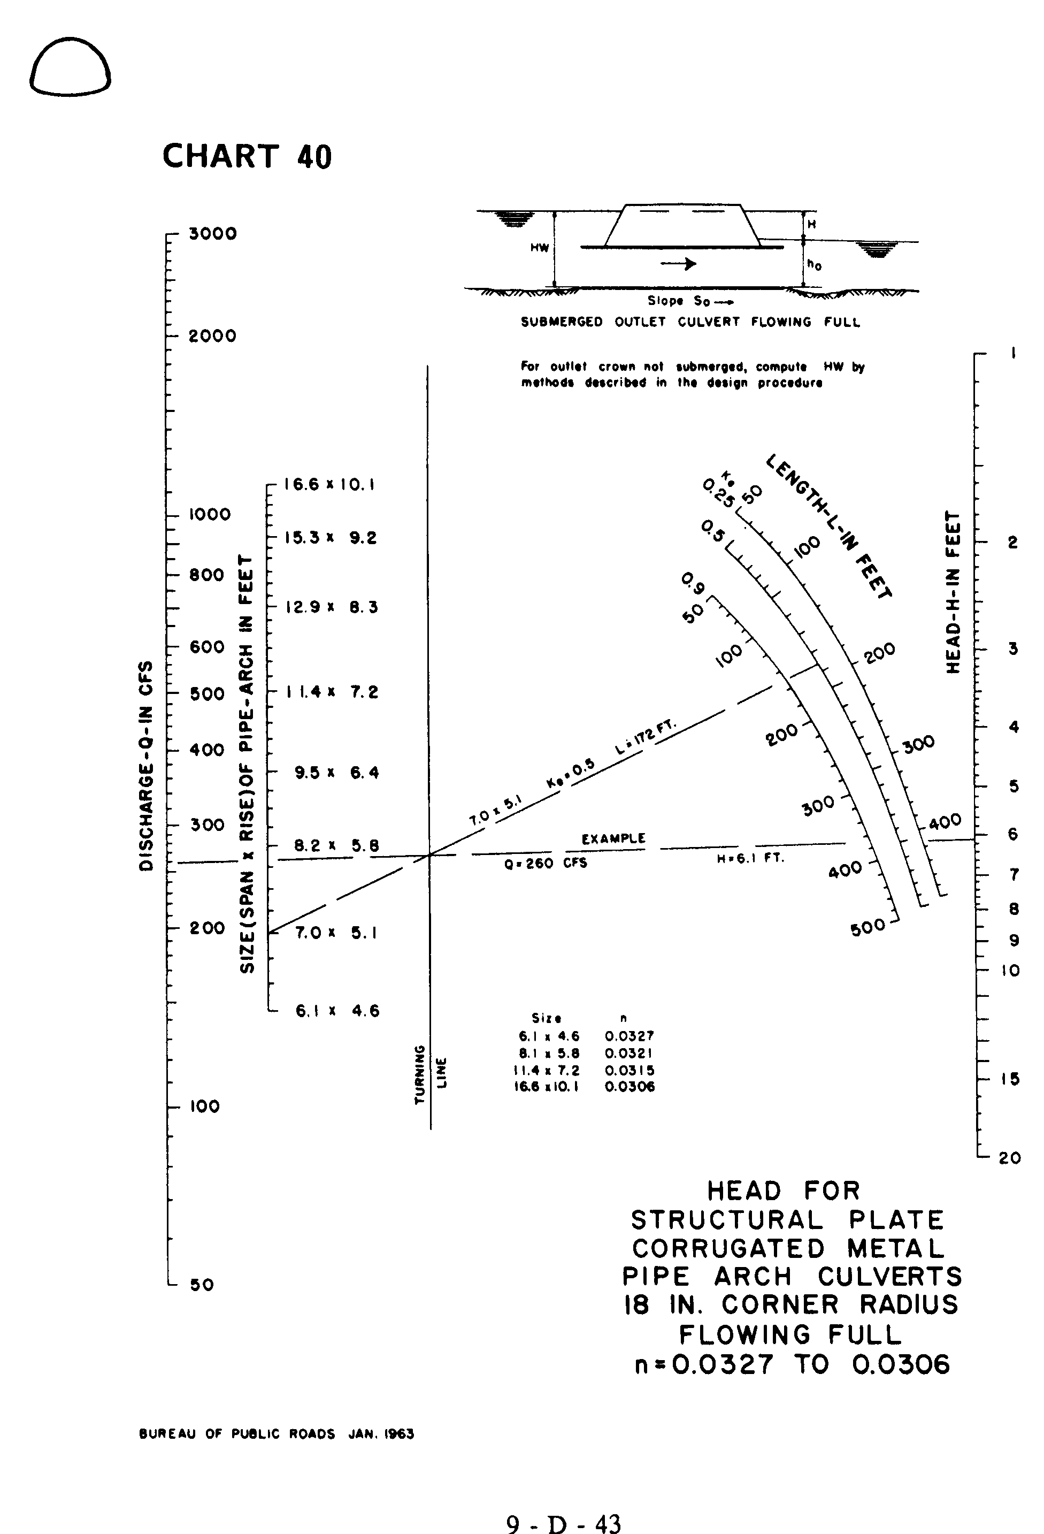

Source: HDS-5

