Appendix 8C-39 Outlet Control, Standard Corrugated

Metal Pipe-Arch
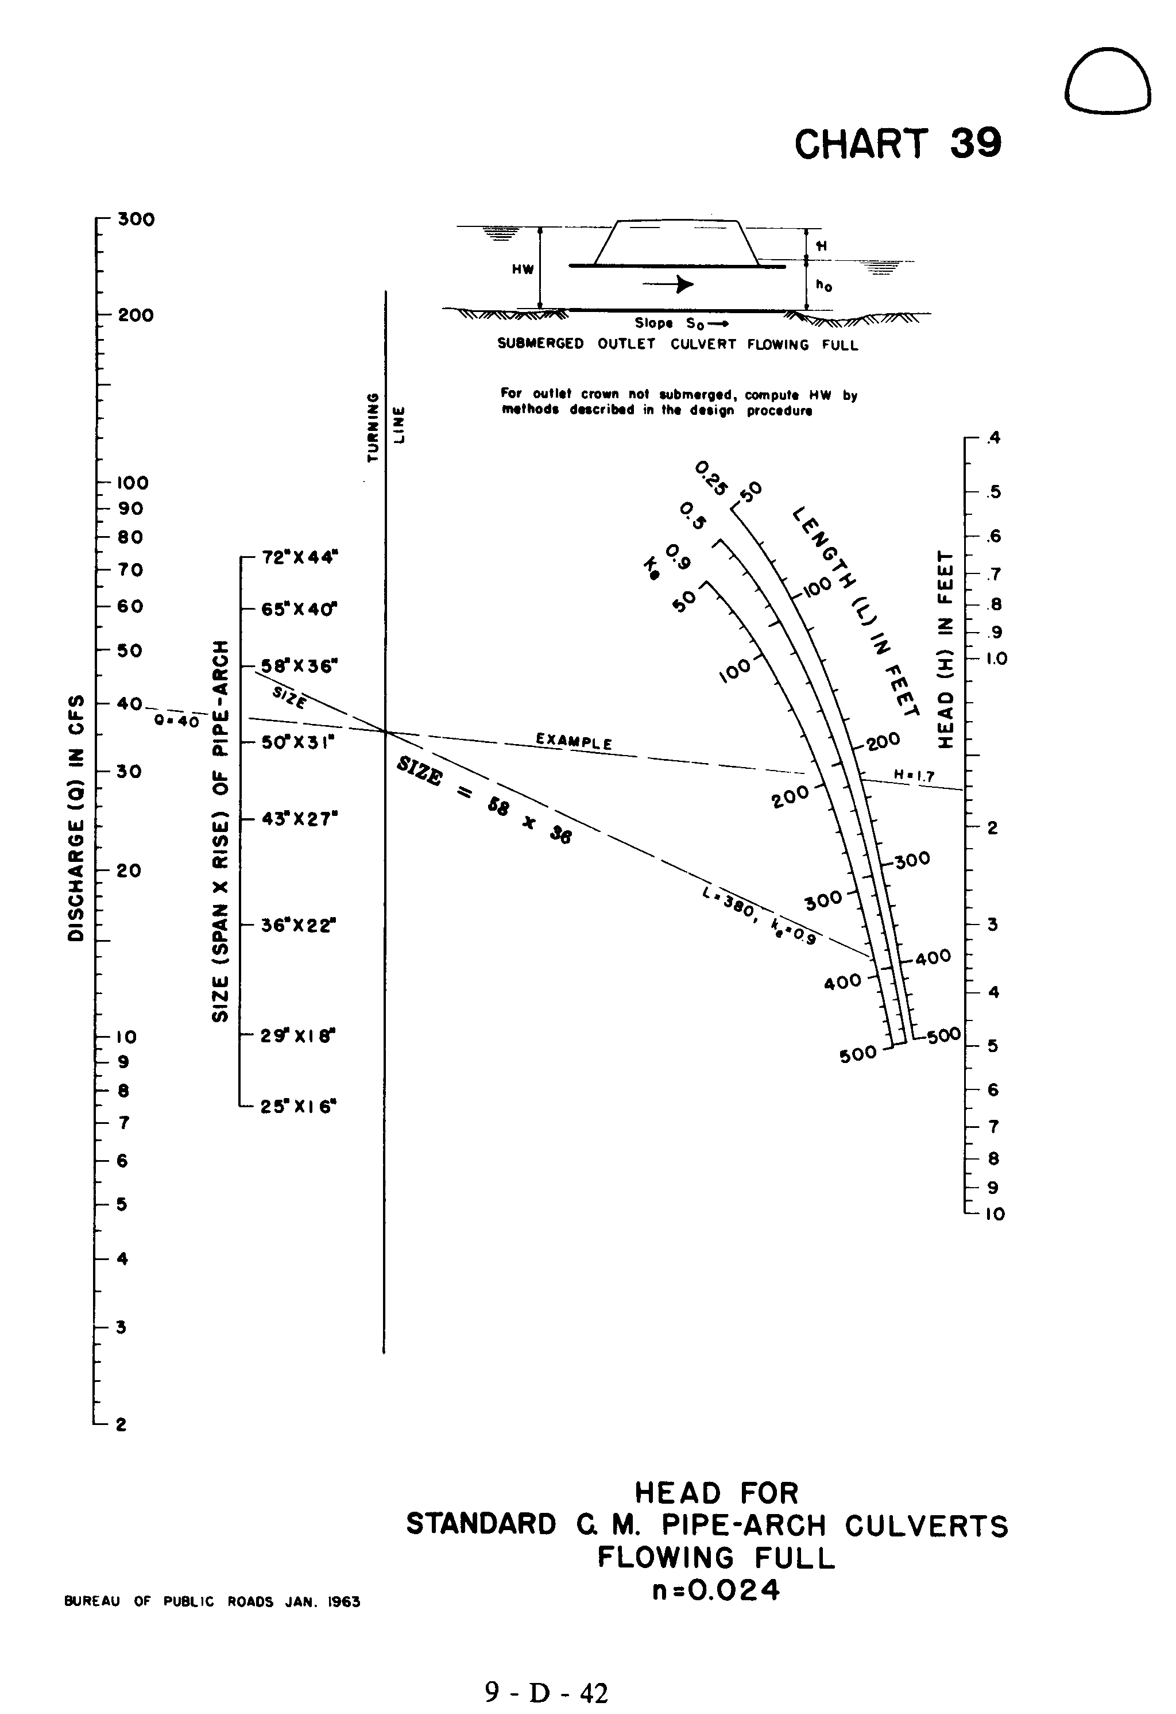

Source: HDS-5

