Appendix 8C-35 Inlet Control,

Structural Plate Pipe-Arch,

18” Corner Radius
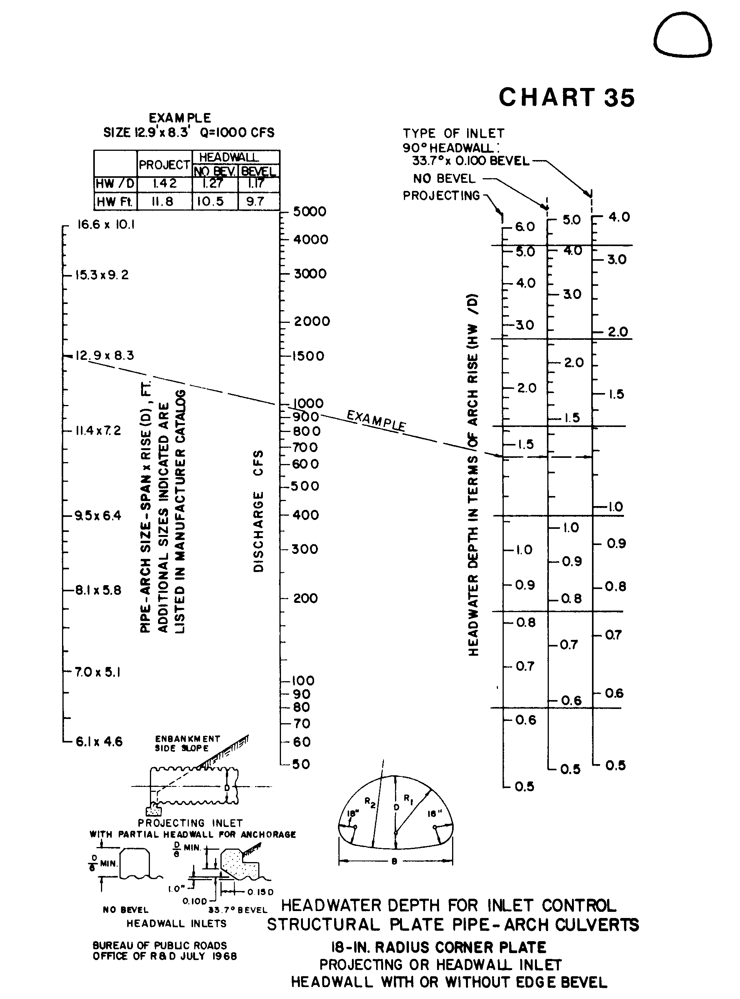

Source: HDS-5

