Appendix 8C-29 Inlet Control, Oval Concrete,

Long Axis Horizontal
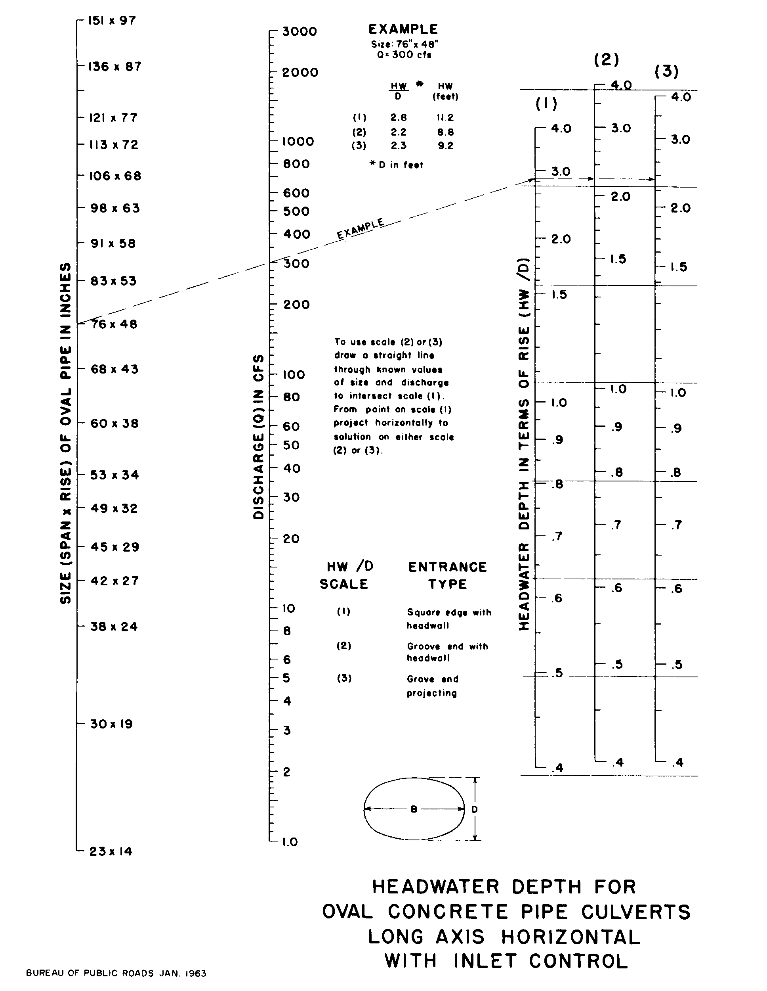

Source: HDS-5

