Appendix 8C-22 Outlet Control,

Corrugated Metal Box, Concrete Bottom

0.3≤ Rise/Span <0.4
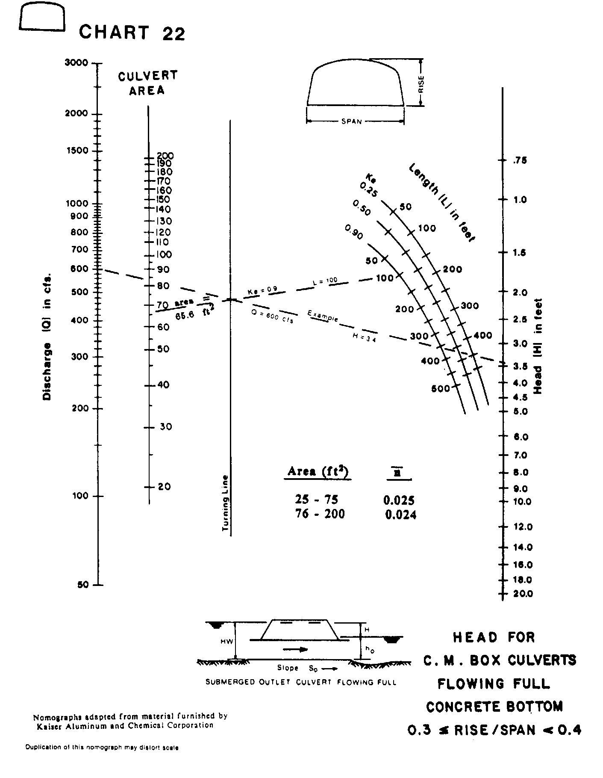

Source: HDS-5

